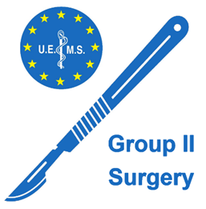**UEMS GROUPING 2 (Surgery)**

Maison des Associations Internationales  
Rue de Washington 40, B-1050 Brussels.

**Friday 25 April 2025 at CET**

13:30 – 15:00 - Room to be announced

**This meeting will be in person only. No online option**

**Advisory Board and Council Papers –** <https://www.uems.eu/event/uems-spring-council-meeting-25-26-april-2025-8/page/introduction-uems-uemo-joint-council-meeting-october-2024-copy-1>

**Agenda**

**1. Roll call of Sections   
2. Approval of the Agenda   
3. Minutes from last meeting – shared October 2024**

**4. Informal Zoom Pre-meeting: 7 April 2025 20:00 CET**Was attended by representatives OMFS, Neurosurgery, Orthopaedic Sections.  
No specific comments except including of Quality of Life elements in Wound Healing ETR.

**5. ETRs and related issues  
Part of AB and Council Agenda**New UEMS ETR Terms of References and Timeline Document

* ETR for Child and Adolescent Psychiatry
* ETR for Competency of Gynaecological Oncology
* ETR for the Specialty of Laboratory Medicine/ Medical Biopathology
* ETR for training in Paediatric Haematology and Oncology
* ETR for the specialty of Urology
* ETR for Wound Healing
* Establishment of the New UEMS MJC Palliative Care
* Presentation of updated ORL competencies (Council agenda)

**6. Specialist Issues from AB and Council Agendas  
UEMS and National Scientific Societies  
Broadening Engagement with UEMS**

**7. Constitutional issues from AB and Council Agenda  
Rules of Procedure: interactions between UEMS/UEMS Sections and supporting specialty associations/scientific societies.**

**8. SEVE Project – standing Item**

**9. Advance notice of elections for Chair and Secretary of Grouping – Autumn 2025**

**9. AOB**