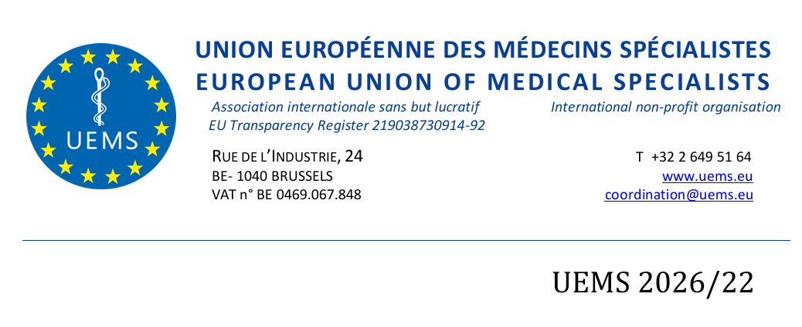

DRAFT AGENDA
GROUPING III
Friday 16th of October 2026
13:30 – 15:00
Room Brussels

Meeting to be held live at:
M.A.I. – Maison des Associations Internationales
40 Rue de Washington
1050 Ixelles,
Bruxelles, Belgium

Agenda:

Approval of the Spring Council meeting minutes

Roll call of Sections:
Anaesthesiology
Child & Adolescent Psychiatry
Clinical Neurophysiology
Dermatology and Venereology
Emergency Medicine
Laboratory Medicine / Medical Biopathology
Medical Genetics
Medical Microbiology
Nuclear Medicine
Occupational Medicine
Pathology
Pharmacology
Psychiatry
Public Health
Radiology
Radiation Oncology and radiotherapy

Specialtist Issues - European Training Requirements
Vote on the introduction of a single presentation of the ETRs, effective from this Council

ETR for the Competence in Paediatric Rheumatology

atology - item deferred from Spring Council

ETR for Competency in Emergency Surgery ETR for General Haematology

ETR for the Specialty of Nephrology

ETR for General Practice/Family Medicine

ETR for the Specialty of Rheumatology

ETR for the Specialty of Thoracic Surgery

ETR for the Specialty of Paediatrics

ETR for the Competence in Paediatric Endocrinology and Diabetes

ETR for the Competence in Paediatric Infectious Diseases

ETR for the Competence in Paediatric Urology

ETR for the Competence in Upper GastrointestinaI Surgery

Constitutional Matters

Proposal for the creation of first two Divisions of Paediatrics Section

AOB:

Roberta Petrino, Emergency Medicine: Climate Change and Health And Sustainability of Healthcare. Also supported by Fabriziomaria Gobba, Occupational Medicine, Bernadtka Dubicka Child and Adolescen Psychiatry

Patrick Twomey, Vesna Kusec, Laboratory Medicine: Proposal to Change Section Name and Annex V EU Directive 36/05

Bernadka Dubicka topic proposal - The impact of the online world on health eg health mis-information

Supporting documents:
https://www.uems.eu/event/uems-autumn-council-meeting-16-17-october-2026-brussels-belgium-14

