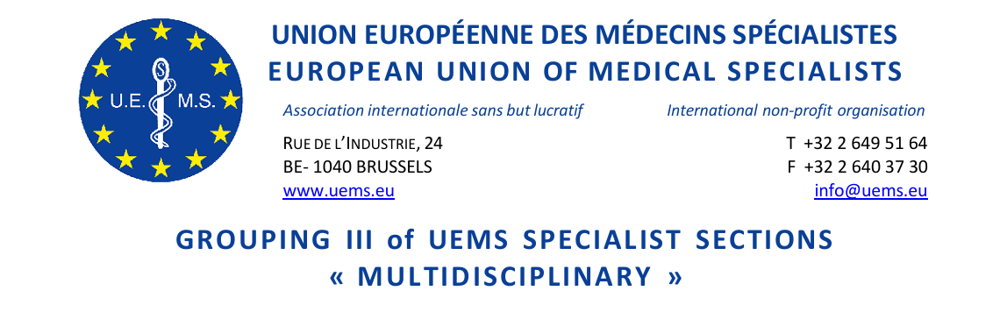

GROUPING III MEETING of UEMS SPECIALIST SECTIONS & EUROPEAN BOARDS
Friday, 17 October 2025
Sheraton Grand Tbilisi Metechi Palace 20 Telavi Street,
Tbilisi 0103 Georgia
13:30-15:00
Room USHBA

NOTES
- Roll call of Sections
The following 14 Sections were represented by either President or Secretary:
Anaesthesiology, Clinical Neurophysiology, Dermatology and Venereology, Emergency Medicine, Laboratory Medicine, Medical Genetics, Medical Microbiology (by proxy to Laboratory Medicine), Nuclear Medicine, Occupational Medicine (by proxy to Pathology), Pathology, Pharmacology, Psychiatry, Public Health Medicine, Radiation Oncology and Radiotherapy, Radiology.
- Approval of the Agenda
Approved.
- Approval of the minutes of last Meeting (25 April 2025, Brussels)
No comments: aproved.
- Specialist issues - European Training Requirements
  - PDM for Competence in Obstetric Anaesthesiology: supported
  - ETR for Specialty geriatric Medicine: supported
  - ETR for Competence in Reproductive medicine: supported
  - ETR for Competence in transitional Care of Adolescent and Young Adults: supported
  - ETR for Specialty of Pathology: supported
- Constitutional Matters
  - Winding up the UEMS Section of Cardiothoracic Surgery:
EEC: brief discussion whether the specialty is listed in Annex V: will be checked in Advisory Board.
  - Winding up the UEMS Thematic Federation for Vertigo: no comments
  - Proposal to establish a new UEMS Section for Cardiac Surgery: supported
  - Proposal for the establishment of a new UEMS MJC for Disaster Medicine: fully supported
- Miscellaneous/AOB
Section of Laboratory Medicine reports about experiences with NMAs failing to contribute fee to Sections.
Presentation of new Interest Group Laboratory Diagnostics (Vesna Kušec): fully supported.
Dates for next UEMS Council Meetings:
Spring 2026: 24–25 April 2026 Tunis
Autumn 2026: 16–17 October 2026 Brussels
Reminder on 1st UEMS Congress in Leuven, Belgium, May 2026
- Report of Grouping III:
TG to give a brief report of the Grouping meeting to the Advisory Board.

