t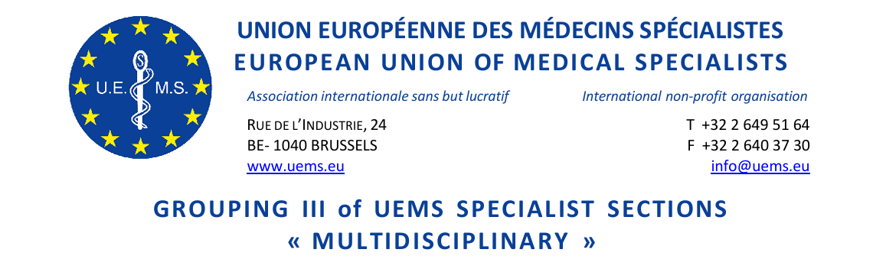

GROUPING III MEETING of UEMS SPECIALIST SECTIONS & EUROPEAN BOARDS

Carthage Thalasso Resort
Tunis Governorate, Gammarth, PB 270
Tunisia

Friday, 24 April 2026
13:30-15:00
Room Carthage V

DRAFT AGENDA and notes

- Roll call of Sections
- Anaesthesiology
- Child & Adolescent Psychiatry & Psychotherapy
- Clinical Neurophysiology
- Dermatology and Venereology
- Emergency Medicine
- Laboratory Medicine/ Medical Biopathology
- Medical Genetics
- Medical Microbiology
- Nuclear Medicine
- Occupational Medicine
- Pathology
- Pharmacology
- Psychiatry
- Public Health Medicine
- Radiation Oncology and Radiotherapy
- Radiology
- Approval of the Agenda
- Approval of the minutes of last Meeting (17 October, Tbilisi, Georgia) (document attached)
- First UEMS Congress May 2026
- Specialist issues - European Training Requirements
  - Overview of Submitted ETRs and Introduction of the New ETR RC Team, as presented by Nada Čikeš
  - PDM for Disaster Medicine for Anaesthesiologists*
  - ETR for the Specialty of Abdominal Wall Surgery*
  - ETR for the Specialty of Endocrinology, Diabetes and Metabolism*
  - ETR for Specialty of Hand Surgery*
  - ETR for Specialty of Obstetrics and Gynaecology*
  - ETR for Specialty of Paediatric Allergology*
  - ETR for the Competence in Paediatric Emergency Medicine*
  - ETR for the Competence in Paediatric Gastroenterology, Hepatology and Nutrition* ^{(deferred from Oct 2025)}
  - ETR for the Competence in Paediatric Rheumatology* ^{(deferred from Oct 2025)}
  - ETR for Specialty of Urology* ^{(deferred from Oct 2025)}
(Note: ETR for Neurology has been deferred to Autumn Council Meeting)
- Constitutional Matters*
  - Proposal for the creation of a Specialty Section in Haematology
- Miscellaneous / AOB
- Report of Grouping III / Next Meeting

* Decision required (in Advisory Board)
**Supporting documents available at https://www.uems.eu/event/uems-spring-council-meeting-24-25-april-2026-tunisia-13/page/introduction-uems-spring-council-meeting-24-25-april-2026-tunisia

