UEMS 2025/07

Training Requirements for the Specialty of Obstetrics and Gynaecology
European Standards of Postgraduate Medical Specialist Training
Project for Achieving Consensus in Training
by

the European Board and College of Obstetrics and Gynaecology

Created with funding from



Authors: Fionnuala McAuliffe SCTA Chair, SCTA Committee Members, Fedde Scheele, Jessica van der Aa, Angelique Goverde (eds.)

Table of Contents
I Introduction 3
II Training Requirements for Trainees 8
III Training Requirements for Trainers 62
Iv Training Requirements for Training Institutions 64

I. INTRODUCTION

1. UEMS Preamble
The UEMS (Union Européenne des Médecins Spécialistes, or European Union of Medical Specialists) is a non-governmental organisation representing national associations of medical specialists at the European level. With its current membership of 40 national associations and operating through 43 Specialist Sections and their European Boards, 17 Multidisciplinary Joint Committees and 4 Thematic Federations the UEMS is committed to promote the free movement of medical specialists across Europe while ensuring the professional consensus on the framework for the highest possible level of their training which will pave the way to the improvement of quality of care for the benefit of all European citizens and beyond.
UEMS and its Postgraduate Medical Specialists Training programmes. In 1994, the UEMS adopted its Charter on Postgraduate Training aiming at providing the recommendations at the European level for high quality training. This Charter set the basis for the European approach in the field of harmonisation of Postgraduate Specialist Medical Training, most importantly with the ongoing dissemination of its periodically updated Chapter 6’s, specific to each specialty. After the most recent version of the EU
Directive on the recognition of Professional Qualifications was introduced in 2011, the UEMS Specialist Sections and other UEMS Bodies have continued working on developing the documents on European Training Requirement(s) (ETRs). They reflect modern medical practice and current scientific findings in each of the specialty fields and particular competencies covered and being represented within the UEMS. In 2012 the UEMS Council adopted the document Template Structure for ETR.
The linkage between the quality of medical care and quality of training of medical professionals. It is the UEMS' conviction that the quality of medical care and expertise are directly linked to the quality of training, achieved competencies and their continuous update and development provided to the medical professionals. No matter where doctors are trained, they should have the same core competencies. The UEMS ETRs reflect many years (or even decades) of experience on the ground of the UEMS Sections/ Multidisciplinary Joint Committees (MJCs) and Boards developing in close collaboration with the relevant European Scientific Societies training requirements coupled with European Medical Assessments. It is one among the clear aims of the UEMS ETRs to raise standards of training to make sure that European patients find high quality standards of safe specialist care. While professional activity is regulated by national laws in EU Member States, it is the UEMS understanding that it has basically to comply with international treaties and UN declarations on Human Rights as well as the WMA International Code of Medical Ethics.
UEMS and European legislation facilitating the mobility of medical professionals. The UEMS Council and its Specialist Sections, first created in 1962, have regularly provided advice and expert opinion to the European Commission. This helped create the framework that informed the drawing up of the Doctors Directives in 1975, which provided for the mutual recognition of medical diplomas and the free movement of doctors throughout the EU. The revised EU Directive on the recognition of Professional Qualifications (2013/55/EU) allows member states to decide on a common set of minimum knowledge, skills and competencies that are needed to pursue a given profession through a Common Training Framework (CTF) which represents the third mechanism that could be used to ensure mobility within the EU. This directive states that “professional qualifications obtained under common training frameworks should automatically be recognised by Member States. Professional organisations which are representative at Union level and, under certain circumstances, national professional organisations or competent authorities should be able to submit suggestions for common training principles to the Commission, in order to allow for an assessment with the national coordinators of the possible consequences of such principles for the national education and training systems, as well as for the national rules governing access to regulated professions”. The UEMS supported CTFs since they encompass the key elements developed in modern educational and training models, i.e. knowledge, skills, professionalism. In addition, the Directive 2011/24/EU of the European Parliament and of the Council of 9 March 2011 on the application of patients’ rights in cross-border healthcare introduced a strong incentive for harmonisation of medical training and achieved competencies among EU/EEA Countries through the requirements to assure good and comparable quality of care to increasingly mobile European citizens.
The UEMS ETR documents aim to provide for each specialty the basic training requirements as well as optional elements, and should be regularly updated by UEMS Specialist Sections and European Boards to reflect scientific and medical progress. The three-part structure of these documents reflects the UEMS approach to have a coherent pragmatic document for each individual specialty, not only for medical specialists but also for decision-makers at the national and European level interested in knowing more about medical specialist training. To foster harmonisation of the ETR by adopting more specific guidelines, the CanMEDS competency framework is recommended which defines the entire set of roles of the professionals which are common across both medicine and surgery. UEMS has an agreement to use an abbreviated version of the competencies within those roles.
Importance of making a distinction between Knowledge and Competency in ETR documents. Competency-based education is not oriented towards the period of clinical rotations, but towards trainee, and trainee’s progress in the acquisition of competencies. Having a clear distinction within an ETR’s contents between competencies and knowledge helps define both how that training should be delivered and how it should be assessed. The UEMS considers that the appropriate use of dicerent methods of assessment of knowledge and acquired skills, emphasising the workplace-based assessment, is an essential component of quality postgraduate training, focused on high standards of specialist medical practice. To improve the methods of assessment it is also recommended to use the so-called Entrustable Professional Activities (EPAs) in all specialties ETRs. In order to recognise common and harmonised standards on the quality assurance in specialist training and specialist practice at a European level some UEMS Specialist Sections and Boards also have, for a long time, organised European examinations (supported and appraised by the UEMS CESMA - Council of European Specialist Medical Assessments).
Overlapping of learning outcomes and competencies. Each of the UEMS ETRs defines a syllabus or knowledge base and describes learning outcomes defined for given competencies. Some of these curricula encompass a whole specialty, other focus on areas within or across specialties and define content of the training requirements for specific areas of expertise. By recognising the potential overlapping it creates the opportunity for those writing ETRs to draft overlapping or common goals for learning outcomes. Similar measurement does not necessarily equate to the same targets. Rather, across dicerent specialties the final goal may dicer, i.e. there may be clearly defined individual goals for trainees with dicerent expectations.
UEMS ETRs and national curricula. The UEMS strongly encourages the National Medical Competent Authorities (NMCAs) to adopt such requirements and believes that this is the most ecicient way of implementation of good standards in postgraduate training. We clearly respect and support the vital role of the NMCAs in setting high standards of training and care in their respective Countries and checking through robust quality control mechanisms the qualifications of medical specialists moving across Europe. The UEMS ETRs are developed by professionals for professionals and this adds unique value to them. UEMS aim is to indicate the knowledge and competencies that should be achieved by trainees in EU/EEA countries and also competencies and organisation of the training centres. The training environment and results described in
UEMS ETRs may be achieved in adapted ways, depending on local traditions, organisation of healthcare system and of medical specialist training. Adaptation of UEMS ETRs to local conditions assures the highest quality of specialist training and each state may include additional requirements, depending on local needs.
Importance of collaboration with other representative European medical bodies. The UEMS always wishes to work with all Colleagues, NMAs, professional and scientific organisations across Europe. In the process of ETRs development, the UEMS recognises the importance of meaningful collaboration with the other European medical representative bodies, the European Junior Doctors (EJD representing doctors in training), the European Union of General Practitioners (UEMO – Union Européenne des Médecins Omnipraticiens), the Standing Committee of European Doctors (CPME - Comité Permanent des Médecins Européens), the Federation of European Salaried
Doctors (FEMS) and the European Association of Senior Hospital Doctors (AEMH - Association Européenne des Médecins Hospitaliers). In addition, UEMS continues to develop closer links with the many European specialist societies. UEMS, in collaboration with its fellow European representative bodies, has constantly been highlighting the importance of coordinated postgraduate specialist medical training programmes always accepting the dicering needs of dicerent specialties. In this way quality medical care is delivered by highly qualified medical specialists - essential to ensuring consumer confidence and protection all over Europe.
Conclusions. UEMS is very proud for all the hard work that has been done until now in developing the UEMS ETRs as well as that they are increasingly implemented as national curricula. However, we also recognise the need for constant improvement, and we are always open to further suggestions. The UEMS insists that the medical profession remains the driver in defining its own specialist training and continuous professional development needs. On this basis, we sincerely look forward to working with the key European Union responsible bodies, as well as the national stakeholders in implementing the basic common strategies and requirements outlined with this initiative. We are confident that the priorities detailed in UEMS ETR documents developed for individual specialties (and/or competencies) will become evident in national strategies and programmes, as well as action plans for postgraduate medical education and training.

- Specialty of Obstetrics and Gynaecology

The specialty of Obstetrics and Gynaecology encompasses comprehensive care for women’s reproductive health across various stages of life. Obstetrics focuses on maternal and fetal medicine, including antenatal care, labor and delivery, and the management of complications during pregnancy and childbirth. Gynaecology addresses the diagnosis and treatment of disorders affecting the female reproductive system, incorporating both medical and surgical interventions. Additionally, the field integrates sexual and reproductive health services, which cover family planning, contraception, infertility management, and menopause care. The discipline further includes recognized subspecialties, such as maternal-fetal medicine, reproductive medicine, urogynecology, gynecologic oncology, and pediatric and adolescent gynaecology, ensuring a holistic approach to women’s health.

- Aims of the Specialty

The EBCOG PACT (European Board and College of Obstetrics and Gynaecology – Postgraduate Assessment of Clinical Training) programme aims to:
- Provide a structured, competency-based framework for postgraduate training in Obstetrics and Gynaecology across Europe,
- Ensure harmonization of standards in education and clinical practice among European countries,
- Focus on foundational skills and knowledge that every specialist in Obstetrics and Gynaecology should acquire before subspecialization, and
- Promote quality assurance in training through assessment and accreditation.
The knowledge, skills and attitudes required of every European gynaecologist have been defined (the ‘core’). Additionally, ‘electives’ have been described, which are positioned between the core and the subspecialties. Each trainee should be trained in at least one elective. This curriculum contains agreements about both medical and general competencies for new European Obstetrician-Gynaecologists.

- Procedure of ETR Development/ Revision
The development and revision of the European Training Requirements (ETR) in pan-European curriculum (EBCOG-PACT) is aligned with the principles of the European Union of Medical Specialists (UEMS).
In succession of the Standards of Care for Women’s Health in Europe published by EBCOG in 2014, the EBCOG PACT training curriculum defines standards for postgraduate training in Obstetrics and Gynaecology in Europe. These standards address endpoints in the medical and professional domains but also provide guidance in training methods, entrustment, faculty development and quality management of training. By the process of seeking consensus on the competencies at the level of independent practice for all trainees in Obstetrics and Gynaecology by the end of their training, EBCOG PACT has laid down the foundation for the implementation of the training standards throughout Europe.
The content (core and electives) of the pan-European curriculum must be reasonable and feasible for implementation in all European countries. The ‘EBCOG standards of care’ determine conditions under which care is delivered and procedures are performed; these were developed in concordance with the subspecialty societies. Trainees must adhere to these conditions. The content of the curriculum (core and electives) is in line with current standards of care and training. Since developments within the disciplines of Obstetrics & Gynaecology occur frequently, the content may not in all cases reflect the most recent recommendations, although the training standards will be updated intermittently. Training to the level of independent practice means that a trainee will have to be able to deliver care or perform a procedure without interference of supervision. National legislation determines whether supervision must be present (without interference) while a trainee delivers care or performs a procedure.
The project was led by a multidisciplinary group led by EBCOG Officers, EBCOG Executive members, EBCOG/UEMS Ob/Gyn National delegates. affiliated societies, group of Experts and the members of the Standing Committee on Training and Assessment (SCTA). The revision process commenced with a Europe wide survey of trainees, trainers, professional colleges and subspecialty societies in 2022 on how PACT could be improved. The findings and proposed changes were approved by EBCOG council in November 2022. From 2023-2024 the SCTA committee undertook bimonthly meetings to revise PACT taking account of comments received. The revised 2025 version was approved by EBCOG executive in September 2024 and by EBCOG council in December 2024. The revision process has been an exemplar of collaboration between all members of the SCTA, ENTOG, Trainees, Trainers, EBCOG Council and our affiliated subspecialty societies (EAPM, ESGO, ESHRE, EUGA).

II. TRAINING REQUIREMENTS FOR TRAINEES

1. Trainee in Obstetrics and Gynaecology

A Trainee in Obstetrics and Gynaecology must be a fully qualified medical doctor who has successfully completed basic medical training and has been accepted into a recognized national training programme in Obstetrics and Gynaecology. The trainee progresses through a structured curriculum that follows the principles and competencies defined in the EBCOG PACT (Pan-European Training Curriculum).

The training aims to ensure the acquisition of comprehensive knowledge, clinical skills, and professional attitudes required for the safe and effective practice of general Obstetrics and Gynaecology. It builds upon the foundational competencies gained during early postgraduate training and advances towards independent specialist practice.
This training programme is aligned with the standards of the European Board and College of Obstetrics and Gynaecology (EBCOG) and the European Union of Medical Specialists (UEMS), ensuring harmonised, high-quality education and evaluation across Europe.

2. Content of training and learning outcomes

a. Competencies required of the trainee (as per CanMEDs framework)

i. Theoretical knowledge
The knowledge and skills in the field of Obstetrics & Gynaecology have been grouped into ten major themes. For every theme this document describes what should be trained in the core part of the curriculum.

  - General Medical Knowledge & Skills
  - Prenatal Care
  - Intrapartum & Postpartum Care
  - Benign Gynaecology
  - Reproductive Medicine
  - Urogynaecology
  - Premalignancy and Gynaecological Oncology
  - Paediatric and Adolescent Gynaecology
  - Sexual Health and contraception
  - Breast Disease

ii. Practical and clinical skills

The trainee can provide obstetrical and gynaecological care at the level of independent practice in the outpatient department, the delivery room and the emergency room.

In all situations, the trainee:
Problem identification; to determine the need for diagnostic evaluation or to recognise pathology.
  - Has specific knowledge about embryology, anatomy and the physiology of female genital organs and breasts.
  - Obtains patient and family history including social issues, performs accurate clinical examination of vital signs, the internal and external genitalia and the abdomen, and interprets the findings adequately.
  - Understands how gynaecological conditions influence sexual function, enquires about sexual function and possible negative sexual experiences, and understands consequences of sexual violence on gynaecological conditions and behaviour.
  - Understands bio-psychosocial aspects of obstetrical and gynaecological conditions.
  - Be aware of the legal and ethical issues that can affect the care of displaced and migrant women, such as their legal status, access to healthcare, and rights to privacy and confidentiality.
  - Advocate for the rights of displaced and migrant women, ensuring they receive the care they need regardless of their legal status. Special attention should be given to safeguarding vulnerable women, including those at risk of trafficking, exploitation, or gender-based violence

Diagnosis; to diagnose without performance of a specific skill.
Diagnosis; to diagnose with performance of a specific skill.
  - Is able to diagnose, assess, investigate, monitor and interpret data considering the most common obstetrical and gynaecological conditions (conditions to be clarified per theme).
  - Undertakes timely and appropriate investigations, such as examining microbiological samples, laboratory investigations, and radiology imaging, and interprets results in liaison with colleagues (e.g. radiologists) in relation to clinical findings to form a differential diagnosis.

Information; to provide information and advice regarding the diagnosis and its implications
  - Maintains effective communication with patients and relatives, according to the principles of shared decision making and informed consent, documents this communication accurately and performs team work with effective communication within the multi-disciplinary health care teams.
  - Participation in clinical morbidity meetings
  - Patient centered debriefing after obstetric and gynaecological complications.

Treatment; to discuss all treatment options, determine the indication for a specific treatment, counsel about the treatment, as well as provide the treatment without performance of a specific skill (e.g. conservative treatment).
  - Is able to recognise and triage acutely ill patients and initiate adequate management, including septic patients, patients with peripartum complications and patients requiring resuscitation.
  - Leads a ward round with a multidisciplinary input, manages the admission and discharge of patients at the ward and the delivery room, and manages handover to another practice.
  - Has specific knowledge about peri-operative care, including ASA classification, indications and contraindications of surgeries, risks of surgeries, indications for blood transfusion, postsurgical complications and indications for admission to the Intensive Care

Treatment; to discuss all treatment options, determine the indication for a specific treatment, counsel about the treatment, as well as provide the treatment with performance of a specific skill (e.g. surgical treatment).
  - Is able to provide basic therapeutic interventions, including safe and appropriate prescription and administration of oxygen, drugs and therapies, blood products, circulation support and urinary catheterisation.
  - Manages the assessment, prevention and treatment of pain.

iii. Trainee should achieve theoretical and practical competence in the following areas (Core Curriculum)
    - Prenatal Care
Problem identification; to determine the need for diagnostic evaluation or to recognise pathology. See next section

Diagnosis; to diagnose without performance of a specific skill. See next section
Diagnosis; to diagnose with performance of a specific skill.
- Embryonic & foetal viability: Transvaginal & transabdominal ultrasound
- Pregnancy location (intra or extra uterine): Transvaginal & transabdominal ultrasound
- Pregnancy age: Transvaginal & transabdominal ultrasound
- Singleton or multiple gestation pregnancy: Transvaginal & transabdominal ultrasound
- Cervical length: Transvaginal & transabdominal ultrasound
- Chorionicity: Transvaginal & transabdominal ultrasound
- Foetal biometry: Transvaginal & transabdominal ultrasound
- Foetal presentation: Transvaginal & transabdominal ultrasound
- Placental site: Transvaginal & transabdominal ultrasound
- Amniotic fluid volume: Transvaginal & transabdominal ultrasound
- Umbilical artery Doppler assessment: Doppler flow measurement

Information; to provide information and advice regarding the diagnosis and its implications.
Promotion of exercises in pregnancy for a healthy lifestyle during pregnancy for improving health-related quality of life as well as ‘breathing techniques and self-help techniques for labour’ with the help of a Physical and Rehabilitation Medicine physician, if needed:
- Teen pregnancy, Advanced maternal age pregnancies
- Pregnancy and obesity
- Pregnancy and diabetes
- Pregnancy and pre-existing hypertension
- Cervical incompetence
- Multiple gestation pregnancy
- Cholestasis of pregnancy
- Pregnancy of unknown location
- Hyperemesis
- (Recurrent) miscarriage
- Vaginal blood loss in first trimester
- Vaginal blood loss in second and third trimester
- Use of medication, indications and safety in pregnancy and breastfeeding (e.g. for psychiatric and medical conditions)
- Breastfeeding
- Consequences of complicated delivery for a following pregnancy and delivery
- Complications of prematurity
- Chromosomal abnormalities by interpreting nuchal translucency / double test / triple test /amniocentesis / chorionic villus sampling / NIPT

Indication for treatment; to determine the indication for a specific treatment, taking all treatment options into consideration. See next section

Treatment; to discuss all treatment options, determine the indication for a specific treatment, counsel about the treatment, as well as provide the treatment without performance of a specific skill (e.g. conservative treatment).
- Second trimester pregnancy termination
- Blood group incompatibility
- Group B streptococcus carrier status
- Abdominal complaints
- (Minor) abdominal trauma in pregnancy
- Malpresentation
- Gestational diabetes
- Oligohydramnios
- Polyhydramnios
- Hypertensive disorders of pregnancy (pregnancy-induced hypertension, pre-eclampsia, eclampsia,HELLP)
- Reduced foetal activity
- Foetal growth restriction
- Premature rupture of membranes
- Intrauterine foetal death
- Postdate pregnancy
- Perinatal infections (Toxoplasmosis, syphilis, varicella-zoster, parvovirus B19, rubella,cytomegalovirus, herpes)

Treatment; to discuss all treatment options, determine the indication for a specific treatment, counsel about the treatment, as well as provide the treatment with performance of a specific skill (e.g. surgical treatment). As covered in above section
    - Intrapartum & Postpartum Care

Problem identification; to determine the need for diagnostic evaluation or to recognise pathology. See next section
Diagnosis; to diagnose without performance of a specific skill. See next section
Diagnosis; to diagnose without performance of a specific skill. See next section
- Feasibility of labour: Physical examination, Intrapartum ultrasound, CTG interpretation, Interpretation and use of partogram

Information; to provide information and advice regarding the diagnosis and its implications See next section
Indication for treatment; to determine the indication for a specific treatment, taking all treatment options into consideration.
- Post-partum haemorrhage; arterial embolization
Treatment; to discuss all treatment options, determine the indication for a specific treatment, counsel about the treatment, as well as provide the treatment without performance of a specific skill (e.g. conservative treatment).
Intrapartum
- Induction of pulmonary maturation
- Premature contractions
- Cervical insufficiency
- Failure of progression of labour
- Intrapartum fever
- Meconium-stained amniotic fluid
- Medical history of caesarean section
- Peripartum pain
- Hypertensive crisis / severe preeclampsia / HELLP
- Placenta previa

Post partum
- Postpartum mastitis (with abscess)
- Postpartum urinary retention
- Thrombo-embolic process
- Postpartum haemorrhage
- Medication safety during lactation
- Thrombotic risk assessment
- Postpartum mental health assessment including postpartum depression/psychosis and safeguarding of the neonate

Treatment; to discuss all treatment options, determine the indication for a specific treatment, counsel about the treatment, as well as provide the treatment with performance of a specific skill (e.g. surgical treatment).
*= performance of skill at least in simulation setting (x) mimimun number of procedures
- Uncomplicated delivery: Assistance of uncomplicated delivery (50)
- Complicated delivery: Assistance of preterm delivery, Vacuum-assisted vaginal delivery (10-20), Forceps-assisted delivery* (0-10), Breech delivery* (5),Assistance of vaginal delivery of multiple pregnancy, Caesarean section (20), Repeat caesarean section (10-15), Caesarean section in patient with high BMI (0-10)
- Twin delivery: Vaginal delivery of wins
- Foetal distress: CTG monitoring, Foetal scalp blood sampling* ,Episiotomy,Emergency caesarean section (10-15)
- Placental abruption
- Uterine rupture
- Shoulder dystocia: All dystocia management manoeuvres*
- Post-partum haemorrhage: Intrauterine balloon tamponade, Surgical compression of atonic uterus, (B-Lynch suturing)*, Abdominal hysterectomy*
- Retained placenta: Manual and surgical removal of placenta
- Uterine inversion: Manual uterine reversion*
- Genital tract trauma: Repair of genital tract trauma
- Vulvar hematoma: Evacuation of vulvar hematoma
- Episiotomy wound: Suturing of episiotomy wound
- 1st/2nd/3rd degree perineal tear: Suturing of 1st/2nd/3rd degree perineal tear
- 4th degree perineal tear: Suturing of 4th degree perineal tear*
- Neonatal support: Supporting the initial care of the healthy/preterm new-born (with low Apgar scores), Accurate resuscitation of the new-born in the first 10 minutes after delivery (when awaiting the arrival of the paediatrician)*

    - Benign Gynaecology

Problem identification; to determine the need for diagnostic evaluation or to recognise pathology.
- Acute gynaecological emergencies
- Abnormal uterine bleeding
- Chronic pelvic pain
- Menopause
- Abnormal vaginal bleeding in menopause

Diagnosis; to diagnose without performance of a specific skill.
- Vaginal discharge
Diagnosis; to diagnose with performance of a specific skill.
- Vulvar abnormalities: Punch biopsy under local anaesthesia
- Intrauterine abnormalities : Endometrial sampling (aspiration/office biopsy)
- Abnormalities of uterus and adnexa: Diagnostic ultrasound
- Abnormalities of the ovary: Diagnostic hysteroscopy

Information; to provide information and advice regarding the diagnosis and its implications.
- Cervical screening
- Breast screening
- Osteopenia/osteoporosis screening
- Weight management

Indication for treatment; to determine the indication for a specific treatment, taking all treatment options into consideration.
- Endometriosis
- Tubo-ovarian abscess
- Abnormal uterine bleeding
- Uterine myoma
- Vaginal septum

Treatment; to discuss all treatment options, determine the indication for a specific treatment, counsel about the treatment, as well as provide the treatment without performance of a specific skill (e.g. conservative treatment).
- Pelvic inflammatory disease/salpingitis
- Abdominal/pelvic pain
- Premenstrual syndrome
- Dysmenorrhoea
- Abnormal uterine bleeding
- Menopausal complaints
- Abnormal vaginal discharge
- Vulvovaginitis
- Uterine fibroids
- Adnexal pathology
- Endometriosis
- Vulvar condylomas
- First trimester miscarriage
- Ectopic pregnancy

Treatment; to discuss all treatment options, determine the indication for a specific treatment, counsel about the treatment, as well as provide the treatment with performance of a specific skill (e.g. surgical treatment).
- Abnormal uterine bleeding: Placement of Intra Uterine Device (15), Endometrial ablation, Total laparoscopic hysterectomy
- Ectopic pregnancy: Laparoscopic removal of ectopic pregnancy (10), (salpingostomy) or salpingectomy
- Early miscarriage / First trimester termination of pregnancy: Dilatation and curettage by suction or blunt curette* (15)
- Bartholin’s cyst: Surgical marsupialisation of cyst (5)
- Vulvar abscess: Surgical excision of abscess
- Ovarian cyst: Simple laparoscopic ovarian cystectomy (5)
- Adnexal pathology: Laparoscopic salpingo-oophorectomy (5), Salpingo-oophorectomy via laparotomy (5)
- Intracavitary polyp: Hysteroscopic polyp resection (5)
- Uterine myoma: Hysteroscopic myoma resection type 0-1 (< 4cm) (3), Myomectomy of subserous myoma via laparotomy (3)
- Pelvic adhesions: Simple laparoscopic adhesiolysis (3), Laparotomy with minimal adhesiolysis (3)
()*=according to local and national protocols and legislation and may include performance of skill at least in simulation setting
    - Reproductive Medicine

Problem identification; to determine the need for diagnostic evaluation or to recognise pathology. See next section
- Male and female subfertility and fertility assessment
- Basic reproductive endocrinology and endocrine abnormalities that could lead to cycle disorders
- (primary amenorrhoea, secondary amenorrhoea, oligomenorrhoea, galactorrhoea,
- hyperprolactinemia, and hirsutism)
- Assessment of female primary and secondary amenorrhea (CNS abnormalities, pituitary dysfunction, anorexia nervosa, ovarian and ovulatory abnormalities, genital tract abnormalities)
- Assessment of recurrent pregnancy loss
- Techniques for assisted conception
- Fertility preservation techniques
Diagnosis; to diagnose without performance of a specific skill.
- Investigation of amenorrhoea
- Hormonal dysfunction
- Pituitary dysfunction
- PCOS and its differential diagnosis
- Hirsutism and Virilism

Diagnosis; to diagnose with performance of a specific skill.
- Genital tract abnormalities: Transvaginal ultrasound, transvaginal 3D ultrasound is preferred
- Subfertility; tubal patency: Diagnostic laparoscopy with tubal testing. Diagnostic hysteroscopy with tubal testing
- Response to fertility treatment: Transvaginal ultrasound with follicle count and follicle measurements (50)
- Ovarian Hyperstimulation Syndrome: Transvaginal ultrasound with evaluation of follicles and intraperitoneal fluid

Information; to provide information and advice regarding the diagnosis and its implications.
- General prognostic factors for pregnancy
- Probability of on-going pregnancy, spontaneous abortion and ectopic pregnancy associated with
- various fertility treatments
- Legal and ethical issues in medical assisted reproduction

Indication for treatment; to determine the indication for a specific treatment, taking all treatment options into consideration.
• Assisted reproduction techniques: Intrauterine insemination

Treatment; to discuss all treatment options, determine the indication for a specific treatment, counsel about the treatment, as well as provide the treatment without performance of a specific skill (e.g. conservative treatment).
- WHO-II cycle disorders; ovulation induction with clomiphene citrate
- OHSS initial / emergency treatment

    - Urogynaecology

Problem identification; to determine the need for diagnostic evaluation or to recognise pathology
Recognise the need for referral for pelvic floor rehabilitation and referral to the relevant medical specialties (including Physical and Rehabilitation Medicine and physiotherapy) for stress and/or urge incontinence
Diagnosis; to diagnose with performance of a specific skill
Diagnosis
Apical compartment prolapse
Anterior compartment prolapse
Posterior compartment prolapse
Stress urinary incontinence
Overactive bladder
Urinary retention
Information; to provide information and advice regarding the diagnosis and its implications
Lifestyle advice
Indication for treatment; to determine the indication for a specific treatment, taking all treatment options into consideration
Vaginal prolapse
Urinary incontinence

Treatment; to discuss all treatment options, determine the indication for a specific treatment, counsel about the treatment, as well as provide the treatment with performance of a specific skill (e.g. surgical treatment). *= performance of skill at least in simulation setting
- Uterine / vaginal vault prolapse: Pessary fitting and on-going care* (10)
- Cystocele / urethrocele: Simple anterior vaginal repair* (10)
- Enterocele / rectocele: Simple posterior vaginal repair* (10)

    - Premalignancy and Gynaecological Oncology

Problem identification; to determine the need for diagnostic evaluation or to recognise pathology. See next section
- Pre-malignant conditions of the vulva in frail women with multiple comorbidities.
- Advanced-Stage Gynaecological Malignancies
- Atypical Grief Reactions

Diagnosis; to diagnose without performance of a specific skill.
- Vulval and cervical carcinoma by evaluation of pathology results

Diagnosis; to diagnose with performance of a specific skill.
- HPV-related genital disease: Vulvoscopy with biopsy ,Colposcopy with biopsy
- Endometrial Hyperplasia: TVS & endometrial biopsy
- Gestational Trophoblastic Disease: TVS
- Endometrial Malignancy: Endometrial Biopsy

Information; to provide information and advice regarding the diagnosis and its implications.
- Vulval Carcinoma
- Cervical Carcinoma
- Endometrial Carcinoma
- Ovarian Carcinoma
- Recurrence or progression of gynaecological oncological disease

Indication for treatment; to determine the indication for a specific treatment, taking all treatment options into consideration.
Covered in sections above

Treatment; to discuss all treatment options, determine the indication for a specific treatment, counsel about the treatment, as well as provide the treatment without performance of a specific skill (e.g. conservative treatment). Covered in sections above
Treatment; to discuss all treatment options, determine the indication for a specific treatment, counsel about the treatment, as well as provide the treatment with performance of a specific skill (e.g. surgical treatment).
- Premalignant conditions of the cervix: Conisation of the cervix (5)
- Cervical Intra-Epithelial neoplasia: Cervical LLETZ (10)
- Stage I low-grade endometrial carcinoma: Laparoscopic hysterectomy*, Abdominal Hysterectomy*
- Genetic conditions, including mutations with indication for risk-reducing salpingectomy, Laparoscopic salpingo-oophorectomy (5) ,Salpingo-oophorectomy via laparotomy (5)
* performance of skill at least in simulation setting
- Paediatric and Adolescent Gynaecology

Problem identification; to determine the need for diagnostic evaluation or to recognise pathology.
- Sexual dysfunction
- Sexual abuse
- Genital mutilation
- Vaginal discharge in a child
- Acute abdominal pain in a child
- Sexually transmitted disease in a child
- Trauma of the vulva, vagina, perineum and/or rectum in a child
- Suspicion of domestic violence or child abuse

Diagnosis; to diagnose without performance of a specific skill.
See next section
Diagnosis; to diagnose with performance of a specific skill.
- Gynaecological conditions in in children*: Adapting communication to the level of the child, Accurate gynaecological examination of the child*
- *= prepubertal and peripubertal children
- Special consideration for those with developmental disorders and those who struggle with gender identity or sexual orientation
- Ensure informed consent is obtained from young people and their guardians

Information; to provide information and advice regarding the diagnosis and its implications.
See next section

Indication for treatment; to determine the indication for a specific treatment, taking all treatment options into consideration.
- Contraception in healthy adolescents

Treatment; to discuss all treatment options, determine the indication for a specific treatment, counsel about the treatment, as well as provide the treatment without performance of a specific skill (e.g. conservative treatment).
- Sexually transmitted diseases in adults, adolescents and prepubertal and peripubertal children

Treatment; to discuss all treatment options, determine the indication for a specific treatment, counsel about the treatment, as well as provide the treatment with performance of a specific skill (e.g. surgical treatment).
- Trauma of the vulva/vagina/perineum/rectum in a child* : Emergency care of vulva/vagina/perineum/rectum
*= prepubertal and peripubertal children
- Sexual Health and Contraception

Problem identification; to determine the need for diagnostic evaluation or to recognise pathology. See next section
- To obtain a full sexual history including information about sexual health, form of used contraception sexual transmitted infections
- Understand the physiological mechanism and pathways of female sexual response
- Understand the impact of gynaecological, endocrine and obstetrical conditions on female sexual health / response

Diagnosis; to diagnose without performance of a specific skill. See next section
- Sexual dysfunction (pain disorders, orgasmic disorders, sexual desire disorders, lubrication): Communication skills
- Sexual abuse
- Domestic violence
- Genital mutilation

Diagnosis; to diagnose with performance of a specific skill.
See next section
Information; to provide information and advice regarding the diagnosis and its implications.
- Provide information on prevention of sexual transmitted infections and unintended pregnancy, lifestyle advice
- Provide information on possibilities of specific psychological/psychotherapeutic interventions
- Provide information on psychosocial aspects of genital mutilation

Indication for treatment; to determine the indication for a specific treatment, taking all treatment options into consideration.
- Unintended pregnancy, family planning
- Sexual transmitted infections
- Dyspareunia

Treatment; to discuss all treatment options, determine the indication for a specific treatment, counsel about the treatment, as well as provide the treatment without performance of a specific skill (e.g. conservative treatment).
- Contraception, emergency contraception
- Hormonal therapy (systematic/local)
- Local therapy (lubricants, moisturizers, topical anesthetics)

Treatment; to discuss all treatment options, determine the indication for a specific treatment, counsel about the treatment, as well as provide the treatment with performance of a specific skill (e.g. surgical treatment).
Sexual pain disorders: Surgical techniques depending of the pain type
Contraception: Placement of diaphragm /cervical cap, Placement of Intra Uterine Device, Placement of contraceptive implants, Laparoscopic sterilisation, Medical and surgical termination of pregnancy
- Breast disease
Problem identification; to determine the need for diagnostic evaluation or to recognise pathology.
- Malignant breast disease
- Genetic risks in malignant breast disease
- Screening methods for breast disease

iv. Trainee should achieve theoretical and practical competence in the following areas (Electives Curriculum)

The postgraduate training in Obstetrics and Gynaecology follows a programme of at least five years. It consists of a core and an elective programme.
This document describes the medical content of the elective modules of the pan-European postgraduate training curriculum in Obstetrics & Gynaecology. The content of the elective modules has been determined through a consensus procedure amongst European gynaecologists and trainees [1,2]. It integrates the knowledge and skills that should be acquired to develop the competencies of the European gynaecologist in additional training.
The content of the curriculum (core and electives) is in line with current standards of care and training. Since developments within the disciplines of Obstetrics & Gynaecology occur frequently, the content may not in all cases reflect the most recent recommendations, although the training standards will be updated intermittently.
Training to the level of independent practice means that a trainee will have to be able to deliver care or perform a procedure without interference of supervision. National legislation determines whether supervision must be present (without interference) while a trainee delivers care or performs a procedure.

Nine electives have been identified, covering:
1. Fetal Medicine
2. Maternal Medicine
3. Benign Gynaecology
4. Reproductive Medicine
5. Urogynaecology & Pelvic Floor
6. Low Genital Tract Disease & Sexual health
7. Paediatric & Adolescent Gynaecology
8. Gynaecological Oncology
9. Breast Disease

- Fetal Medicine
Problem identification; to determine the need for diagnostic evaluation or to recognise pathology.
- Referral to genetic services for families at risk of or with a diagnosis of fetal structural defect

Diagnosis; to diagnose without performance of a specific skill.
- Included in next phases of the clinical pathway

Diagnosis; to diagnose with performance of a specific skill.
- Abnormal flow of the umbilical artery: Doppler flow ultrasound uterine arteries
- Abnormal flow of the middle cerebral artery : Doppler flow ultrasound arteria cerebri media
- Abnormal flow of the ductus venosus: Doppler flow ultrasound ductus venosus
- Congenital anomalies: Advanced ultrasound screening
- Chromosomal abnormalities: Amniocentesis
- Diagnosis of placenta acreta spectrum: Transabdominal and transvaginal ultrasound
- Fetal growth restriction: Transabdominal and transvaginal ultrasound

‘Information; to provide information and advice regarding the diagnosis and its implications.
- Communication of risks for all obstetric procedures.
- Leading on multidisciplinary teams for fetal anomaly assessment including genetics
- Leading an interdisciplinary meeting on complex psychosocial problems during pregnancy.

Indication for treatment; to determine the indication for a specific treatment, taking all treatment options into consideration.
- Included in next phases of the clinical pathway

Treatment; to discuss all treatment options, determine the indication for a specific treatment, counsel about the treatment, as well as provide the treatment without performance of a specific skill (e.g. conservative treatment).
- Pregnancy and delivery planning for pregnancies with fetal anomaly
- Termination of pregnancy for fetal anomaly
- Complex twin pregnancy, e.g. TTTS, MCDA

Treatment; to discuss all treatment options, determine the indication for a specific treatment, counsel about the treatment, as well as provide the treatment with performance of a specific skill (e.g. surgical treatment).
- Operative delivery of fetus with complex congenital anomalies

- Maternal Medicine
Problem identification; to determine the need for diagnostic evaluation or to recognise pathology.
- Psychiatric problems requiring referral to a mental health specialist, social worker or addiction centre
- Women with genetic disorders

Diagnosis; to diagnose without performance of a specific skill.
- Psychiatric disorders in pregnancy and postpartum
- Preconceptional counselling for cases of complex maternal medical history
- Fear of childbirth and posttraumatic stress disorder following childbirth
- Complex psychosocial problems during pregnancy
- Substance abuse
- Management of grief

Diagnosis; to diagnose with performance of a specific skill.
See next section
‘Information; to provide information and advice regarding the diagnosis and its implications.
- Communication of risks communication for all obstetric procedures.
- Leading an interdisciplinary meeting on complex psychosocial problems during pregnancy.
- Leading postpartum debriefing

Indication for treatment; to determine the indication for a specific treatment, taking all treatment options into consideration.
See next section

Treatment; to discuss all treatment options, determine the indication for a specific treatment, counsel about the treatment, as well as provide the treatment without performance of a specific skill (e.g. conservative treatment).
- Complex hypertensive disorders of pregnancy
- Pre-existent diabetes
- Multiple gestation pregnancy
- Pre-existing maternal disease
- Postpartum depression
- Medication safety in pregnancy
- Women with substance abuse

Treatment; to discuss all treatment options, determine the indication for a specific treatment, counsel about the treatment, as well as provide the treatment with performance of a specific skill (e.g. surgical treatment).
- Cervical insufficiency: Insertion of cervical cerclage

- Benign Gynaecology
Problem identification; to determine the need for diagnostic evaluation or to recognise pathology.
See next section’
Diagnosis; to diagnose without performance of a specific skill.
See next section
Diagnosis; to diagnose with performance of a specific skill.
See next section
‘Information; to provide information and advice regarding the diagnosis and its implications.
See next section

Indication for treatment; to determine the indication for a specific treatment, taking all treatment options into consideration.
- Psychosocial aspects of chronic pelvic pain.

Treatment; to discuss all treatment options, determine the indication for a specific treatment, counsel about the treatment, as well as provide the treatment without performance of a specific skill (e.g. conservative treatment).
- Postmenopausal hormonal therapy in patients with comorbidities
- Osteoporosis management

Treatment; to discuss all treatment options, determine the indication for a specific treatment, counsel about the treatment, as well as provide the treatment with performance of a specific skill (e.g. surgical treatment).
- Uterine myoma type 2 (<3cm): Hysteroscopic myoma resection type 2 (<3cm)
- Uterine myoma (which is unresponsive to conservative treatment): Laparoscopic and open myomectomy
- Hypermenorrhoea: Hysteroscopic endometrial ablation or resection, Laparoscopic and open hysterectomy
- Endometriosis (< stage 2): Laparoscopic treatment of endometriosis
- Tubo-ovarian abscess: Laparoscopic management of tubo-ovarian abscess
- Pelvic adhesions: Laparoscopic adhesiolysis
- Genitourinary syndrome of menopause management

- Reproductive Medicine
Problem identification; to determine the need for diagnostic evaluation or to recognise pathology.
- Micro/percutaneous semen aspiration
- Testicular semen extraction
- Genetic disorders
- Pre-implantation diagnosis

Diagnosis; to diagnose without performance of a specific skill.
See next section
Diagnosis; to diagnose with performance of a specific skill.
See next section
‘Information; to provide information and advice regarding the diagnosis and its implications.
See next section

Indication for treatment; to determine the indication for a specific treatment, taking all treatment options into consideration.
- Psychosocial situation of couples in fertility treatments (shared decision making)

Treatment; to discuss all treatment options, determine the indication for a specific treatment, counsel about the treatment, as well as provide the treatment without performance of a specific skill (e.g. conservative treatment).
- Advanced ovulation-induction techniques
- IUI stimulation
- Galactorrhoea
- Hyperprolactinemia
- Pituitary adenoma

Treatment; to discuss all treatment options, determine the indication for a specific treatment, counsel about the treatment, as well as provide the treatment with performance of a specific skill (e.g. surgical treatment).
- Subfertility: Intra Uterine Insemination
- Ovarian Hyper Stimulation Syndrome

- Urogynaecology & Pelvic Floor
Problem identification; to determine the need for diagnostic evaluation or to recognise pathology.
- Neurological disorders (spina bifida, multiple sclerosis, Parkinson’s, spinal damage, neuropathy)

Diagnosis; to diagnose without performance of a specific skill.
See next section

Diagnosis; to diagnose with performance of a specific skill.
- Abnormalities in strength and motility of the pelvic floor and levator ani: Manual palpation measurement of strength and motility of the pelvic floor and levator ani muscle
- Abnormalities in urinary tract disorders: Transperineal & endo-anal ultrasound, Interpretation of urodynamic investigations

‘Information; to provide information and advice regarding the diagnosis and its implications.
- Working with a urogynaecology multidisciplinary team

Indication for treatment; to determine the indication for a specific treatment, taking all treatment options into consideration.
- Psychosocial aspects of prolapse and incontinence

Treatment; to discuss all treatment options, determine the indication for a specific treatment, counsel about the treatment, as well as provide the treatment without performance of a specific skill (e.g. conservative treatment).
- Prescribing anticholinergics and anti-muscarinic medications
Treatment; to discuss all treatment options, determine the indication for a specific treatment, counsel about the treatment, as well as provide the treatment with performance of a specific skill (e.g. surgical treatment).
- Stress and urge incontinence: Placement of midurethral sling
- Uterine / vaginal vault prolapse: Vaginal hysterectomy , Sacrospinous fixation, Colpocleisis

- Low Genital Tract Disease & Sexual health
Problem identification; to determine the need for diagnostic evaluation or to recognise pathology.
- Physiology and pathology of female low genital tract
- Understand the pathological mechanism and pathways of female sexual response
- Gender dysphoria – theoretical knowledge

Diagnosis; to diagnose without performance of a specific skill.
See next section

Diagnosis; to diagnose with performance of a specific skill.
- Premalignant and malignant vulvar conditions: Vulvoscopy with biopsy
- Sexual problems: PLISSIT model of sexological counselling
- Genito Pelvic Pain and Penetration Disorder : Educational Gynaecological Examination
- Primary vaginismus: Communication skills

‘Information; to provide information and advice regarding the diagnosis and its implications.
- Inform about the life-style changes, possibilities of sexual life due to above mentioned diagnoses
- Inform about the fertility possibilities by sexual problems (primary vaginismus), gender dysphoria, by premalignant and malignant vulvar conditions
- Psychosocial aspects of vulvovaginal disease
- Psychosocial aspects of gender dysphoria (theoretical knowledge, consultation with psychiatrist/sexuologist)
- Psychosocial aspects of sexual assault

Indication for treatment; to determine the indication for a specific treatment, taking all treatment options into consideration.
- Diagnoses mentioned above in diagnoses process

Treatment; to discuss all treatment options, determine the indication for a specific treatment, counsel about the treatment, as well as provide the treatment without performance of a specific skill (e.g. conservative treatment).
- Vulvar dermatosis
- Lack of sexual desire
- Medical aspects of sexual assault
- Primary vaginismus

Treatment; to discuss all treatment options, determine the indication for a specific treatment, counsel about the treatment, as well as provide the treatment with performance of a specific skill (e.g. surgical treatment).
- Genital condylomata: Laser evaporisation,Surgical excision of lesions
- Genital mutilation type III: Reconstructive surgery of infibulated scar
- Gender dysphoria: Depending from type:FtM – hysterectomy, adnexectomy

- Paediatric & Adolescent Gynaecology
Problem identification; to determine the need for diagnostic evaluation or to recognise pathology.
See next section
Diagnosis; to diagnose without performance of a specific skill.
See next section
Diagnosis; to diagnose with performance of a specific skill.`
- Persistence of vulvar and/or urinary problems: Cystoscopy / vaginoscopy

‘Information; to provide information and advice regarding the diagnosis and its implications.
- Prepubertal vaginal bleeding
- Adnexal mass

Indication for treatment; to determine the indication for a specific treatment, taking all treatment options into consideration.
- Trauma of vulva / vagina / perineum / rectum

Treatment; to discuss all treatment options, determine the indication for a specific treatment, counsel about the treatment, as well as provide the treatment without performance of a specific skill (e.g. conservative treatment).
- Contraception in adolescents with health problems
- Vulvovaginal pain
- Vaginal discharge
- Acute abdominal pain
- Chronic abdominal pain
- Premature puberty
- Pubertal delay
- Menstrual abnormalities (e.g. primary amenorrhoea and genetic disorders)
- Developmental disorders of the genital tract
- Vulvovaginal pathology (e.g. lichen sclerosus)

Treatment; to discuss all treatment options, determine the indication for a specific treatment, counsel about the treatment, as well as provide the treatment with performance of a specific skill (e.g. surgical treatment).
- Vulvar or vaginal foreign body: Vaginoscopy with removal of foreign body

All accounts for the prepubertal and peripubertal child and the adolescent.

- Gynaecological Oncology
Problem identification; to determine the need for diagnostic evaluation or to recognise pathology.
See next section
Diagnosis; to diagnose without performance of a specific skill.
See next section

Diagnosis; to diagnose with performance of a specific skill.
- Premalignant and malignant vulvar conditions: Vulvoscopy with biopsy
- Ovarian malignancy: Malignancy Risk Index (RMI) calculation

‘Information; to provide information and advice regarding the diagnosis and its implications.
See next section
Indication for treatment; to determine the indication for a specific treatment, taking all treatment options into consideration.
See next section
Treatment; to discuss all treatment options, determine the indication for a specific treatment, counsel about the treatment, as well as provide the treatment without performance of a specific skill (e.g. conservative treatment).
See next section

Treatment; to discuss all treatment options, determine the indication for a specific treatment, counsel about the treatment, as well as provide the treatment with performance of a specific skill (e.g. surgical treatment).
- Premalignant conditions of the cervix: Conisation of the cervix
- Stage I, low-grade endometrial carcinoma: Laparoscopic hysterectomy, Abdominal hysterectomy
- Hereditary cancer predisposition syndromes with indication for risk-reducing salpingectomy with risk-reducing salpingo-oophorectomy: Laparoscopic salpingo-oophorectomy, Salpingo-oophorectomy via laparotomy

- Breast Disease
Problem identification; to determine the need for diagnostic evaluation or to recognise pathology.
See next section’
Diagnosis; to diagnose without performance of a specific skill.
See next section
Diagnosis; to diagnose with performance of a specific skill.
- Breast (pre)malignancy: Fine needle aspiration*, Breast biopsy
*This does not apply to countries where this is performed by radiologists.

‘Information; to provide information and advice regarding the diagnosis and its implications.
- Recurrence or progression of breast malignancy
- Borderline breast pathology
- Genetics in breast malignancy

Indication for treatment; to determine the indication for a specific treatment, taking all treatment options into consideration.
- Breast premalignancy
- Breast malignancy

Treatment; to discuss all treatment options, determine the indication for a specific treatment, counsel about the treatment, as well as provide the treatment without performance of a specific skill (e.g. conservative treatment).
- Galactorrhoea
- Mastalgia
- Postpartum mastitis

Treatment; to discuss all treatment options, determine the indication for a specific treatment, counsel about the treatment, as well as provide the treatment with performance of a specific skill (e.g. surgical treatment).
- Borderline lesions of the breast: Surgical excision of breast lesion
- Postpartum breast abscess: Puncture and drainage of abscess

iii. Non-technical skills and professionalism (as per soft CanMEDs competencies)
Human factors and non-technical skills
Human Factors studies how individuals interact within their job environment. It includes organizational and job factors, as well as individual characteristics. Non-technical skills are included in the individual factors and are cognitive, social and personal resource skills that do not relate directly to the clinical job but are complementary to the technical skills and crucial to delivery of safe and effective patient care.

This section describes the human factors, more specifically non-technical skills, that are relevant in the pan-European postgraduate training curriculum in Obstetrics & Gynaecology. These competencies and skills have been determined through scientific research amongst societal stakeholders from all over Europe. These skills should be acquired during training, in addition to the medical expertise outcomes, to answer to the needs of society and of the stakeholders of the specialist in Obstetrics and Gynaecology. The application of human factors training has the potential to improve efficiency and quality of care delivered and enhance patient safety

Suggestions for the assessment of these skills are provided in the ‘Entrustment and Portfolio’ section of the curriculum. The assessment forms address the non-technical skills and describes specific competencies to be developed. Communication and Leadership are considered individually in the following sections due to their relevance in training Obstetrics and Gynaecology

Personal Leadership and development
- Be a lifelong learner and a good role model
- Mindfulness to obtain an equilibrium between work/life balance
- Developing self-awareness and be able to recognize personal competencies and limitations
- Give, seek and accept feedback, reflect upon it and use it for improvement
- Use a reflective practice approach for self-improvement
- Continuously improve empathetic listening as well as effective and clear communication

Professional leadership
- Manage workload and resources
- Maintain standards of care delivered
- Contribute to the progress of health care via research, quality improvement projects, education and by facilitating the implementation of innovations
- Understand the importance of planning and prioritizing within various levels of healthcare systems
- Have knowledge of different leadership styles and be able to adapt leadership style according to situations

Teamwork
- Collaborate respectfully with other professionals, such as nurses, midwives and healthcare providers from other disciplines, and contribute to a safe and constructive working environment
- Facilitate inter-professional shared decision making, recognizing and relying on the expertise of others
- Focus on team performance while acknowledging standards of care and legal aspects
- Display leadership, particularly in critical situations

Situation awareness
- Understand the importance of situation awareness, especially in the context of labour ward management and obstetric emergencies.
- Comprehend the relevance of information gathering and interpretation for the creation of a good situational awareness.
- Project plans and anticipate future actions for the development of individual and team situational awareness

Decision making and task management
- Develop capacities to access clinical situations, define problems and generate different management plans accordingly.
- Be able to select a management option, implement decision and review outcomes
- Recognize the importance of planning and preparation in a complex clinical system
- Adapt and respond in timely manner to change

Clinical leadership in Obstetrics and Gynaecology
Effective Clinical Leadership is crucial to the delivery of excellence in healthcare and has been demonstrated to improve patient outcomes. Over the last decades, the increasing complexity in the delivery of healthcare and growing societal demands for accountability, transparency and quality of care have brought new responsibilities for doctors. Daily clinical practice demands not only robust medical knowledge and skills, but complementary proficiencies in areas such as service management and development, aiming to maintain high standards of care and to generate continuous quality improvement.
Healthcare systems across Europe are facing common challenges such as evolving patient demographics (e.g. ageing population, high disease burden), scientific advances (e.g. artificial intelligence, innovation in healthcare services and delivery) and increasing healthcare costs. Additional challenges are felt in the human resources sector where shortage of skilled healthcare workers, due to difficulties in retaining staff and poor projections on growing needs, causes challenges at an organizational level because staff shortages lead to longer working hours, stress and staff burnout causing further difficulties in retaining staff.
Traditionally, clinical leadership has not been formally taught as doctors are seen as innate leaders within their local systems. The increasing demands from healthcare systems and change in the requirements on how clinical care is delivered has made leadership development and training an integral part of Doctor’s training. Leadership knowledge has an important role in formal leadership roles (ex: Clinical directors, governance structures, clinical leads), but is equally important in non-formal leadership roles e.g.in obstetric emergencies and when working in multidisciplinary teams. Leadership requirements may also change over time and formal leadership training will allow for better resilience and adaptability, thus obtaining the best healthcare outcomes in high reliability organisations.
For the assessment of these skills the trainee should complete or audit or quality improvement project during developing core competencies. It is further recommended that the trainee also complete an audit/quality improvement project whilst completing elective competencies. To further develop leadership skills trainees may undertake an elective in Clinical leadership.

The following section aims to outline general leadership competencies in postgraduate training in Obstetrics & Gynaecology
Managing with a system-based approach
- Understand how the different components of the healthcare system come together to form a complex system (including local and national policies, laws relevant to the delivery of woman’s care).
- Understand and adapt to diversity, development, and innovation within individual systems.
- Perform triage and prioritise tasks considering the available resources
- Balance patient-related outcomes and costs
- Ensure respectful care, privacy and patient comfort in care provision, setting, and context

Delivering person-centered care
- View the patient in a holistic perspective, respect diversity and give individualized care
- Communicate respectfully and empathetically and use active listening fostering mutual confidence and trust
- Facilitate the balance between evidence-based recommendations and patient´s preferences in shared decision-making processes, ensuring patient empowerment and informed consent
- Work according to ethical standards and the universal human rights of mothers and babies
- Advocate for patients, community, and health professionals rights

Quality improvement (QI) and patient safety
- Recognize the importance of establishing a local “just culture”, that promotes patient safety and is conductive to quality improvement environment
- Contribute actively to the evaluation of service standards
- Recognise quality issues and identify system dynamics that enable/hinder service improvement
- Enable the introduction of new services, systems and processes within a QI perspective
- Measure impact of developed QI projects
Collaborate with other health professional team members in quality improvement and patient safety initiatives

Definitions:
Quality Improvement within healthcare is the effort made to improve patient outcomes, delivery of care and professional development within a complex and dynamic system that is in constant evolution. It implies the diagnosis of problems within a healthcare system, with an aim to treat the issues identified using change management and subsequently measure improvement

Clinical audit is a cyclic quality improvement tool that is aimed at reviewing clinical practice against explicit evidence-based standards and introducing change with aim to improve patient care and outcomes when standards are not met. Follow-up audit cycles can be used to confirm an incremental improvement in clinical practice.
Just Culture takes a systems approach to incidents, where within there is a shared accountability to maintain patient safety, enabling healthcare professional to learn without fear of retribution

Communication & Psycho-Social Skills Training
Effective communication is an essential skill in the patient-doctor interaction as stipulated in the general competencies of the core curriculum. It has been shown to improve health outcomes as well as patient satisfaction. Furthermore, teamwork performance depends on communication skills. Finally, skills in written communication are important in keeping medical records and reporting health care information. Albeit communicative competency is in part a personal quality, communicative skills can be (further) developed by focused training, feedback and assessment.
This document presents a tentative guideline for training in communication and psycho-social skills which allow the trainee to develop an effective personal communication style with respect of patient’s autonomy, to cover bio-psycho-social aspects adequately and to consider sexuality in the context of obstetrical and gynecological conditions.

Communication & Psycho-Social Skills
Communication is the very core of every doctor interaction with patients and their relatives. It is the doctor’s responsibility to create a secure setting in which both patient and doctor feel comfortable to talk. Training in communication skills will enable the trainee and patient to exchange information effectively and to establish a therapeutic doctor-patient relationship in various clinical situations. Effective communication is based on the principles of biomedical ethics (beneficence, non-maleficence, respect and autonomy), aims at informed decision-making and applies a patient-centred approach. The patient-centred approach is characterised by an authentic, congruent and transparent attitude, consists of active-listening i.e. waiting, checking, mirroring and summarizing and of adapted individualized information-giving based on the elicit – provide – elicit method.
For particularly demanding situations, such as breaking bad news, addressing sexual (dys)function (including enquiring about sexual abuse) and chronic pelvic or vulvar pain syndromes, more specific skills are recommended, such as:
- The 6 steps SPIKES (Setting / Perception / Invitation / Knowledge / Emotions / Strategy) protocol.
- NURSE (Naming / Understanding / Respecting / Supporting / Exploring).
- PEARLS (Partnership / Empathy / Apology / Respect / Legitimation / Support).

Another aspect of communication concerns the role of the doctor within the health care team. Collaboration and shared responsibility for health care delivery pose additional demands on doctors, especially in the domain of sharing (medical) information. Documentation of medical information at various instances, such as the patient’s clinical file, operation report, discharge or consultation letter, does not only serve the purpose of health care delivery but also is a medico-legal requirement.
It is necessary that the trainee develops:
- Skills for effective patient handover, e.g. with use of the SBAR (Situation / Background / Assessment / Recommendation) method.
- Skills for record keeping and writing medical reports.

Training and assessment of communication and Psycho-social skills
Like other skills in Obstetrics and Gynaecology, learning and improving communication skills is a continuous process based on combining theoretical knowledge, experience from simulation situations and practice on the job under direct (and later indirect) supervision. Use of a structured communication skills framework or model is recommended. This framework describes the various elements of the doctor-patient encounter and specific skills to be trained. Feedback and stimulation of self-reflection are the cornerstones of formative assessment to direct further training.
Training verbal communication and bio-psycho-social skills
Theoretical knowledge is learned from textbooks (e.g. Bio-Psycho-Social Obstetrics and Gynecology; a competency-oriented approach by Paarlberg KM and Van de Wiel HB) and/or e-learning either on an individual basis or in specifically designed courses on a local, national or international level (for instance, by the International Society of Psychosomatic Obstetrics and Gynaecology (ISPOG).
Role-playing or simulation patients offer a “dry lab” practice for both doctor-patient situations and team training and may complement practicing under live conditions with direct and indirect (case discussion) supervision. In these trainings the different aspects of communication, such as empathy, structure, verbal and non-verbal expression as well as the overall impression should be considered. It is essential that feedback is provided in a structured way and considers the personality of the trainee.
Assessment of communication and bio-psycho-social skills
Direct observation is the best method for teaching and assessing communication skills. Both verbal and non- verbal communication can be addressed. Furthermore, other (para-)medical staff and even patients may provide input for assessment through multisource feedback. If direct observation is not possible, videotaping trainee-patient encounters may be helpful.
A portfolio should be kept with multi-source feedback and OSCE assessments but may also include brief written reflections by the trainee.
Training communication skills in teamwork setting
Specific simulation courses for patient handover and complex situations are organised locally, nationally or internationally. For communication in teams, the SBAR method is recommended.
Training and assessment of written communication
Depending on the specific document and the local and/or national setting, criteria for medical documentation should be clearly stated and passed on to the trainee. Discussion of the medical documents prepared by the trainees will demonstrate in how far the trainee is fulfilling these criteria.

Simulation Training of Gynaecological Skills

In 2014, EBCOG signed the Joint European-American Recommendation which established that, in order to improve resident training and to reduce patient morbidity and mortality rate, every teaching hospital should have a “Gynaecological simulation lab” available.
The rationale behind this recommendation is that all gynaecological diagnostic and surgical acts demands psychomotor skills. It is vital that these psychomotor skills are trained and tested in a safe environment prior to implementing the maneuvers on a patient.
For surgery it has been clearly proven that training in the operating room without prior skill lab training significantly increases patients’ morbidity and mortality rates. Moreover, with the introduction of modern technologies, surgery is becoming increasingly more digital and requires adaptations to the educational model to address the demands for new skills as needed not only by surgeons but also by healthcare professionals in general. The increase in complexity that these developments bring, demands a well-oiled machine in the operating room, where surgeons, nurses and other supportive staff can operate in synergy and with increased efficiency.
Simulating is a great way not only to learn, but also to do it safely, with no harm done to yourself or to others and offering the possibility to personally apply problem-solving strategies [1].

Gynaecological simulation lab
The Gynaecological simulation lab must be designed to develop and enhance the necessary skills critical to the success of future Ob/Gyn physicians. Ob/Gyn residents at all levels of training participate in the simulation curriculum and graduate better equipped to perform complex procedures and to improve healthcare quality and safety.
- Gynaecological procedures
Model: Gynaecological Phantom
Skills: Gynaecological examination
Speculum insertion
Taking cervical cytology/HPV swab
Intra Uterine Device placement/removal
Colposcopy (with cervical biopsy)
2. Gynaecological Surgery
Model: Surgical simulations with inanimate models, suturing pads
Skills: Suturing with different techniques and different material
Exercises of different surgical procedures (vaginal cuff closure, treatment of ectopic pregnancy, removal or marsupialization of cysts)
3. Endoscopy (Laparoscopy and Hysteroscopy)
All stakeholders, including specialists, trainees, and healthcare professionals recognize the importance of gynaecologic endoscopic skills. These skills require extensive practice before being performed on live patients. Simulation-based training in gynaecological endoscopic procedures is generally well received and appreciated. Existing bibliographies emphasize the effectiveness of simulation training in enhancing learning. Benefits include the opportunity for feedback and repetitive practice. Research shows that longer duration of simulator practice is linked to greater learning gains. In surgery, technical skills have a direct impact on clinical outcomes, with 2,5 times more readmissions, 3 times more complications and up to 5 times more deaths after surgeries completed by poor performers vs. the top performers.
Clinicians who perform endoscopic surgery without proper training in specific psychomotor skills, are a higher risk to increased patient morbidity and mortality. The apprentice-tutor model was useful for many years, but the complexity of modern surgical technology requires specific skills to be also taught outside the operating theatre.
In the wake of the spread of minimally invasive surgery and continuous technological evolution, but above all in response to the request for an appropriate and necessary training program, several and numerous training systems have been designed and implemented. The different training systems can be separated into physical systems and virtual systems. Physical simulators are for example the box trainer and laparoscopic instrumentation, while virtual simulators are those computer-based systems that involve the use of virtual reality software.

Laparoscopic Box Trainers
This type of surgical simulator uses real surgical instruments and video equipment generally used in the operating room. It typically consists of a box-like structure with ports where trocars and surgical instruments can be inserted. Inside the box, there are various simulated anatomical models with tasks that mimic real surgical procedures. The simulations models inside the box are manipulated and managed under the visual information created by a video source and a monitor. In this training mode, practitioners practice skills such as instrument handling, suturing, and tissue manipulation in a controlled, low-risk environment.

Hysteroscopic Box Trainers
This type of surgical simulator uses real hysteroscopic instruments and video equipment generally used in hysteroscopic surgery. It typically consists of a female genital model containing an inanimate model representing the spatial distribution and orientation of the different planes and angles of a normal uterus.

Home Trainers

Home trainers provide the advantage that they are independent of the quite expensive standard endoscopic set up. In the frame of working hours regulation, the trainee can perform training at home with eventually hybrid support or, in the future, support through our programmes.

For external specialized training centers:

Animal Models
This type of simulators uses live, anesthetized animals, offering the most realistic endoscopic training without involving patients. However, using animals raised ethical and economic concerns.

Cadaver training
This type of training permits a 3-dimensional observation and dissection of human anatomy and opportunity to consolidate and see first-hand the different structures of the pelvic anatomy. However, using cadavers raised ethical and economic concerns.
Virtual reality and surgical procedure simulators
Both virtual reality and surgical procedure simulators are quite expensive and therefore it is not feasible to recommend it today as a necessary and obligatory part of a hospital Gynaecological Simulation room.
Specific training institutions can provide today this kind of training for each individual.
Virtual reality surgical simulators represent the latest advancement in surgical training. Sophisticated software can reproduce endoscopic surgical procedures, allowing trainees to record their training sessions. This opportunity facilitates result evaluation and comparison with others. Additionally, there is the possibility of updating the software to create more complex tasks and procedures.
Surgical procedure simulators are advanced training tools designed to replicate real-life surgical procedures. They use various technologies, such as virtual reality, augmented reality, and physical models, to create realistic practice environments for surgeons. The advantage of using these simulators is clear: the person concerned can acquire a more complete training, which involves the anatomy, the manual skills of the surgical act in all its nuances in an environment where any error does not lead to complications or consequences.

Training Curriculum
A structured gynaecological training programme should fully embrace this approach and encompass a series of well-defined steps, combining dry lab training with in-OR training [2-7]. At each phase, an assessment should take place to validate whether the trainee can proceed to the next level. The following steps can be defined in this approach:
Basic endoscopic training (dry lab): Knowledge acquisition of general endoscopic principles and techniques combined with basic practical endoscopic skill training.
Start of in-OR training: After the trainee has proven to be in possession of the necessary basic endoscopic knowledge and practical skills, the in-OR training can be started. In this phase the trainee can assist an expert endoscopic surgeon, who acts as a mentor, and is exposed to basic OR practices and teamwork.
Advanced endoscopic training (dry lab): Knowledge acquisition of standard level procedures and training of advanced practical skills.
Start of in-OR surgery: Once the skills laboratory phase is past, live surgery may be undertaken, according to a stepwise approach starting with close supervision and simple procedures and step by step expanding to less supervision for simple procedures and moving on to more complex ones.

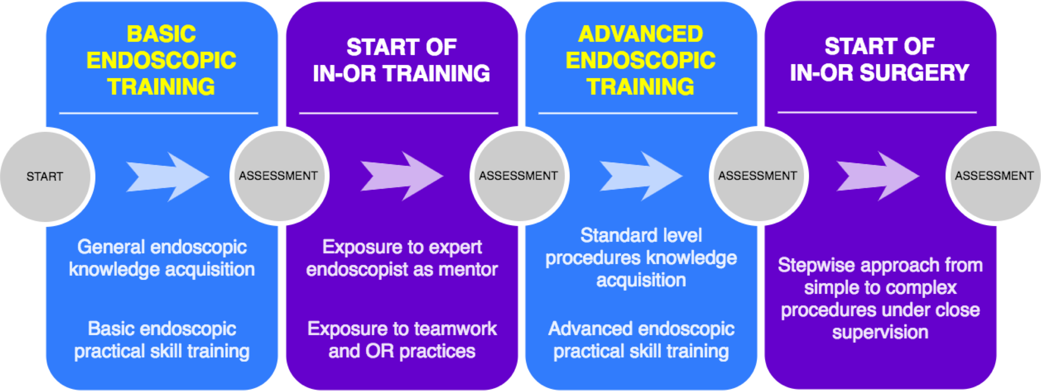

This approach aims to train and assess the necessary endoscopic skills as much as possible in a dry lab setting, before moving on to live patients in the OR [8,9]. The benefit of this is threefold:
- Trainees are much more self-assured when they enter the OR, confident that they have acquired the necessary knowledge and skills.
- Expert mentors save time by not teaching basic skills, can receive proper assistance from trainees, and can focus more on the procedures at hand.
- The patient receives better care due to properly trained trainees and is much less exposed to unskilled trainees.

Example of a simulation training programme in endoscopic skills
The savant societies ESGE and ESHRE under the auspices of EBCOG and accepted as an EU4Health programme, has elaborated a well-balanced diploma curriculum: the Gynaecological Endoscopic Surgical Education and Assessment (GESEA) programme [10-16], which is based on a structured approach similar to what is proposed in this document - see appendix for details.

Gynaecological skills to be trained (core curriculum)

Skills in outpatient clinic:
o Gynaecological examination
o Speculum insertion
o Pap Smear execution
o Placement/Removal of Intra Uterine Device
o Colposcopy (with biopsy)
o LLETZ of the cervix
o Placement/Removal of subcutaneous implants

Basic conventional surgical skills:
o Punch biopsy under local anaesthesia
o Surgical removal and marsupialization of cyst
o Dilation & Curettage

Advanced conventional surgical skills
o Laparotomy with minimal adhesiolysis
o Salpingo-oophorectomy via laparotomy
o Anterior vaginal repair
o Posterior vaginal repair
o Myomectomy of subserous myoma via laparotomy
o Colpocleisis (at least in simulation setting)

Basic endoscopic skills:

Laparoscopy:
o Diagnostic laparoscopy
o Diagnostic laparoscopy with tubal testing
o Simple laparoscopic adhesiolysis
o Laparoscopic sterilization

Hysteroscopy:
o Diagnostic hysteroscopy
o Diagnostic hysteroscopy with endometrial biopsy
o Visual D&C [17]

Advanced endoscopic skills:

Laparoscopy:
o Laparoscopic removal of ectopic pregnancy (salpingostomy) or salpingectomy
o Laparoscopic needle aspiration of simple cysts
o Laparoscopic electrocoagulation of the ovary
o Simple laparoscopic ovarian cystectomy
o Laparoscopic salpingo-oophorectomy

Hysteroscopy:
o Hysteroscopic polyp resection
o Hysteroscopic myoma resection type 0-1 (< 2cm)
o Hysteroscopic endometrial ablation

References:

1. Campo R, Wattiez A, Tanos V, Di Spiezio Sardo A, Grimbizis G, Wallwiener D, et al. Gynaecological endoscopic surgical education and assessment. A diploma programme in gynaecological endoscopic surgery. Gynecol Surg. 2016;13:133-7.
2. Diesen DL, Erhunmwunsee L, Bennett KM, Ben-David K, Yurcisin B, Ceppa EP, et al. Effectiveness of laparoscopic computer simulator versus usage of box trainer for endoscopic surgery training of novices. J Surg Educ. 2011;68(4):282-9.
3. Escamirosa FP, Flores RM, Garcia IO, Vidal CR, Martinez AM. Face, content, and construct validity of the EndoViS training system for objective assessment of psychomotor skills of laparoscopic surgeons. Surg Endosc. 2015;29(11):3392-403.
4. Hofstad EF, Vapenstad C, Chmarra MK, Lango T, Kuhry E, Marvik R. A study of psychomotor skills in minimally invasive surgery: what differentiates expert and nonexpert performance. Surg Endosc. 2013;27(3):854-63.
5. Munro MG. Surgical simulation: where have we come from? Where are we now? Where are we going? J Minim Invasive Gynecol. 2012;19(3):272-83.
6. Mulla M, Sharma D, Moghul M, Kailani O, Dockery J, Ayis S, et al. Learning basic laparoscopic skills: a randomized controlled study comparing box trainer, virtual reality simulator, and mental training. J Surg Educ. 2012;69(2):190-5.
7. Sroka G, Feldman LS, Vassiliou MC, Kaneva PA, Fayez R, Fried GM. Fundamentals of laparoscopic surgery simulator training to proficiency improves laparoscopic performance in the operating room-a randomized controlled trial. Am J Surg. 2010;199(1):115-20.
8. Molinas CR, Binda MM, Campo R. Dominant hand, non-dominant hand, or both? The effect of pre-training in hand-eye coordination upon the learning curve of laparoscopic intra-corporeal knot tying. Gynecol Surg. 2017;14(1):12.
9. Campo R, Wattiez A, Wallwiener D, et al. Training and education in endoscopic surgery: is there a future for endoscopy in OB&GYN training? Gynecol Surg. 2005; 2:57–65.
10. Campo R, Wattiez A, Tanos V, Di Spiezio SA, Grimbizis G, Wallwiener D, Brucker S, Puga M, Molinas R, O'Donovan P, Deprest J, Van BY, Lissens A, Herrmann A, Tahir M, Benedetto C, Siebert I, Rabischong B, De Wilde RL (2016) Gynaecological endoscopic surgical education and assessment. A diploma programme in gynaecological endoscopic surgery. Eur J Obstet Gynecol Reprod Biol 199:183– 186
11. Campo R, Reising C, Van Belle Y, Nassif J, O'Donovan P, Molinas CR (2010) A valid model for testing and training laparoscopic psychomotor skills. Gynecol Surg 7:133–141
12. Molinas CR, Campo R (2010) Defining a structured training program for acquiring basic and advanced laparoscopic psychomotor skills in a simulator. Gynecol Surg 7:427–435
13. Molinas CR, De Win G, Ritter O, Keckstein J, Miserez M, Campo R (2008) Feasibility and construct validity of a novel laparoscopic skills testing and training model. Gynecol Surg 5:281–290
14. Campo R, Wattiez A, Tanos V, Di Spiezio SA, Grimbizis G, Wallwiener D, Brucker S, Puga M, Molinas CR, O'Donovan P, Deprest J, Van Belle Y, Lissens A, Herrmann A, Tahir M, Benedetto C, Siebert I, Rabischong B, De Wide RL (2016) Gynaecological endoscopic surgical education and assessment. A diploma programme in gynaecological endoscopic surgery. Gynecol Surg 13:133–137
15. Campo R, Molinas CR, De Wilde RL, Brolmann H, Brucker S, Mencaglia L, Odonovan P, Wallwiener D, Wattiez A (2012) Are you good enough for your patients? The European certification model in laparoscopic surgery. Facts Views Vis Obgyn 4:95–101
16. Campo R, Wattiez A, De Wilde RL, Molinas CR (2012) Training in laparoscopic surgery: from the lab to the OR. Zdrav Var 51:285–298
17. Casadio P, Raffone A, Salucci P, Raimondo D, Seracchioli R, Carugno J, Di Spiezio Sardo A (2023). Visual dilation and curettage for the fertility-sparing treatment of atypical endometrial hyperplasia/endometrial intra-epithelial neoplasia: an easy to perform in-office technique. Int J Gynecol Cancer. 1;33(5):837-838

Simulation Training of Obstetrical Skills

Introduction
Simulation training is recommended as a key part in the Obstetrics & Gynaecology curriculum to acquire the necessary skills, such as delivery by vacuum extractor or forceps, before these skills are used in clinical practice.

` Equipment
Potential equipment for training may be very diverse and can definitely be inexpensive. Some examples of equipment, tools, models, trainers or mannequins are given below, ranging from inexpensive to expensive (and thus more advanced) options: basic birthing mannequins, basic gynaecological training models modified for vacuum extractor / ventouse, Kiwi, forceps, CTG monitoring, foetal blood sampling, B-Lynch (foam rubber), neonatal/adult mannequins for basic resuscitation, advanced birth mannequins, perineal repair trainer, caesarean section skills trainer, emergency hysterectomy / intra partum hysterectomy trainer, advanced full-scale birthing simulator etc.

- Hybrid simulator: can be a combination of a patient (actor) and a simulator, or a combination of several different simulators.
- Gaming technologies: All sorts of computer-based simulators and games and virtual and augmented reality platforms are available for medical training.
- Presentations, videos and implementation tools, including management algorithms, including virtual reality training.
All departments of obstetrics and gynaecology are required to provide basic birthing mannequins for individual technical skills training and hybrid simulators for interprofessional team training.

- Basic birthing mannequins

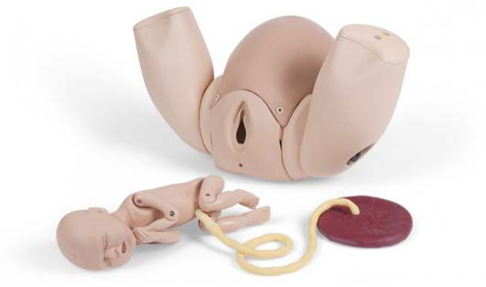
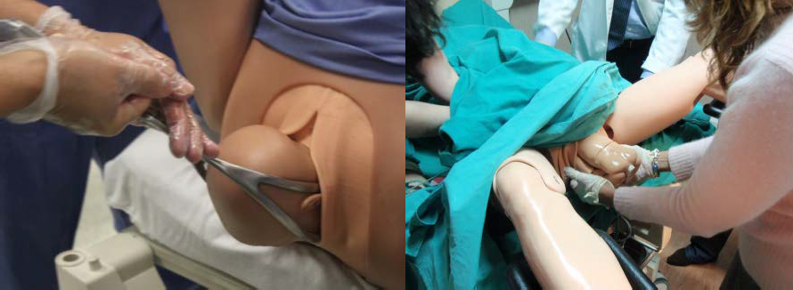
Courtesy of Jette Led Sørensen, Denmark

- Basic gynaecological training models modified for vacuum extractor / ventouse, Kiwi, forceps, CTG monitoring, foetal blood sampling, B-Lynch (foam rubber) etc.
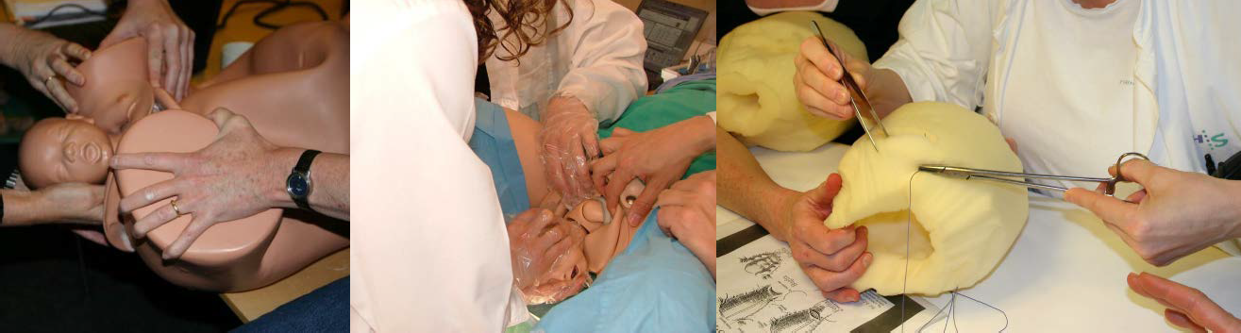
Courtesy of Jette Led Sørensen, Denmark Courtesy of Diogo Ayres-de-Campos, Portugal

- Advanced full-scale birthing simulator
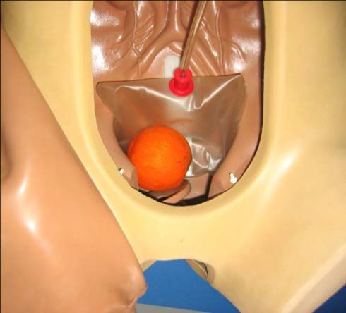
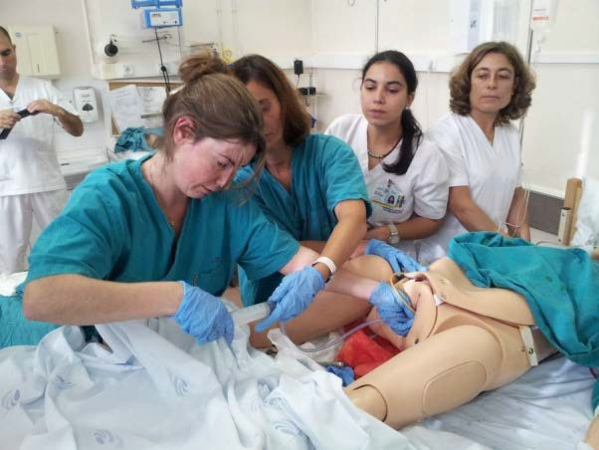
Courtesy of Diogo Ayres-de-Campos, Portugal

- Hybrid simulator: can be a combination of a patient (actor) and a simulator, or a combination of several different simulators. For instance, this may involve a patient (actor) with a birthing mannequin between the legs, or an adult mannequin for basic resuscitation combined with a basic birthing mannequin.
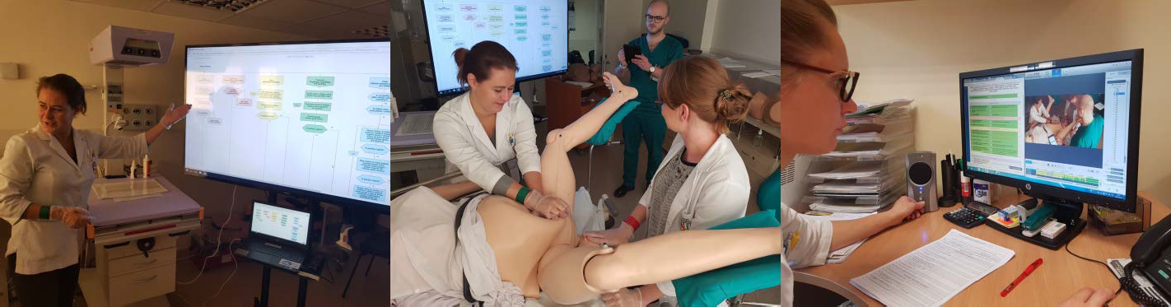
Hydralab® courtesy of Ruta Nadisauakiene, Lithuania

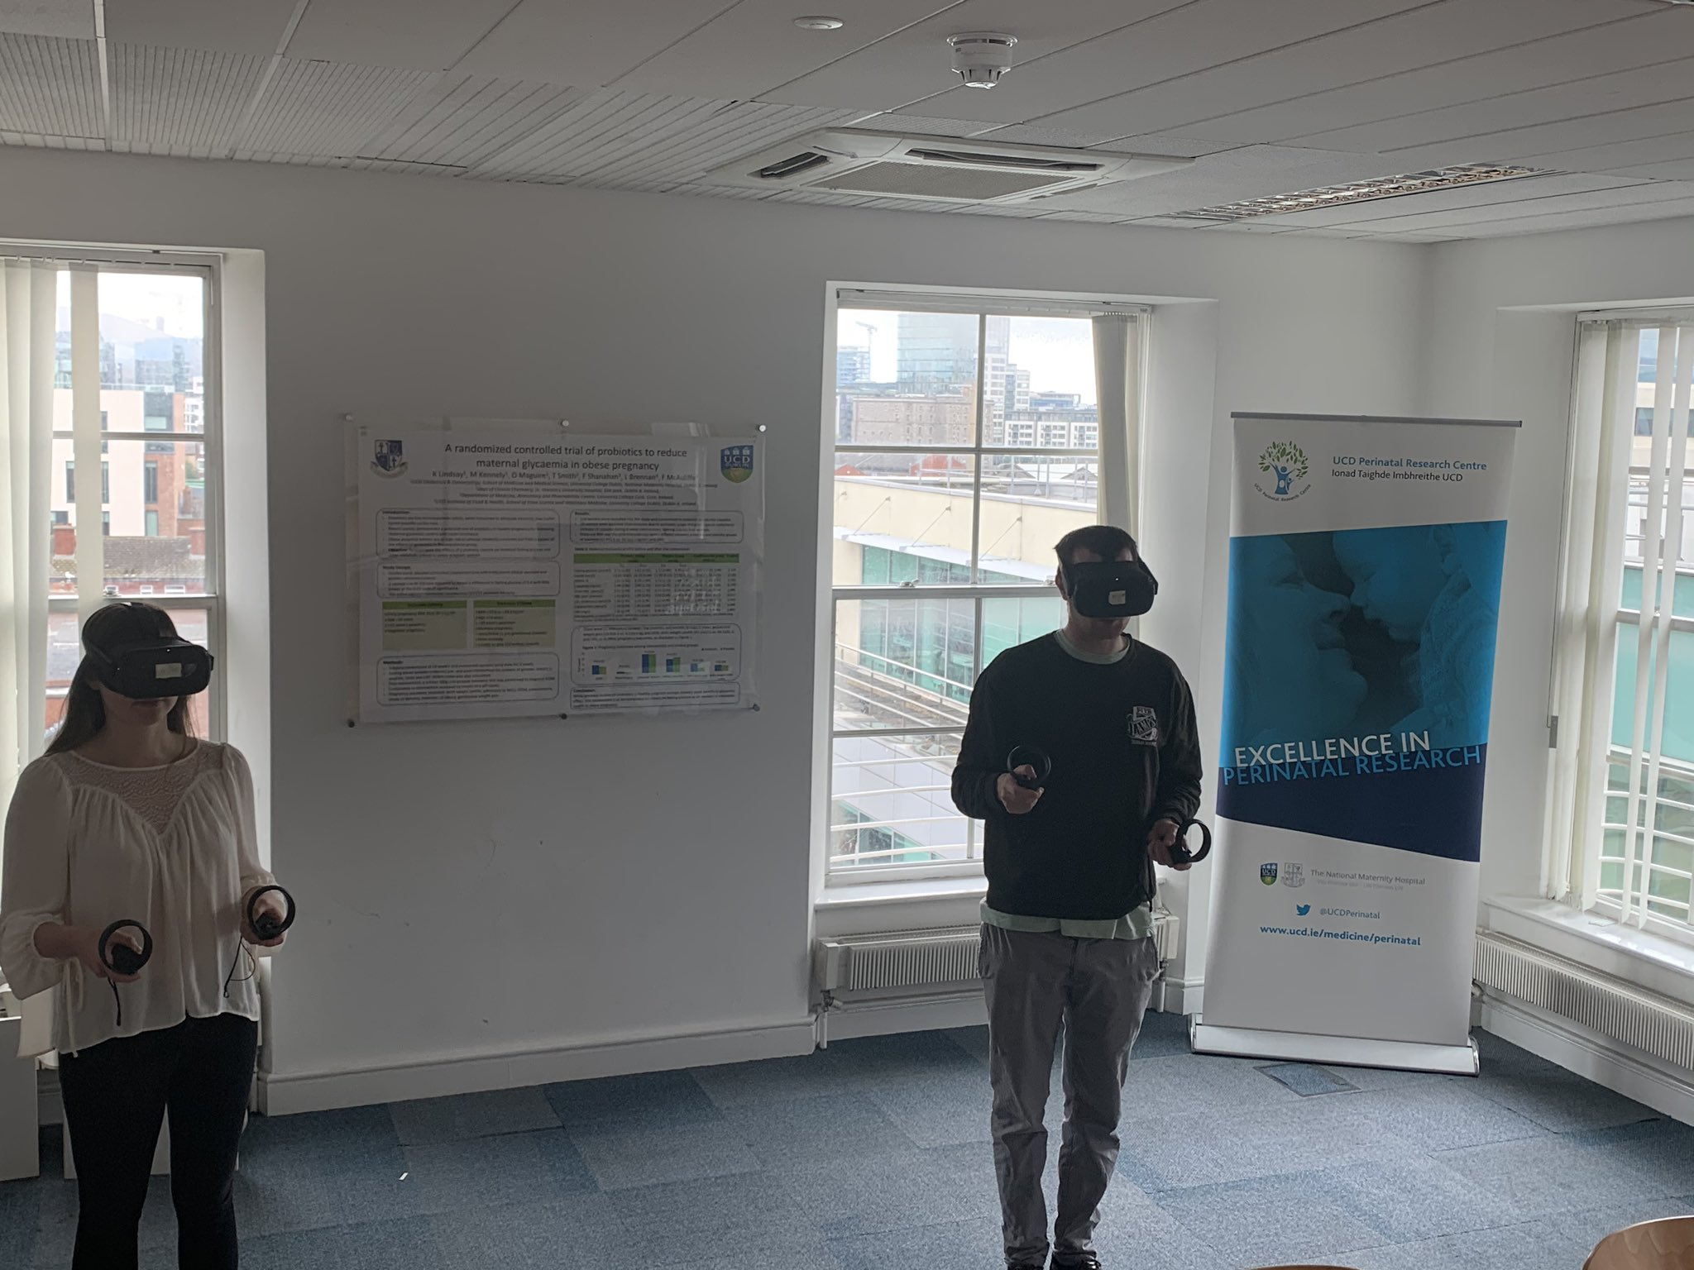

Virtual reality training courtesy of Fionnuala McAuliffe, Ireland

Types of simulation training and examples

Individual technical skills training
- Basic level with basic skills training (basic birth mannequins)
- Complex level of skills training (more advanced mannequins)

Interprofessional team training
- Basic team training with hybrid simulator
- High fidelity simulation with advanced full-scale birthing simulator

Simulation in obstetrics (minimal requirements)
- Basic birthing mannequins
- Basic training models modified for vacuum extractor / ventouse, Kiwi, forceps, CTG monitoring, foetal blood sampling, B-Lynch (foam rubber) etc.

Interprofessional team training
- Hybrid simulators
- Patients (actors)

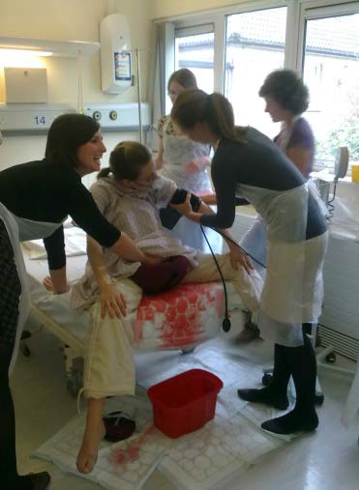
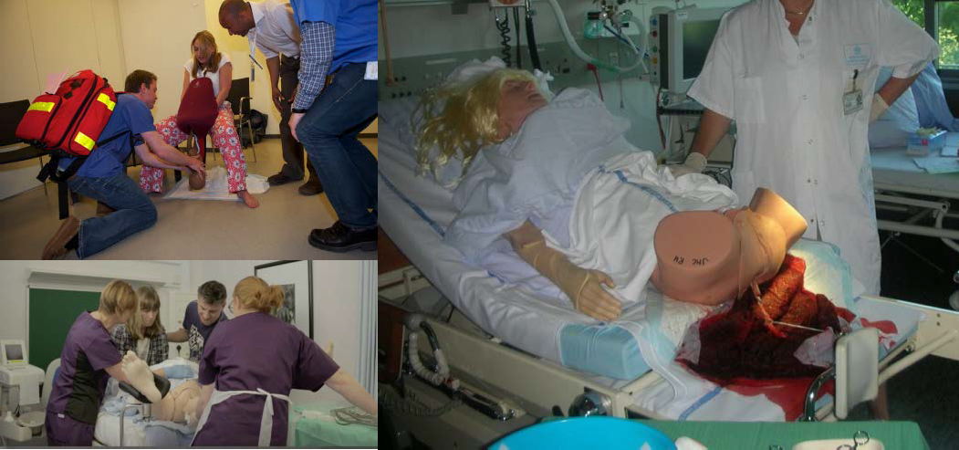

Courtesy of Tim Draycott & Cathy Winter, PROMPT, UK | Courtesy of Jette Led Sørensen, Denmark

Simulation Setting
There are three types of simulation settings, all of which have advantages and disadvantages [8]:
- Simulation centre (off-site simulation); away from the actual patient care unit.
- In-house elsewhere in the department (off-site simulation); training room(s) specifically set up for simulation training away from the patient care unit, but within the hospital. In-house training facilities may be part of hospital departments.
- In situ simulation; a blend of simulation and actual working environments, for training under working conditions. These situations may be announced (staff is informed beforehand about the simulation event) or unannounced (staff is not informed beforehand).
To determine the preferred simulation setting for a particular institution, it may be helpful to consider the overall objectives of simulation-based education as well as specific local factors, such as feasibility.

Obstetrical skills (core curriculum)
General Medical Knowledge & Skills
  - Lead a ward round with a multidisciplinary view, manages admittance and discharge of patients at the ward and the delivery room and manages handover to another practice
  - Recognise and triage acutely ill patients, septic patients, patients with peripartum complications and patients requiring resuscitation, and initiate adequate management.

Basic obstetric skills
- Assistance of uncomplicated delivery
- Vacuum-assisted vaginal delivery
- Forceps-assisted delivery
- Breech delivery
- Assistance during vaginal delivery of multiple pregnancy
- Foetal blood sampling
- All dystocia management manoeuvres
- Postpartum bleeding
- Intrauterine balloon tamponade
- Surgical compression of atonic uterus
- B-Lynch suturing

Skills in perineal repair
- Episiotomy
- Repair of genital tract trauma
- Suturing of episiotomy wound
- Suturing of 1st/2nd/3rd degree perineal tears
- Suturing of 4th degree perineal tear

Advanced obstetric surgery
- Caesarean section
- Repeat caesarean section
- Caesarean section in high BMI patient
- Emergency caesarean section
- Abdominal hysterectomy (at least in simulation or through alternative learning strategies)
- Manual and surgical removal of placenta
- Manual uterine reversion (at least in simulation or through alternative learning strategies)
- Evacuation of vulvar hematoma

Neonatal mannequins for basic resuscitation
- Support the initial care of the healthy/preterm new-born (with low Apgar scores)
- Resuscitate the new-born accurately in the first 10 minutes after delivery

References:
- Sørensen JL, Ostergaard D, LeBlanc V, Ottesen B, Konge L, Dieckmann P, van der Vleuten C, et al. Design of simulation-based medical education and advantages and disadvantages of in situ simulation versus off-site simulation. BMC medical education. 2017;17(1):20.
- Kneebone R, Nestel D, Wetzel C, Black S, Jacklin R, Aggarwal R, Yadollahi F, Wolfe J, Vincent C, Darzi A. The human face of simulation: patient-focused simulation training. Academic medicine : journal of the Association of American Medical Colleges. 2006;81(10):919- 24.
- Harden RM. Ten questions to ask when planning a course or curriculum. MedEduc. 1986;20(4):356-65.
- Kern DE, Thomas PA, Howard DM, Bass EB. Curriculum development for medical education. A six step approach. London: The John Hopkins University Press; 2009.
- McEvoy A, Kane D, Hokey E, Mangina E, Higgins S, McAuliffe FM. Virtual reality training for postpartum uterine balloon insertion - a multi-center randomized controlled trial. Am J Obstet Gynecol MFM. 2024 Jul 15:101429. doi: 10.1016/j.ajogmf.2024.101429.
- Ryan GV, Callaghan S, Rafferty A, Higgins MF, Mangina E, McAuliffe F Learning Outcomes of Immersive Technologies in Health Care Student Education: Systematic Review of the Literature. .J Med Internet Res. 2022 Feb 1;24(2):e30082.
- Dunlop K, Dillon G, McEvoy A, Kane D, Higgins S, Mangina E, McAuliffe FM. The virtual reality classroom: a randomized control trial of medical student knowledge of postpartum haemorrhage emergency management. Front Med (Lausanne). 2024 Mar 19;11:1371075. doi: 10.3389/fmed.2024.1371075
- Kane D, Ryan G, Mangina E, McAuliffe FM A randomized control trial of a virtual reality learning environment in obstetric medical student teaching. Int J Med Inform. 2022 Dec;168:104899. doi: 10.1016/j.ijmedinf.2022.104899
- Ryan G, Rafferty A, Murphy J, Higgins MF, Mangina E, McAuliffe FM. Virtual reality learning: A randomized controlled trial assessing medical student knowledge of fetal development. Int J Gynaecol Obstet. 2023 Mar 8. doi: 10.1002/ijgo.14684.
- McEvoy A, Kane D, Hokey E, Mangina E, Higgins S, McAuliffe FM. Virtual reality training for postpartum uterine balloon insertion - a multi-center randomized controlled trial. Am J Obstet Gynecol MFM. 2024 Jul 15:101429. doi: 10.1016/j.ajogmf.2024.101429.

Ultrasound Skills Training

Ultrasonography has been established as an important diagnostic tool in the daily practice of obstetrics and gynaecology. It is of paramount importance that trainees receive a structured and supervised training in ultrasonography because ultimately it is the skill of the ultrasonographer, i.e. the gynaecologist, that determines the quality of the images and thus the added clinical value of this form of investigation.
The curriculum for the core and electives in postgraduate training in obstetrics and gynaecology relies on independent practice of ultrasonography skills by the gynaecologist. This section provides a concise description of the training curriculum for ultrasonography skills in terms of
- The knowledge and skills in ultrasonography that the trainee will have reached at the endpoint of training to the level of competence as described in the EBCOG Core curriculum;
- Methods for learning these skills;
- Tools for quality assessment of these skills.
The specific items were extracted from the core curriculum and grouped according to their common denominator or subject heading. Suggestions for training and assessment were derived from the ISUOG Education Committee recommendations for basic training in obstetric and gynaecological ultrasound [1].

General outlay of ultrasonography training

A three step programme is recommended:
- Theoretical training: technical aspects of equipment, imaging and reporting.
- Practical training: under supervision in a clinical setting until the level of independence has been reached.
- Assessment of the trainee’s performance: logbook or collection of pictures as an illustration of the trainee’s ability to produce quality images and to recognize pathologies.

Ultrasonography Training Curriculum

- General principles of ultrasound scanning

  - Basic physical principles of ultrasound, including safety;
  - Transducer, image production, knobs, scanning planes (TA & TV) , measurements;
  - Basic principles of Doppler ultrasound and umbilical artery Doppler;
  - Infusion scanning (gel or saline infusion): safety and indication;
  - Documentation of findings.
The general principles will be learnt via textbook and/or e-learning modules and will be discussed with a dedicated supervisor.
Practical skills of handling the transducers and scanning apparatus as well as infusion scanning will be practiced under direct supervision of a trained ultrasonographer until full proficiency has been achieved.
Assessment: knowledge-based assessment (exam), direct clinical observation

- Ultrasonography in gynaecology
Assessing normal and abnormal appearances of the endometrium, myometrium, and adnexae; application of ultrasound criteria to discriminate between normal and abnormal findings (e.g. RMI [2], IOTA [3]), in collaboration with Radiology.

This part will be learnt in a stepwise process:
- Orientation via textbook and/or e-learning modules
- Practical experience under direct supervision; supervision will diminish while experience is building up Assessment: knowledge-based assessment (exam), direct clinical observation, portfolio of at least 50 cases (variety of uterine (myometrium and endometrium) and adnexal pathology)

- Ultrasonography of pregnancy
- First trimester
  - Assessing normal and abnormal findings between 4 and 10 weeks in singleton and twin pregnancies (including ectopic pregnancy);
  - Assessing normal and abnormal findings between 10 and 14 weeks in singleton and twin pregnancies (chorionicity);
  - Dating of pregnancy

- Second trimester and third trimester
  - Foetal presentation
  - Foetal biometry: dating, assessing size and estimating foetal weight
  - Assessing the placenta and amniotic fluid volume
  - Distinguish between normal and abnormal foetal size and growth patterns, use of Doppler flow of umbilical artery
  - Assessing cervical length
This part will be learnt in a stepwise process:
- orientation via textbook and/or e-learning modules
- practical experience under direct supervision; with increased experience, less supervision will be needed. Assessment: knowledge-based assessment (exam), direct clinical observation, portfolio of at least 50 cases (variety of first, second and third trimester cases).

References:
  - ISUOG Education Committee recommendations for basic training in obstetric and gynaecological ultrasound. Ultrasound Obstet Gynaecol 2013; DOI 10.1002/uog.13208
  - Jacobs I, Oram D, Fairbanks J et al A risk of malignacy index incorporating Ca125, ultrasound and menopausal status for the acurate preoperative diagnosis of ovarian cancer. Br J Obstet Gynaecol 1990;97:922-929
  - Timmerman DV, Bourne TH, Collins WP et al. Terms, definitions and measurements to describe the sonographic features of adnexal tumors: a consensus opinion from the International Ovarian Tumor Analysis (IOTA) group. Ultrasound Obstet Gynecol 2000; 16:500- 505.

b. Levels of Competence Entrustable Professional Activities

The curriculum consists of 10 themes that comprise various entrustable professional activities. Once a trainee has reached full competence in the performance of a specific professional activity, i.e. at the level of independent practice, the trainee will be granted entrustment for that specific professional activity and eventually for the entire theme. Depending on local regulations and laws, granted entrustment means that the trainee is being declared proficient and allowed to practice the concerning professional activity without supervision. When training according entrustment decisions, trainee’s should always be aware of the possibility of requesting supervision, even if entrustment for independent practice was granted for a specific activity. This demands reflective practice of the trainee. In high-risk situations, it is expected that the trainee recognises this risk and demands supervision if patient safety is at stake. In some countries independent practice is restricted by law, therefore the execution of entrustment may be tailored to local or regional legislation.
Throughout the years, the trainee will collect entrustment for the various professional activities; entrustment is therefore not limited to the last day of training. The actual scheme of entrustment will be determined by and adapted to local or regional infrastructure.
Entrustment, as will be described below, entails more than assessment, and is documented in the personal portfolio of the trainee. This document describes the steps to be taken in the process of training in order to reach entrustment. It provides the guidelines for portfolio evaluation and entrustment decisions, including tools of assessment.

Entrustment of Professional Activities
A professional activity includes all tasks and aspects needed to execute such an activity in the context of patient care. Entrustment of a professional activity to the trainee means that the trainee is considered competent on all aspects of the professional activity in such a way that they can perform the activity independently. Entrustment may concern a small domain of practice like the caesarean section, or a larger domain like ‘Intrapartum & Postpartum Care’ as part of maternal care.
The learning process of a trainee, aimed at reaching the level of independent practice, is based on active engagement in delivery of care, provision of formative feedback by clinical supervisors and reflection on progress by the trainee. In time, these clinical activities will lead to increasing competence, and supervision is adapted accordingly. In the initial stages of training, supervision will be strict, and clinical supervisors will need to be present while the trainee is performing a specific activity in order to talk the trainee through the process or to intervene when necessary. As the trainee gradually gains experience and competence, supervision will evolve towards a more guiding and supporting role with decreasing need of intervention. This allows the trainee to experience a higher degree of autonomy. When the trainee has achieved competence, the activity can be delegated to the trainee, and supervision may occur indirectly (not being present in the same room) and at the discretion of the supervisor. Once clinical supervisors, informed by both the portfolio and their own judgement, are convinced that the trainee can perform the activity without interference of a supervisor, the trainee will be granted entrustment for this specific activity following the process described below. The strategy of entrustment is based on international literature.
Development of competence moves through five levels: from the trainee observing the supervisor performing the activity (level 1), to the trainee performing the activity fully independently (‘supervisor does not need to be present’). This is shown in table 1.

Table 1: Five levels of competence in achieving entrustment of an activity.
Levels of competence: | 1  Supervisor performs the activity, the  trainee observes | 2  Supervisor talks trainee through activity | 3  Supervisor intervenes incidentally | 4  Supervisor may be present just in  case | 5  Supervisor does not need to be present
Trainee: | Development of trainee’s competence |  |  |  | Entrustment (to be achieved after formal decision)

Portfolio
In the portfolio, the trainee keeps a record of all the activities and perspectives related to his/her development to support the request for a higher level of competence and, finally, for entrustment. For the decisions on level of competence and achievement of entrustment, data are collected from three sources (triple source entrustment):
- Learning experiences: depicting the learning achievements of the trainee
- Logbook summarizing clinical experience, including specific diagnoses and treatments.
- Courses; e.g. laparoscopic skills training course, management course etc.
- Academic experience, scholarly work, presentations, peer-reviewed scientific articles.
- Personal development plan, with regular updates of progress in training, reflective reports and reports of discussions with the tutor.

- Assessment for entrustment: depicting the assessment achievements of the trainee
- Structured feedback from supervisors, colleagues and patients; e.g. 360 degree feedback
- Workplace-based assessments, e.g. mini-CEX, OSATS1 See addendum 1 for examples of formal assesment tools in the clinical workplace.
- Knowledge and skills assessments, e.g. exam results

- The competence committee adds professional impressions: depicting the ‘master-apprentice’ image
- Brief minutes of the competence committee meeting describing the professional impressions, which are added to the portfolio.

Entrustment process and decision
In the formalisation of entrustment, the trainee should play an active role in the initiation of entrustment decisions. However, the actual decision on entrustment for an activity lies with the competence committee. It is recommended that the competence committee is comprised of at least 2 members that know the trainee’s performance well and preferably at least 2 other clinical faculty members.
Once every 3 to 6 months, the trainee is expected to write a clear and concise request to the competence committee in which he/she suggests to move up to a higher level of competence for a particular activity. The request should be supported by information in the portfolio. Based on the three sources information, the competence committee determines the level of competence and thus the degree of supervision required for the professional activities specified in the request. This process may be particularly important in the transition from level of competence 3 to 4, as well as the transition from level 4 to 5 (entrustment decision). For the transitions in the lower levels, the competence committee may mandate the decision to clinical supervisors, to prevent excessive administrative processes.

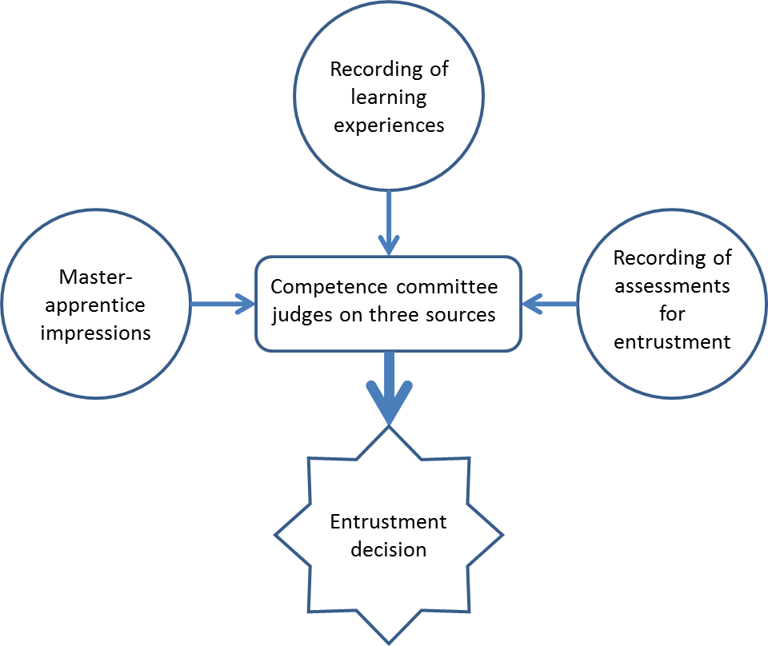
Figure 1: Triple source entrustment
There are two possible outcomes of this process:
- If the competence committee is indecisive about the level of competence that is achieved, more information about the trainee’s performance is gathered and the decision is postponed.
- If the competence committee has reached agreement on the level of competence, the decision is briefly motivated in writing (to be recorded in the portfolio) and the activity is signed off.
Once the trainee has reached the highest level of competence, the competence committee grants entrustment for this particular professional activity.
In some jurisdictions, it is legally impossible for a trainee to perform a clinical activity completely without supervision. In these cases, when the competence committee judges that the trainee is competent for independent practice but is not allowed to act accordingly for formal reasons, the trainee can be granted entrustment on paper, with the provision that this entrustment will be effectuated by the end of training.
The competence and entrustment decisions by the competence committee are recorded in the portfolio, so that the trainee, the clinical faculty and the competence committee may verify at any time which level of competence has been reached and whether entrustment has been granted.
The assessment image
It is vital to stress that assessment for entrustment is only one of the sources to base the entrustment decision upon.
Regarding assessment for entrustment, please consider:
- The process of assessment of entrustment can be seen as a picture made up of more or less pixels. The higher the number of assessments, the more pixels are present in the assessment image.
- Diversity of assessment tools creates diversity in the colour scheme of the assessment image and, therefore, a clearer picture.
- Taking many assessments for entrustment requires great investments of time, effort, and finances. Assessment for entrustment should be useful, and resources for assessment should be used economically. Only when necessary, e.g. in case of doubt about trainee performance, the number of assessments for entrustment may be increased to get a more detailed picture of the trainee’s performance (sequential assessment).
- Throughout training, assessment may shift from more knowledge-based assessment to more skills- based assessment in the clinical setting with observations in the workplace, as independence in practice is increasing.
Assessment and feedback may be used for entrustment, as well as for learning. Regarding assessment and feedback for learning, please consider:
In the learning process, it is necessary for clinical faculty to have information about the trainee’s level of professional performance to provide optimal feedback to the trainee and to coach the trainee to improve his/her competence. The trainee will perceive feedback for learning differently than assessment for entrustment, since it is low-stake. Assessment and feedback for learning are extremely important for optimal ‘master-apprentice’ learning and tutoring of the trainee. It is therefore recommended to create a learning environment that is as safe as possible and to leave low-stake assessment and feedback for learning unrecorded in the portfolio. The portfolio is directed at high-stake information for entrustment.
Low-stake assessment and feedback for learning should be given separately from high-stake assessment for entrustment; since if the two are combined, trainees may experience assessment and feedback for learning as high-stake (a hurdle to pass instead of something to learn from).
Figure 2: Assessment for entrustment versus assessment for learning
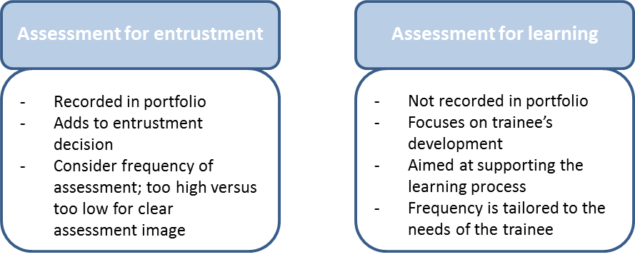

Determining the training time schedule and the trainee’s progress
Each training institution may determine the targets for entrusting their trainees over time in a training time schedule. The trainee and the competence committee should repeatedly evaluate the trainee’s progress over time, aiming to comply with the schedule
Diploma
When all EPAs have been signed off and thus training has been completed, the well-documented portfolio may be presented to the Standard Committee for Training and Assessment (SCTA) of EBCOG to receive a diploma issued by EBCOG. The diploma will state that the gynaecologist has been trained and entrusted according to European standards and will be signed by the chair of the SCTA and president of EBCOG.

3. Organisation of training

a. Schedule of training
The minimum duration of postgraduate training in Obstetrics and Gynaecology should be five years, with a minimum duration of the core curriculum of three years, depending on national and local governance.

b. Curriculum of training
The Project for Achieving Consensus in Training (PACT) is a pan-European training curriculum aimed at achieving a higher level of quality training and ensuring optimal healthcare in obstetrics and gynaecology. PACT training curriculum defines standards for postgraduate training in Obstetrics and Gynaecology in Europe. These standards address endpoints in the medical and professional domains but also provide guidance in training methods, entrustment, faculty development and quality management of training.

Core training includes a European consensus of what should be mandatory for all trainees. Elective modules include more advanced and in depth training, as a basis for subspeciality training. All trainees should have at least one elective in an area of personal interest during their postgraduate studies.

c. Assessment and evaluation
Trainees are required to build a portfolio in which both numbers of specific activities and written feedback on the activities are being kept, as one of the pillars on which the entrustment process is based. Entrustment of a professional activity to the trainee means that the trainee is considered competent on all aspects of the professional activity in such a way that they can perform the activity independently.
The trainee's portfolio serves as a comprehensive record of their development, supporting their progression to higher levels of competence and eventual entrustment. The evaluation process is based on Triple Source Entrustment, which gathers data from three key sources: (1) Learning Experiences – This includes a personal portfolio summarizing clinical cases and treatments, participation in courses, academic contributions, and a personal development plan with progress updates and reflective reports;
(2) Assessment for Entrustment – Evaluations come from structured feedback from supervisors, colleagues, and patients (e.g., 360-degree feedback), workplace-based assessments (e.g., mini-CEX, OSATS), and formal knowledge and skills assessments like exam results, and
(3) Competence Committee Review – The committee provides professional impressions based on the master-apprentice model, summarizing their observations in brief meeting minutes, which are added to the portfolio.
- Formative Assessments
Every 3 to 6 months, the trainee must submit a formal request to advance to a higher competence level for a specific activity, supported by portfolio evidence. This structured approach ensures a well-rounded and evidence-based decision-making process for assessing the trainee’s readiness for greater responsibility.
- Summative Assessments
PACT may provide a minimum number of skills for trainees to perform in several modules for adequate training. However, competency is the most important goal in each skill. If a trainee is not feeling competent for that skill, they should approach their tutors for further assistance. PACT also provides information on how to determine the training time schedule and trainee's assessment. The trainee and the competence committee should repeatedly evaluate the trainee’s progress over time, aiming to comply with the schedule.
e. Governance
For internal quality management a clear governance structure with properly defined responsibilities for the training programme is mandatory. Internal quality management regards the measures taken from within the training institute and is aimed at continuous improvement of training, according to a plan-do-check-act cycle. This internal quality cycle addresses several aspects as (1) description of a local training plan based on PACT, which is tailored to the local context: the local curriculum, (2) monitoring of how the local training plan is translated into daily work: the curriculum in action, (3) monitoring of the educational climate, (4) monitoring and discussion of didactic performance of staff, and (5) developing plans for improvement and follow-up of the training issues that have arisen.
The internal quality management system is adaptable and may operate on a short term basis. It provides useful information for an external accrediting body, which makes it a transparent system. External training recognition is performed either by national accrediting bodies or by the accreditation & hospital visitation committee of EBCOG, the Standing Committee of Training Recognition.

III. TRAINING REQUIREMENTS FOR TRAINERS

1. Process for recognition as trainer

a. Requested qualification and experience
A trainer should be a programme director of Obstetrics & Gynaecology with at least 3 years’ experience of independent practice after completing the 5 year Obstetrics and Gynaecology training programme, have CCST, have educational experience and ideally have participated in a Train the Trainers course for programme Directors, for example EBCOG Train the Trainers course.

b. Core competencies of trainers
The core competencies for Trainers include those of the principles from the Academy of Educational Standards. These include:
- safe patient care
- creating a stimulating learning environment
- applying educational tools, such as feedback, to enhance reflective practice by the trainee
- monitoring and assessment of the trainee’s learning process
- continuing professional development as an educator.

The trainer should possess the necessary Clinical Expertise that includes practical procedures and managing complex cases, have good communications skills, demonstrate good leadership skills to manage teams and resources effectively. They should uphold ethical standards, maintain team well-being and promote a culture and environment of positive learning
Trainers need to be skilled in delivering education, providing feedback and assessing trainee’s progress.

2. Quality management for trainers
Trainers should receive formal training in postgraduate teaching and assessment. As a minimum, this should include the following information or training:
- How to teach on the job (e.g. in the clinic, on wards)
- How to teach individuals, in small groups and in didactic lecture formats
- How to give effective feedback
- How to use formative assessment methods to support trainees
- How to identify and support trainees in difficulty
- How to use and document workplace-based assessments
- Have Leadership training and communications skills

In those countries that have a system of summative assessment during or at the end of training (e.g. local or national examination), clinical trainers who participate in the examination committee should be trained on how to write examination questions and how to design a validated exam.
For ‘programme directors’, specific courses are warranted that focus on the management of postgraduate medical education and guidance of the trainers corps. Local organisations and arrangements shall apply to each country.

IV. TRAINING REQUIREMENTS FOR TRAINING INSTITUTIONS

1. Process for recognition as training centre

a. Requirement on staff and clinical activities
Minimal number of patients cared for as inpatients and as outpatients

Minimal number of patients cared for must be sufficient to fulfil the requirements of The Project for Achieving Consensus in Training (PACT 218, rev. 2025; UEMS European Training Requirements in Obstetrics and Gynaecology, 2018), where the Minimum numbers for several procedures are recommended for adequate training per one trainee. Also, the numbers need to be sufficient for a trainee to obtain skills required by this document.
The numbers need to be judged by the Visiting Team in relation to the number of trainees at the training centre and local organisation of the training process.

Range of clinical specialties

Clinical specialties available at the location of the training centre must allow for required multidisciplinary cooperation (neonatology, internal medicine, surgery, anaesthesiology) and training in the 10 major themes in the core curriculum:

1. General Medical Knowledge & Skills
2. Prenatal Care
3. Intrapartum & Postpartum Care
4. Benign Gynaecology
5. Reproductive Medicine
6. Urogynaecology
7. Premalignancy and Gynaecological Oncology
8. Paediatric and Adolescent Gynaecology
9. Sexual Health and Contraception
10. Breast Disease

There is also a requirement to allow trainee to select at least one of the elective modules during the core specialty training.

Elective Modules

- Fetal Medicine
- Maternal medicine
- Benign Gynaecology
- Reproductive Medicine
- Urogynaecology & Pelvic Floor
- Low Genital Tract Disease & Sexual Health
- Paediatric & Adolescent Gynaecology
- Gynaecological Oncology
- Breast Disease

Composition and availability of faculty, training programme defined, guidelines applies Trainee / trainer ratio

At any training centre, there should be a co-ordinator of the training (programme director), mentors, educational supervisors (tutors), and trainers. There should be a departmental training programme in line with the EBCOG PACT requirements, including rotational training programme. All trainees should have a named educational supervisor and an individualised training programme. There should be written instruction for trainers. The trainers should be full time employees of the organisation should follow the national training programme, and have the designated time for tutoring. Ideally, they should be alumni of the EBCOG Training the Trainers course. They should be involved in a regular, scheduled assessment of the trainee’s progress. The optimal trainee/trainer ratio is up to 2.

Minimal scientific activity

All trainees shall be involved in clinical audits, presentations, and scientific report writing on a monthly basis throughout the 5 year programme. The Training unit should have sufficient quality research and audit experience to support the trainees in achieving research projects, audits and quality improvement projects.

b. Requirement on equipment, accommodation

The unit should have facilities for practical and/or theoretical training:

Neonatal resuscitation
Adult resuscitation (skills drills)
Emergency obstetrics and gynaecology
Intensive care of high-risk patient
Fetal monitoring
Ultrasound scanning
Genetics for prenatal diagnosis
Family planning instruction
Basic Infertility work-up
Laparoscopy (diagnostic and operative)
Endometrial ablation techniques

There should be access to the following simulation equipment:
Obstetrics/Neonatology
Basic birth mannequin
Adult resuscitation mannequin
Neonatal resuscitation mannequin
Models for vacuum extraction/forceps
Perineal repair trainer
Caesarean Section trainer
Emergency hysterectomy/intra-partum hysterectomy trainer
Laparoscopy
Pelvic trainer
Training models for laparoscopic psychomotor skills
Training models for laparoscopic suturing skills
Female genital model
Training models for hysteroscopic psychomotor skills

Trainees should have adequate access to:
A reading room and a computer
Internet
Recent textbooks at the department
International medical journals (electronic)
A room for rest
Modern teaching equipment
Conference room in the department or shared conference room with other departments etc.

Opportunities for R&D

Trainees should participate in departmental research projects and scientific publications. They should be involved in clinical audits and quality improvement projects. They should be able to attend scientific meeting. They should be trained in basic research methodology and statistics.

2. Quality management within training institutions
Accreditation

The mission of the European Board & College of Obstetrics & Gynaecology (EBCOG) is to harmonise postgraduate training in Obstetrics and Gynaecology in Europe at the highest possible level in order to provide optimal health care in all areas encompassed by the definition of the specialty. EBCOG Accreditation is one the key elements in this process. Accreditation is checking on all conditions of training of specialist, which are well summarized in the publication The Project for Achieving Consensus in Training (PACT 2018, rev. 2025) which was accepted by UEMS as the European Training Requirements in Obstetrics and Gynaecology in 2018. Accreditation process is managed by the EBCOG Standing Committee on Training Recognition (SCTR). The process is fully voluntary.
The major components of the accreditation are:
1. Request from interested department of obstetrics and gynaecology from EBCOG country
2. Filling-in the application forms for obtaining the necessary basic information about to-be-visited place
3. Setting-up the Visiting Team composed of the Lead Visitor and Co-Visitors, one of the Co-Visitors is nominated by the ENTOG – European Network of Trainees in Obstetrics and Gynaecology
4. One day on-site visit is performed in a line with Day Programme of the Visit
5. Visiting team produces structured Visiting Report and sends it with its recommendations to the Chair of SCTR
6. Chair of the SCTR provides the Final Visiting Report with recommended term of accreditation period (full 4 years or conditional shorter period) to the EBCOG Executive Board for the final approval
7. When approved and when all the conditions are met the EBCOG Certificate of Accreditation for training is issued
8. Re-accreditations could follow (first re-accreditation on-line followed then by on-site again)

Currently, there are three ways of accreditations with links to the EBCOG:
1. EBCOG accreditations with clear rules and requirements (fee, Executive Board approval, EBCOG Certificate, published on the EBCOG web). This is the current model of hospital visitations by SCTR.

2. Nationally run EBCOG accreditations, fully in lines with the EBCOG rules and principals (fee, Executive Board approval, EBCOG Certificate, published on the EBCOG web).
3. National accreditations using the EBCOG example, with closer or looser links to EBCOG and PACT (without fee, without EBCOG certificate, not being published on the EBCOG web).

Clinical Governance

The Project for Achieving Consensus in Training (PACT) is setting-up an example of the education and training in specialty of obstetrics and gynaecology in Europe, including all the necessary components for quality assurance and continuous improvement. Clinical audits quality improvement projects, attention to clinical effectiveness, proper management of information, openness, participation in research and publications, and risk management on the side of patients and staff are important parts of the operations of training institution. The national training programme should be in line with the PACT principles.

Manpower planning

Training institution must have sufficient staff for clinical work and education and training with proper trainee to trainer ratio.

Regular report

Training institution should provide regular reports on their clinical activities. Training activities and trainees’ evaluations should be reported in a form of Trainee´s Portfolio.

External auditing

External auditing of training institution by EBCOG is done through the evaluation of information provided on the application documents and by the local on-site/on-line EBCOG accreditation visit.

Transparency of training programmes

The departmental training programme should be written down and publicly available and should be submitted with the application forms.

Structure for coordination of training

The training should be coordinated by a designated programme coordinator. Trainees should follow a rotational training system with a clear structure (order, duration of rotations etc), they should have individualised training plans, which should cover also the out-of-specialty training, and, eventually, the missing components of training in the department.

Framework of approval – how are they approved

The EBCOG accreditation process (as described previously) is a mean of approval for education and training in obstetrics and gynaecology according to the EBCOG rules and principles.

Glossary including list of acronyms with explanations
General
- UEMS – Union Européenne des Médecins Spécialistes (European Union of Medical Specialists)
- ETR / ETRs – European Training Requirement(s)
- CTF – Common Training Framework
- EU/EEA – European Union / European Economic Area
- NMCAs – National Medical Competent Authorities
- MJCs – Multidisciplinary Joint Committees
- CESMA – Council of European Specialist Medical Assessments
- EPA / EPAs – Entrustable Professional Activity / Activities
- WFME – World Federation for Medical Education
- ISPOG – International Society of Psychosomatic Obstetrics and Gynaecology

Professional & Educational Bodies
- EJD – European Junior Doctors
- UEMO – Union Européenne des Médecins Omnipraticiens (General Practitioners)
- CPME – Comité Permanent des Médecins Européens (Standing Committee of European Doctors)
- FEMS – Federation of European Salaried Doctors
- AEMH – Association Européenne des Médecins Hospitaliers
- EBCOG – European Board & College of Obstetrics and Gynaecology
- PACT – Postgraduate Assessment of Clinical Training (EBCOG-Pact curriculum)
- SCTA – Standing Committee on Training and Assessment
- ENTOG – European Network of Trainees in Obstetrics and Gynaecology
- SCTR – Standing Committee on Training Recognition

Obstetrics & Gynaecology Clinical Acronyms
- ASA – American Society of Anesthesiologists (classification for peri-operative risk)
- HELLP – Hemolysis, Elevated Liver enzymes, Low Platelets
- BMI – Body Mass Index
- CTG – Cardiotocography
- NIPT – Non-Invasive Prenatal Testing
- PCOS – Polycystic Ovary Syndrome
- OHSS – Ovarian Hyperstimulation Syndrome
- TVS – Transvaginal Sonography
- RMI – Risk of Malignancy Index
- TTTS – Twin-to-Twin Transfusion Syndrome
- MCDA – Monochorionic Diamniotic (twin pregnancy type)

Psychosocial / Communication Models
- SPIKES – Setting, Perception, Invitation, Knowledge, Emotions, Strategy (breaking bad news)
- NURSE – Name, Understand, Respect, Support, Explore
- PEARLS – Partnership, Empathy, Apology, Respect, Legitimation, Support
- SBAR – Situation, Background, Assessment, Recommendation
- PLISSIT – Permission, Limited Information, Specific Suggestions, Intensive Therapy
Assessment & Training
- OSATS – Objective Structured Assessment of Technical Skills
- OSCE – Objective Structured Clinical Examination
- mini-CEX – Mini Clinical Evaluation Exercise

Surgical & Clinical Procedure Acronyms
- LLETZ – Large Loop Excision of the Transformation Zone
- IUD – Intrauterine Device
- IUI – Intrauterine Insemination
- ICSI – Intracytoplasmic Sperm Injection
- IVF – In-Vitro Fertilisation
- D&C – Dilatation and Curettage
- D&E – Dilatation and Evacuation

Reproductive & Neonatal Terms
- CNS – Central Nervous System
- GBS – Group B Streptococcus
- B-Lynch (suture) – Compression suture technique for postpartum haemorrhage

Contributions Appendices including general UEMS documents
The content of this document process has been an exemplar of collaboration between all members of the SCTA, ENTOG, Trainees, Trainers, EBCOG Council and our affiliated subspecialty societies.

List of general UEMS documents
To be included as appendices where applicable to the specialty:
Document written by TF Green and Sustainable Medical Practice
Document written by TF Equality, Diversity and Inclusivity
Training objectives for UEMS specialists pertaining to the care of adolescents and young adults (version sept 2022)
Genetics + Genomics for UEMS ETRs_220303

Examples of Entrustable Professional Activities
Benign Gynaecology

Step in achievement of EPA: | In progress | In progress | In progress | Achieved | Achieved
Level of competence:  Activity (core curriculum) | 1  Supervisor performs the activity, the trainee  observes | 2  Supervisor talks trainee through activity | 3  Supervisor intervenes incidentally | 4  Supervisor may be present just in case | 5  Supervisor does not need to be present
Perform punch biopsy under local anaesthesia
Perform vaginal ultrasound for general picture of
uterus and adnexa
Perform vaginal ultrasound to diagnose
intrauterine abnormalities
Perform vaginal ultrasound to diagnose adnexal
abnormalities
Provide contraception in healthy adult, including
IUD insertion
Provide contraception in patient with a health
problem or concomitant disease
Counsel condylomas
Counsel and treat endometriosis
Counsel and treat fibroids
Counsel and treat adnexal pathology
Counsel tubo-ovarian abscess
Counsel and treat menorrhagia and
dysmenorrhea with medication
Counsel and treat abnormal uterine bleeding

Counsel and treat sexually transmitted disease and
pelvic inflammatory disease
Counsel and treat vaginal discharge and
vulvovaginitis
Counsel and treat abdominal/pelvic pain
Counsel and treat menopausal complaints
Counsel and treat premenstrual syndrome
Counsel and treat Bartholin cyst and vulvar abscess
Perform laparoscopic sterilisation
Perform dilatation and curettage by suction or
blunt curette for miscarriage and know how to evacuate a midterm pregnancy
Perform laparoscopic needle aspiration of simple
cyst
Perform laparoscopic electrocoagulation of the
ovary
Perform simple laparoscopic ovarian cystectomy
Perform laparoscopic salpingo-oophorectomy
Perform simple laparoscopic adhesiolysis
Perform hysteroscopic polyp resection
Perform hysteroscopic myoma resection type 0-1
(< 4cm)
Perform salpingo-oophorectomy via laparotomy
Perform myomectomy of subserous myoma via
laparotomy
Perform laparotomy with minimal adhesiolysis

Sign off EPA

Name
Hospital
Address
Telephone number
E-mail address
Signature

Reproductive Medicine

Step in achievement of EPA: | In progress | In progress | In progress | Achieved | Achieved
Level of competence:  Activity (core curriculum) | 1  Supervisor performs the activity, the trainee  observes | 2  Supervisor talks trainee through activity | 3  Supervisor intervenes incidentally | 4  Supervisor may be present just in case | 5  Supervisor does not need to be present
Assess male and female (sub)fertility
Counsel prognostic factors for pregnancy in
general
Counsel probability of on-going pregnancy, spontaneous abortion and ectopic pregnancy with
the different fertility treatments
Counsel assisted reproduction techniques (IUI, IVF,
ICSI)
Treat WHO-II cycle disorders / ovulation induction
Treat OHSS initial (emergency treatment)
Perform diagnostic laparoscopy with tubal testing
Perform diagnostic hysteroscopy with tubal testing
Perform transvaginal ultrasound with follicle count
and follicle measurements
Perform transvaginal ultrasound with evaluation of
follicles and intraperitoneal fluid

Sign off EPA

Name
Hospital
Address
Telephone number
E-mail address
Signature

Urogynaecology

Step in achievement of EPA: | In progress | In progress | In progress | Achieved | Achieved
Level of competence:  Activity (core curriculum) | 1  Supervisor performs the activity, the trainee  observes | 2  Supervisor talks trainee through activity | 3  Supervisor intervenes incidentally | 4  Supervisor may be present just in case | 5  Supervisor does not need to be present
Refer patients with stress and/or urge incontinence to pelvic floor physiotherapist or
other medical specialist
Diagnose rectovaginal fistula
Counsel apical, anterior and posterior vaginal
repair
Perform pessary fitting and on-going care
Perform colpocleisis
Perform simple anterior and posterior vaginal
repair

Sign off EPA
Name
Hospital
Address
Telephone number
E-mail address
Signature

References:
- Charter on Training of Medical Specialists in the European Community, Charter adopted by the Management Council of the UEMS, October 1993
- Fras Z. The current role, continuing challenges, and future strategy of the UEMS. In: Fras Z, Destrebecq F, eds. Building on solid foundations to improve specialist healthcare for European citizens. UEMS 50th Anniversary Conference, Brussels, 18th April 2008. Book of papers. Brussels: European Union of Medical Specialists, 2008: 37-40.
- Harvey L. History of the UEMS. In: Fras Z, Destrebecq F, eds. Building on solid foundations to improve specialist healthcare for European citizens. UEMS 50th Anniversary Conference, Brussels, 18th April 2008. Book of papers. Brussels: European Union of Medical Specialists, 2008: 29-32.
- Twomey C. Postgraduate Training for Medical Specialists – what more can be done for greater harmonisation in Europe? In: Fras Z, Destrebecq F, eds. Building on solid foundations to improve specialist healthcare for European citizens. UEMS 50th Anniversary Conference, Brussels, 18th April 2008. Book of papers. Brussels: European Union of Medical Specialists, 2008: 19-22.
- Directive 2005/36/EC of the European Parliament and of the Council of 7 September 2005 on the recognition of professional qualifications. http://data.europa.eu/eli/dir/2005/36/oj
- Directive 2013/55/EU, of the European Parliament and of the Council of 20 November 2013 amending Directive 2005/36/EC on the recognition of professional qualifications and Regulation
(EU) No 1024/2012 on administrative cooperation through the Internal Market Information System ('the IMI Regulation'). http://data.europa.eu/eli/dir/2013/55/oj
- Directive 2011/24/EU of the European Parliament and of the Council of 9 March 2011 on the application of patients’ rights in cross-border healthcare. http://data.europa.eu/eli/dir/2011/24/oj
- Frank JR, Snell L, Sherbino J, editors. CanMEDS 2015 physician competency framework. Ottawa: Royal College of Physicians and Surgeons of Canada; 2015 Copyright© 2015 The Royal College of Physicians and Surgeons of Canada.
https://www.royalcollege.ca/rcsite/canmeds/canmeds-framework-e. Reproduced with permission.
- WFME Global Standards for Quality Improvement in PGME. The 2023 Revision.
https://wfme.org/wp-content/uploads/2023/03/WFME-STANDARDS-FOR-POSTGRADUATE-
MEDICAL-EDUCATION_2023.pdf

