- Introduction

Dear Colleagues,

It is my pleasure to present this report on behalf of the UEMS Executive for the Autumn 2025 Council, hosted in Tbilisi, Georgia. We extend our sincere gratitude to the Georgian Association of Medical Specialties (GAMS) for their warm hospitality and for facilitating the organisation of these meetings and associated events. Our presence here symbolises both continuity and renewal — a reflection of the UEMS’s ever-growing reach and its enduring European identity.

The UEMS stands today as a strong, cohesive and forward-looking organisation. The consolidation of its Statutes and Rules, the modernisation of governance and digital infrastructure, and the professionalisation of financial management have created a solid foundation for future growth. This evolution reflects the commitment of our Members, Sections, Divisions, Multidisciplinary Joint Committees and the Brussels Office — whose collective work ensures that the organisation continues to operate in a fully harmonised, transparent and resilient framework.

Over the past semester, the UEMS has continued to strengthen its institutional capacity and deepen its engagement with European partners and National Medical Associations.

The European Accreditation Council for Continuing Medical Education (EACCME) has consolidated its modernised framework and advanced towards the implementation of an accredited provider model, while maintaining a high level of activity and international recognition. In 2024, a total of applications processed represented a 10.6% increase compared to the previous year, confirming the sustained growth of EACCME 3.0 and the continuous expansion of accredited live events, webinars, and blended learning activities across Europe.

In parallel, the Council of European Specialist Medical Assessments (CESMA) continued to enhance the quality and visibility of European examinations, with a growing number of European Diplomas awarded and several new assessments under development. These achievements reflect the increasing trust in the UEMS framework for accreditation and assessment, and its pivotal role in promoting excellence, transparency, and comparability in postgraduate medical education.

The ETR Review Committee has also finalised the introduction of its revised procedures, further consolidating the leadership of the UEMS in competency-based medical education across Europe.

At the same time, new strategic directions are emerging. The UEMS is expanding its participation in EU projects, fostering dialogue on green and sustainable medical practice, and exploring new frontiers in digital health, artificial intelligence and data governance. These initiatives underline our capacity to innovate while remaining true to our founding mission: to uphold excellence, independence and solidarity in specialist medical training and practice across Europe.

In addition, the UEMS has updated its corporate visual identity, introducing a revised logo and an updated document template, reinforcing institutional coherence and visibility across all official communications and reports.

As we prepare for the 1st UEMS Congress to be held in Leuven in 2026, we are reminded that this event — like our association itself — belongs to all UEMS members. It will be a milestone moment to celebrate our shared achievements, reflect on the challenges ahead, and reaffirm our common purpose: to serve the medical specialists of Europe and the patients they care for, guided always by the values of humanism, democracy and freedom.

João Miguel Grenho
UEMS Secretary General

- EACCME

  - Strategic Developments and Agreements
Over the course of 2024 and 2025, the European Accreditation Council for Continuing Medical Education (EACCME) has entered a phase of consolidation and strategic growth. The implementation of the EACCME 3.0 framework, which redefined the association’s accreditation model, has reached full operational maturity. Internal workflows have been streamlined and coordination with providers has improved substantially, resulting in greater efficiency, transparency, and consistency across accreditation processes. The introduction of a revised fee schedule in early 2024 contributed to a more balanced and sustainable financial model that can adapt dynamically to users’ needs and feedback while preserving low providers’ costs.

Building on this foundation, the UEMS is finalising the creation of a new, additional acreditation pathway. This initiative is designed to recognise long-standing, compliant providers and to facilitate a closer and more structured partnership with them. Under this model, trusted institutions will benefit from simplified procedures and enhanced guidance, creating a framework that promotes long-term commitment, quality assurance, and mutual trust between the EACCME and its partners. Preparatory work will be concluded in 2025, with the new pathway to be presented at the Spring 2026 Council meeting and implementation foreseen for July 2026.

The EACCME has also expanded its scope of accreditation, further reinforcing its inclusivity and interprofessional reach. The system now encompasses the field of Dentistry, and a formal agreement with the European Union of General Practitioners (UEMO) enables the accreditation of CME/CPD activities in General Practice and Family Medicine. Scientific oversight for these activities is provided by expert panels designated by UEMO, ensuring the same standards of independence and scientific quality that underpin all EACCME-accredited education.

Parallel to these internal developments, the EACCME has strengthened its network of international partnerships. The collaboration agreements with SEAFORMEC in Spain and PhMA in Greece have led to a marked increase in accredited events within Southern Europe, while renewed dialogue with ACCME (USA) and other accreditation councils continues to foster convergence of standards at global level. The UEMS has also reinforced cooperation with European institutions and taken part in several EU-funded projects, positioning the EACCME as an active contributor to the European policy agenda on lifelong medical education and professional development.
Finally, the ongoing digital transformation of the UEMS has greatly enhanced the operational environment of the EACCME. The full deployment of the Odoo management platform across finance and accreditation departments has improved traceability, reporting, and data integration. The gradual rollout of a redesigned online interface for providers and reviewers has simplified submission, evaluation and communication workflows, thereby increasing responsiveness and service quality.

Through these combined efforts, the EACCME continues to evolve as a modern, reliable and internationally recognised system of accreditation — one that embodies the UEMS’s commitment to excellence, transparency and cross-border collaboration in continuing medical education across Europe.

  - EACCME in figures

Table 1: Live educational events applications 2010-31st August 2025

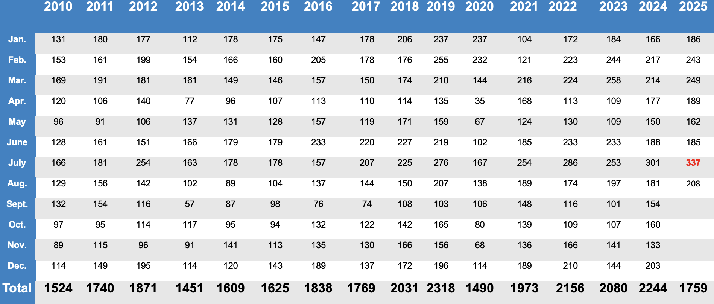

Following the inevitable downturn during the COVID-19 years (2020–2021), when in-person activities were largely suspended, the number of accredited Live Educational Events (LEEs) has risen steadily and, since 2022, has consistently exceeded 2,000 per year. This recovery has evolved into a clear growth trend, peaking, after de COVID pandemic, at 2,244 applications in 2024.

In 2025, activity remains at an exceptionally high level, with 1,759 applications registered by the end of August, indicating that the year is likely to close among the busiest in EACCME history. Particularly significant is July 2025, which recorded 337 applications, an absolute record for a single month since the creation of the EACCME. This peak confirms the strong momentum of post-pandemic recovery and demonstrates the maturity and reliability of the EACCME’s operational systems.

These results are the outcome of a sustained collective effort. The dedication of the EACCME Office, the professionalism of reviewers, and the technical support provided by UEMS Bodies and National Accreditation Authorities have enabled the system to manage an unprecedented volume of applications while maintaining its hallmark standards of quality, independence, and scientific integrity.

The consolidation of digital tools, notably through the Odoo platform, and the procedural refinements introduced under the EACCME 3.0 framework have been instrumental in managing this growth efficiently. The ability to handle increasing demand without compromising quality stands as a tangible indicator of institutional maturity and confirms the EACCME’s position as a trusted partner for medical education providers across Europe and beyond.

Ultimately, the record achieved in 2025 reflects not only the vitality of the Live Educational Event format but also the success of a coordinated and forward-looking effort across the entire UEMS community — staff, reviewers, UEMS Bodies, and external partners — whose shared commitment ensures that the EACCME remains a benchmark of excellence in continuing medical education.

Table 2: e-Learning Material applications (* data until 31st August)

During the period between 1st January and 31st August 2025, a total of 163 E-Learning Material (ELMs) were approved, remaining stable when compared with the 161 registered in the same period of 2024.
This consolidation follows the sharp reduction observed between 2023 and 2024, which reflected not only the transition to the EACCME 3.0 framework and the introduction of stricter educational and quality assurance criteria, but also the normalisation of figures after the exceptional increase recorded during the COVID-19 years.

During that period, many Live Educational Events (LEEs) were temporarily converted into ELMs due to the travel and gathering restrictions imposed across Europe, leading to an artificial inflation of ELM numbers between 2020 and 2022. This trend has since gradually reversed as on-site educational activities resumed and the accreditation landscape returned to a balanced configuration.

The current figures therefore represent a stabilization following both the post-pandemic adjustment and a year of adaptation to the modernised system. The slight increase recorded in 2025 (plus 1.2 percent) suggests that the structural and procedural improvements implemented since 2024 – including the integration of the Odoo digital management platform, the harmonisation of review processes, and enhanced communication with providers – are now producing tangible results.

Feedback received from providers indicates greater familiarity with the EACCME 3.0 procedures and improved adaptation to the revised accreditation requirements. The present trend thus reflects the consolidation of a quality-driven and sustainability-oriented model, ensuring that continuing medical education within the UEMS framework remains credible, transparent and aligned with the strategic priorities defined for 2024–2026.

Table 3: Webinar Packages Applications (* data until 31st August)

During the period between 1st January and 31st August 2025, a total of 37 Webinar Packages were accredited, compared with 27 during the same period of 2024, representing an increase of approximately 37 percent. This rise consolidates the strong momentum recorded in 2024, confirming the continued relevance of this format within the EACCME portfolio. After a period of adjustment following the post-pandemic decline in online-only activities, the number of webinar packages has now stabilised.

The data for 2025 indicate that providers are increasingly integrating webinar packages as part of comprehensive educational strategies, combining accessibility with thematic continuity and pedagogical coherence. The format remains particularly suited to multi-part learning programmes and continues to serve providers seeking flexible, high-quality online education options. Its steady expansion reflects both the maturity of the format and the confidence of providers in the digital accreditation procedures implemented under EACCME 3.0.

Table 4: Reviewing Scientific and Educational Material (* data until 31st August)

During the period between 1 January and 31 August 2025, a total of 4 applications for Reviewing Scientific and Educational Material were processed, compared with 8 during the same period of 2024, representing a 50% decrease. This reduction contrasts with the growth trend observed in previous years and likely reflects a temporary adjustment following the peak of post-pandemic digital learning activity. It may also indicate a shift of interest among providers towards other accredited formats, particularly live and blended learning activities, which have continued to expand within the EACCME portfolio.

Nevertheless, the Reviewing Scientific and Educational Material format remains a valuable tool for disseminating high-quality educational content and supporting self-directed learning. Continuous monitoring of provider engagement and feedback will help ensure that this format remains aligned with evolving pedagogical preferences and technological developments in Continuing Medical Education.

  - Activity under the SEAFORMEC Agreement

Table 5: Live educational events applications 2019-2025 (* data until 31st August)

Table 6: -Learning Material applications 2019-2025 (* data until 31st August)

 | 2019 | 2020 | 2021 | 2022 | 2023 | 2024* | 2025*
Total | 47 | 89 | 94 | 138 | 195 | 78 | 101

Table 7: Blended Learning applications 2019-2025 (* data until 31st August)

Under the SEAFORMEC Agreement, activity continued to show a positive trajectory during 2025. Between 1 January and 31 August 2025, a total of 208 Live Educational Events (LEEs) were accredited, compared with 145 during the same period of 2024, representing an increase of approximately 43 percent. This significant growth reflects the steady recovery of live educational activity in Spain following the post-pandemic transition and the ongoing confidence of providers in the EACCME–SEAFORMEC partnership.

The figures suggest that on-site events have regained their central role in continuing medical education, supported by streamlined accreditation procedures and closer cooperation between both institutions.

In parallel, 101 applications for e-Learning Material were processed under the SEAFORMEC framework during the same period, up from 78 in 2024, corresponding to a 29 percent increase. This continued expansion of online learning tools demonstrates the consolidation of digital education as a permanent and complementary component of the Spanish CME landscape. The rise also indicates the successful adaptation of providers to the technical and pedagogical standards required under EACCME 3.0, enhancing the overall quality and diversity of accredited content.

The joint implementation of live and digital formats under SEAFORMEC confirms the effectiveness of this cooperation model, which continues to strengthen the alignment between European and national accreditation systems. The 2025 results illustrate a balanced and sustainable distribution of educational activities across modalities, fostering accessibility, quality, and mutual recognition within the broader framework of continuing medical education in Europe.

  - Activity under the PhMA Agreement

During the period between 1 January and 31 August 2025, a total of 380 applications for accreditation were processed under the EACCME–PhMA Agreement. This figure represents a substantial level of activity and confirms the consolidation of the collaboration with the Panhellenic Medical Association as a key component of EACCME’s international outreach. The volume of applications reflects both the maturity of the partnership and the strong engagement of Greek providers in continuing medical education.
The sustained demand observed in 2025 demonstrates that the agreement continues to deliver consistent results, supported by streamlined coordination and the full alignment of accreditation standards between the EACCME and the PhMA. A decisive factor contributing to this increase has been the implementation of the national requirement making EACCME accreditation mandatory for all CME/CPD events organised in Greece. This regulatory development has reinforced the role of the EACCME as the central reference framework for quality assurance in medical education and has significantly broadened the range of activities submitted for review.

The 2025 data confirms Greece’s position as one of the most active national partners within the EACCME network. While the recorded figure of approximately 380 accredited activities per year likely reflects only part of the country’s overall CME landscape, it underscores the gradual implementation of national accreditation requirements and their growing alignment with the EACCME system. This steady and structured progression illustrates increasing confidence in the joint accreditation framework and highlights the value of close cooperation between European and national structures in promoting transparent, harmonised, and high-quality continuing medical education across Europe.
  - Procedural and operational developments

Throughout 2025, the EACCME focused on consolidating the procedural and operational reforms initiated during the previous year, ensuring a more coherent and transparent framework for the accreditation of continuing medical education activities. The Odoo management platform is now fully operational, providing unified support for application tracking, reviewer coordination and financial administration. This integration has significantly improved the consistency and efficiency of workflows across all categories of accreditation.

Building on this foundation, the UEMS is finalising the creation of a new, additional accreditation pathway. This initiative is designed to recognise long-standing, compliant providers and to facilitate a closer and more structured partnership with them. Under this model, trusted CME providers will benefit from simplified procedures and enhanced guidance, creating a framework that promotes long-term commitment, quality assurance and mutual trust between the EACCME and its partners. Preparatory work will be concluded in 2025, with the new pathway to be presented at the Spring 2026 Council meeting and implementation foreseen for July 2026.

In parallel, the EACCME continued to clarify and refine the accreditation criteria applicable to events submitted by foundations and similar entities. These clarifications aim to ensure transparency and consistency in the evaluation of organisational independence, financial structure and educational content, thereby maintaining alignment with the principles of impartiality and scientific integrity.

More broadly, the EACCME has demonstrated continued responsiveness to the evolving educational landscape and to questions raised by providers and reviewers. Criteria, definitions and procedural concepts are regularly revisited and adjusted whenever necessary, ensuring that the system remains transparent, fair and fully aligned with current practice. This proactive and adaptive approach reinforces the EACCME’s reputation as a responsive, service-oriented and quality-driven accreditation body, capable of addressing new challenges promptly while upholding its rigorous standards.

- European Training Requirements

At the UEMS Council meeting held in Brussels on 26 April 2025, significant progress was achieved in the ongoing consolidation of the UEMS European Training Requirements (ETRs) framework. The meeting featured the formal presentation of the new UEMS ETR Terms of Reference and Timeline Document (UEMS 2025/07) by Professor Nada Čikeš, Chair of the UEMS ETR Review Committee (ETR RC).

This document updates and systematises the principles, structures, and processes governing the development, review and adoption of ETRs within the organisation.

The new framework introduces a more transparent and participatory approach, ensuring closer collaboration between UEMS Sections and Boards, scientific societies, and national representatives. It also reinforces the integration of Competency-Based Medical Education (CBME) principles, encourages inter-professional cooperation, and includes references to wider UEMS policy areas such as sustainability, equality and professional ethics. These methodological refinements collectively strengthen the quality, consistency and credibility of the UEMS ETR system.

At the same meeting, the following European Training Requirements (ETRs) were formally adopted after structured review by the ETR Review Committee and prior discussion within the Advisory Board and the Groupings:
• Professional Development Module in Anaesthesiology for Geriatric Patients
• ETR for Child and Adolescent Psychiatry
• ETR for Competency in Gynaecological Oncology
• ETR for Laboratory Medicine / Medical Biopathology
• ETR for Paediatric Haematology and Oncology
• ETR for Urology
• ETR for Wound Healing

These approvals confirm the ongoing consolidation of the ETR framework and the active engagement of UEMS Specialist Sections and Boards in advancing competence-based medical education. The documents adopted in April represent a broad spectrum of clinical and methodological domains and were developed through extensive consultation with relevant European scientific societies and national authorities.

At the October 2025 Council meeting in Tbilisi, five new documents are being presented for adoption, following review and endorsement by the ETR Review Committee:
• Professional Development Module (PDM) for the Competence in Obstetric Anaesthesiology
• ETR for the Specialty of Geriatric Medicine
• ETR for the Competence in Reproductive Medicine
• ETR for the Competence in Transitional Care of Adolescents and Young Adults
• ETR for the Specialty of Pathology

Each of these documents responds to clearly identified needs within the UEMS Specialist Sections and addresses fields of growing clinical and educational significance across Europe. Collectively, these new ETRs reaffirm our association’s commitment to harmonising specialist education in key disciplines while fostering innovation in competency-based training and assessment.

In preparation for 2026, the UEMS, through the ETR Review Committee, will continue to support development and revision of ETRs, while further refining templates and supporting documentation. It will also maintain the alignment of training frameworks with evolving European regulatory developments and professional practice trends. This structured and iterative cycle of development, review and update ensures that UEMS ETRs remain relevant, coherent and fully representative of the highest standards of postgraduate specialist education in Europe.

- UEMS in the EU

- European and International Affairs Office

In 2025, the UEMS continued to reinforce its presence and credibility within the European and international policy landscape through the coordinated work of the Office for European and International Affairs, under the leadership of Dr Marc Hermans.

The UEMS executive remains the key institutional interface of the organisation, ensuring that the views of European medical specialists are consistently represented in EU and international policy dialogues on healthcare, education and professional practice.

The Office has pursued a strategy focused on visibility, cooperation and influence, further reinforcing the UEMS’s presence in major European policy fora and its participation in EU-funded initiatives addressing areas of strategic relevance such as health workforce resilience, mental wellbeing and innovation in medical education. Through its active involvement in projects such as KeepCaring, DISCERN, and the recently launched Care2Care initiative, as well as the MaMoMS project – aimed at mapping medical specialties across EU countries to enhance transparency and comparability of postgraduate medical training – the UEMS continues to consolidate its standing as a recognised and trusted partner within European research and educational consortia.
At the same time, the UEMS maintained regular and constructive exchanges with the European Commission, the European Parliament, and other key institutional partners. Particular attention has been devoted to legislative developments affecting professional mobility and recognition, as well as to emerging themes such as public health preparedness and workforce planning. The Office also continued to cultivate relationships with organisations such as WHO Europe, Mental Health Europe, and the European Observatory on Health Systems and Policies, ensuring that the expertise of European specialists contributes to broader health system discussions.

Beyond its representational function, the Office plays an important role in internal coordination and communication, notably through the EU Affairs Monthly Review, which provides structured and accessible updates to UEMS Members on European policy trends. This tool, alongside targeted briefings and project updates, supports a more coherent approach to information-sharing and institutional visibility.

Through these efforts, the UEMS has maintained and expanded its reputation as a reliable, forward-looking partner in European health and education policy. The activities of the European and International Affairs Office have been instrumental in advancing this goal, positioning the UEMS as both a representative voice and a constructive contributor to Europe’s evolving health policy framework.
A detailed account of the work undertaken throughout 2025 will be presented by Dr Marc Hermans, Officer for European and International Affairs.

- 1st UEMS Congress

Preparations for the 1st UEMS Congress, to be held at the University of Leuven from 27 to 30 May 2026, advanced substantially throughout 2025. This will be the first congress organised directly under the auspices of the UEMS, representing a major milestone in the association’s institutional and scientific development. It is conceived as a truly collective initiative involving all UEMS Bodies, National Medical Associations, European Medical Organizations, Institutional partners and academic institutions. The Congress will provide an unprecedented platform to shape the strategic direction of the association for the coming decade, reinforcing its position as the leading voice of medical specialists in Europe.

The UEMS President, Professor Vassilios Papalois, chairs the Organising Committee, ensuring both scientific and institutional coherence. His leadership underlines the importance of the event for the UEMS as a whole and for the establishment of the foundations that will guide the association’s evolution in the years ahead.

The Congress is designed not merely as a scientific meeting, but as a defining institutional moment for reflection, dialogue and collective planning. It will be also an exceptional occasion to celebrate the UEMS achievements.

The draft programme outlines a four-day structure combining plenary sessions, high-level keynote lectures, workshops, panel debates and interactive thematic tracks. The sessions will address a wide range of topics of central importance to European medical specialists. Among the themes under preparation are the future of medical specialisation and cross-border professional mobility, the harmonisation of postgraduate training standards, the integration of competency-based medical education, the impact of digital transformation and artificial intelligence in healthcare, and the growing relevance of sustainability and environmental responsibility in medical practice.

Further sessions will explore the role of European Training Requirements (ETRs) as a tool for harmonisation, the continuous evolution of the EACCME accreditation system, and the interaction between scientific societies, regulators and EU institutions in shaping medical policy. Panels dedicated to ethical and societal dimensions of medical practice — such as inclusivity, diversity and humanism in healthcare — will provide an additional layer of reflection on the values that underpin the UEMS mission.

The Congress will also include a Young Specialists Forum, offering an interactive space for early-career doctors to engage directly with representatives of UEMS Sections, Boards and European institutions. This initiative reflects the UEMS commitment to nurturing the next generation of medical specialists and ensuring continuity in leadership and innovation. Parallel networking sessions and institutional meetings will facilitate cooperation between UEMS Bodies and external partners, while highlighting best practices in education, assessment and quality assurance.
Preparations are progressing smoothly and according to schedule. The final programme will be confirmed in the coming weeks, with registrations already open and early engagement indicating strong interest from the professional community.

The Congress will stand as a tangible demonstration of the unity, diversity and dynamism of the UEMS community, offering a forum for exchange between policymakers, educators, and clinical leaders. More than a scientific gathering, it will mark a decisive moment in the history of the association — setting the tone for its future strategic orientation and reaffirming the UEMS role as a cornerstone of European medical excellence and cooperation.

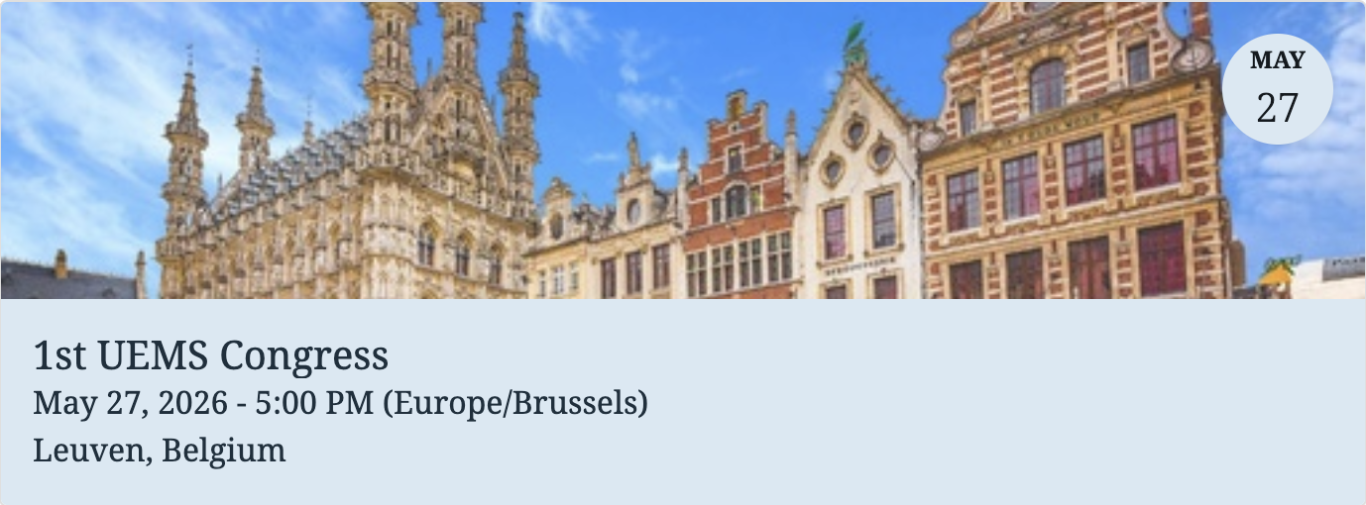


- Internal Issues

- Creation and restructuring of UEMS Bodies

At its meeting in Brussels on 26 April 2025, the UEMS Council approved the creation of two new Multidisciplinary Joint Committees (MJCs), reflecting the organisation’s continued responsiveness to emerging fields of medical relevance and its commitment to ensuring that specialist structures remain representative of current healthcare priorities.

The first new body, the MJC on Palliative Care Medicine, was proposed by Professor Jörg Weimann (SPIFA, Germany) and unanimously endorsed by the Council. The initiative responds to the recognised need for harmonised specialist training and equitable access to palliative care services across Europe. The MJC will focus on developing European Training Requirements, creating an inventory of existing training programmes, and establishing a European Board and Board Examination in Palliative Care Medicine. The proposal is supported by the UEMS Sections of Anaesthesiology and Paediatrics, and by the European Association for Palliative Care (EAPC).

The second new body, the MJC on Perinatal and Infant Mental Health, was proposed by Professor Marisa Casanova Dias, President of the UEMS Section of Psychiatry, and approved by the Council. The initiative addresses a critical interdisciplinary gap in healthcare, aiming to promote prevention, early detection and management of mental health conditions affecting mothers, infants and families. The MJC is supported by the Sections of Psychiatry, Child and Adolescent Psychiatry, Obstetrics and Gynaecology, and Public Health Medicine, with additional collaboration expected from Paediatrics and General Practice. Its work will focus on harmonising training programmes, fostering interdisciplinary collaboration, supporting research and policy dialogue, and raising awareness at both professional and public levels.

The establishment of these two MJCs demonstrates the continued capacity of the UEMS to identify emerging needs, create collaborative frameworks across specialties, and ensure that the organisation remains aligned with the evolving landscape of European healthcare and medical education. Both initiatives embody the UEMS commitment to promoting excellence, equity and innovation across all domains of specialist medical practice.

For the October 2025 Council meeting in Tbilisi, several structural developments are being presented for discussion and decision. These include:

• The winding up of the UEMS Section of Cardiothoracic Surgery, following the decision to create a new Section structure that better reflects the current professional and educational reality of the discipline.
• The winding up of the UEMS Thematic Federation for Vertigo, with its functions and expertise to be integrated into relevant existing UEMS Bodies.
• The proposal to establish a new UEMS Section for Cardiac Surgery, presented by Professor Dirk Van Raemdonck (President of the UEMS Section of Thoracic Surgery). This initiative aims to recognise the autonomy and scientific maturity of Cardiac Surgery as a distinct specialty, while ensuring continued cooperation with Thoracic Surgery under a coherent governance framework.
• The proposal to establish a new MJC on Disaster Medicine, presented by Dr Roberta Petrino (President of the UEMS Section and Board of Emergency Medicine). The new MJC seeks to provide a structured platform for interspecialty collaboration in preparedness, response and recovery during major health emergencies and humanitarian crises.
• The presentation of the revised UEMS CPD Charter, by Dr Hannu Halila (Chair of the CME/CPD Working Group). This long-awaited update represents a comprehensive revision of the UEMS position on Continuing Professional Development (CPD), reaffirming the organisation’s commitment to maintaining relevance, coherence and leadership in an evolving professional landscape. The revised Charter articulates the UEMS vision on the principles, values and operational standards that underpin lifelong learning and professional development for medical specialists across Europe. It emphasises the central role of continuous education in ensuring clinical excellence, ethical integrity and adaptability in the face of rapid scientific and societal change.

These developments collectively demonstrate the continuing evolution of the UEMS structure, ensuring that its Bodies remain scientifically coherent, operationally effective and representative of contemporary medical practice. They also highlight the association’s responsiveness to emerging fields of expertise and its commitment to maintaining a balanced, forward-looking posture.

- Finances

The financial position of the UEMS remains sound and stable, reflecting careful planning, disciplined management and continued commitment to transparency and accountability. The consolidated accounts for 2024 confirmed a balanced outcome, with revenue and expenditure remaining within projections. The first semester of 2025 maintained this positive trajectory, showing steady income from accreditation and membership contributions, alongside prudent control of operational costs.

The financial indicators for the first half of 2025 confirm the robustness of the association’s economic structure. The profit and loss account displays sustained financial equilibrium across all core activities, with a moderate surplus that ensures the capacity to fund ongoing commitments and new initiatives. The UEMS common investment continued to perform positively despite a less favourable market environment, yielding a bonus of €53,660.34, a result that illustrates the effective and cautious management of available liquidity.

An important structural development concerns the UEMS loan, whose repayment is progressing according to schedule. The association is expected to be debt-free by mid-2026, marking the completion of a long-term financial stabilisation process and further strengthening the independence of the UEMS. This milestone will allow for increased investment in strategic areas such as digital infrastructure, member services, and educational development.

The contribution of UEMS bodies to the core activities of the organization, which is called our management fee, for 2025 was reviewed and adjusted to 9%, down from 10% in previous years. This change reflects the ongoing efforts of the Treasurer and Executive to ensure proportionality between administrative expenditure and the scope of services delivered to and on behalf of our UEMS Bodies. The adjustment also mirrors the consolidation of financial procedures, and the efficiency gains achieved through the integration of digital tools in financial administration. The total amount corresponding to the 2025 management fee will be transferred from the UEMS bodies in early November.

The budget plan for 2026 foresees continued financial stability and a cautious growth trajectory. Forecasts include sustained revenue from the EACCME, balanced by planned reinvestment in quality assurance, staff development, and institutional initiatives aligned with the UEMS Strategic Goals for 2026. The overall approach remains conservative yet forward-looking, prioritising financial sustainability, transparency, and the capacity to support the organisation’s expanding portfolio of activities.

The UEMS financial governance continues to demonstrate maturity, responsibility and foresight. Sound financial management has long been a cornerstone of the organisation’s credibility and stability, underpinning its ability to act with independence and to deliver value to its members. The discipline and transparency shown in recent years reinforce confidence among stakeholders and ensure that the UEMS remains well prepared to address future challenges with both prudence and ambition.

A full presentation of the accounts and the 2026 budget proposal will be delivered by the UEMS Treasurer, Dr Othmar Haas, during the Advisory Committee and the Council meetings.

- The UEMS House - Domus Medica Europaea

Table 8: DME Income (* data until 31st August)

As of 31 August 2025, total revenue from tenants and related services at the Domus Medica Europaea amounted to €87,899, compared with €51,415 recorded for the whole of 2024.
This result, achieved within the first eight months of the year, confirms a clear upward trend in occupancy and service-related income and anticipates a strong year-end performance. If current patterns are maintained, total revenue for 2025 is projected to reach approximately €120,000–125,000, representing the highest annual figure since 2021.

The most significant growth came from the serviced office contracts, with several tenants consolidating or expanding their use of UEMS facilities. The Cancer Patient Forum (CPE) became the principal contributor, generating €33,839 by August 2025, a threefold increase compared to 2024 (€10,500), reflecting its transition from partial-year to full-year occupancy. Other steady contributors include the Alliance for Regenerative Medicine, which increased from €10,500 in 2024 to €16,919 by August 2025, and the European Urological Foundation, maintaining stable activity with €10,021.

Income from meeting room rentals also increased, reaching €2,700, reflecting the return of in-person meetings and the growing use of DME facilities by UEMS Bodies and external organisations. Service fees, including virtual office and postal address contracts, rose to €6,822, already exceeding the 2024 full-year total (€3,815), while parking revenue remained strong at €7,253, confirming the steady reinstatement of on-site operations.

Overall, the 2025 figures reflect a substantial recovery in the utilisation of the Domus Medica Europaea, supported by diversified tenancy, improved occupancy continuity and renewed demand for professional meeting spaces. The positive trajectory points towards full post-pandemic stabilisation and positions the DME once again as a reliable and strategically valuable institutional asset. Revenue performance is expected to consolidate further in 2026, as long-term tenant agreements are renewed and remaining office capacity is optimised in line with the operational needs of UEMS Bodies and external partners.

Beyond its financial contribution, the Domus Medica Europaea continues to offer state-of-the-art facilities for meetings, training sessions and hybrid events, serving as a modern and functional hub for the activities of UEMS Bodies. Its strategic location in the heart of Brussels — within walking distance of the European Commission — ensures unparalleled accessibility and visibility, reinforcing the UEMS presence at the centre of European medical and institutional life. The combination of advanced infrastructure and central positioning makes the DME a cornerstone of the organisation’s operational and representational capacity.

- The UEMS Office in Brussels

- Current workforce

Table 9: current workforce of the UEMS office in Brussels.

As of October 2025, the UEMS workforce comprises 19 staff members, corresponding to a total of 18.3 Full-Time Equivalents (FTE), compared with 16.6 FTE in 2024. This represents a moderate and strategic reinforcement of human resources, consistent with the steady expansion of the organisation’s activities and the continued professionalisation of its administrative and operational structures.

The largest share of staff continues to be allocated to EACCME accreditation activities, which account for 6.9 FTE, reflecting both the sustained volume of applications and the increasing complexity of quality assurance procedures. The Administration and Finances Unit remains stable with 2 FTE, ensuring continuity in financial governance and compliance.

Administrative support to UEMS Bodies totals 3 FTE, providing logistical and communication assistance to the growing number of Sections, Boards and MJCs. Similarly, Coordination of Internal and External Affairs accounts for 3 FTE, covering institutional liaison, communications, and stakeholder relations at European level. The Head Office Management structure includes 1.4 FTE, reflecting the balance between executive coordination and administrative oversight, complemented by 1 FTE of internship or temporary staff to ensure operational flexibility.

The overall increase in staffing reflects the evolving needs of the organisation and the sustained growth of its portfolio, particularly in accreditation, policy coordination and interinstitutional engagement. The reinforcement achieved in 2025 has strengthened internal capacity, enhanced responsiveness and ensured greater continuity of service to UEMS Bodies and external partners.

In parallel, the UEMS continues to invest in staff development and retention, promoting a working environment that values competence, collaboration and well-being. Continuous training opportunities, cross-departmental coordination and internal mobility initiatives support the professional growth of staff members and the sharing of institutional knowledge. This approach has contributed to a stable and experienced administrative team, capable of upholding the organisation’s standards of quality, efficiency and accountability. The UEMS thus maintains a lean yet highly skilled workforce, fully aligned with its long-term strategic priorities and its mission to serve the European medical community.

Image 1. Current organogram of the UEMS office in Brussels
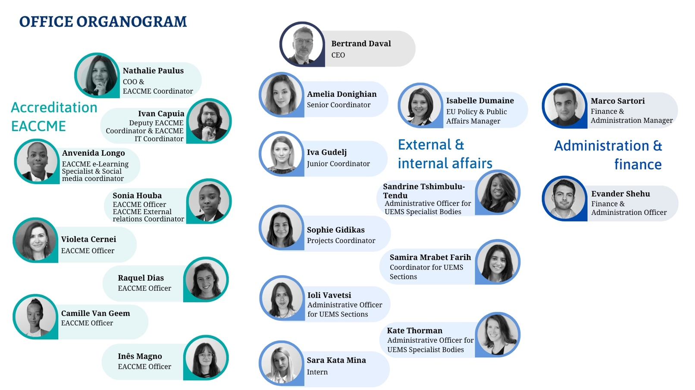
Image 2: HR breakdown by department

- Administrative and Operational Overview

Throughout 2025, the UEMS Office in Brussels continued to play a pivotal role in supporting the operational, administrative and policy-oriented activities of the association. The consolidation of internal structures, optimisation of digital tools, and reinforcement of human resources reflect a proactive response to the growing complexity and volume of UEMS activities.

From an organisational standpoint, the Office maintained full operational continuity across all its departments. The Accreditation Unit managed a sustained workload linked to EACCME applications and the preparation of the upcoming “Accredited Provider” pathway, while contributing to the refinement of quality assurance and feedback mechanisms. The Administrative and Coordination Unit ensured the preparation and follow-up of all UEMS statutory meetings, the organisation of internal elections, and the provision of secretarial support to the Executive, Council, Advisory Board and numerous UEMS Bodies.

In parallel, the External Affairs Department continued to strengthen UEMS representation and visibility within the European institutional environment. It coordinated the association’s participation in joint EU-funded projects such as DISCERN, KEEPCARING and MAMoMS, maintained active liaison with the European Medical Organisations (EMOs), and contributed to policy monitoring and institutional communication. Regular updates to the UEMS website, newsletters and public information materials supported a consistent and transparent communication strategy.

The year also saw the continuation of several strategic digital development projects, including the creation of a secure Members’ Portal, the UEMS Fellowship Register, and the Charter Project defining cooperation principles with scientific societies. These initiatives are designed to enhance internal coordination, streamline administrative processes and promote a more integrated approach to information management.

In terms of staffing, 2025 brought moderate but targeted reinforcement of the Office structure. New team members joined key operational areas, including Ms Sophie Gidikas, appointed as UEMS Project Coordinator; Ms Camille Van Geem, as EACCME Administrative Officer; Ms Ioli Vavetsi, as Administrative Assistant for the Surgery Department; and Ms Inês Magno, who joined on a part-time basis to support accreditation activities. These additions ensured the continuity of services and addressed increased workload following natural staff turnover.

Beyond staffing and project development, the Brussels Office continued to provide essential day-to-day support to all UEMS structures, ensuring efficient coordination between statutory bodies, Sections and Boards, and external partners. The Office also played a central role in the preparation and implementation of Council and Executive decisions, contributing to institutional consistency, transparency and procedural rigour.

The UEMS Office remains the operational and institutional cornerstone of the organisation. Combining stability, adaptability and innovation, it continues to ensure that UEMS activities are carried out with professionalism, efficiency and full alignment with the association’s mission to promote excellence in specialist medical practice and education across Europe.

- Final Remarks

As 2025 draws to a close, the UEMS stands as a stronger, more cohesive and forward-looking organisation. The work accomplished throughout the year — across accreditation, training, institutional development and European policy — has further consolidated our capacity to act as a credible and unifying voice for medical specialists in Europe.

The achievements of this period have not only strengthened the operational and structural foundations of the association but also prepared it for a new phase of growth and strategic reflection. The consolidation of the EACCME 3.0 framework, the refinement of the European Training Requirements, and the growing engagement with European and international partners all point to a UEMS that is both responsive and visionary — capable of addressing today’s challenges while anticipating those of tomorrow.

Looking ahead, 2026 will mark a decisive milestone with the celebration of the 1st UEMS Congress in Leuven. This event will provide a unique platform to reaffirm our collective mission, to showcase the contribution of European medical specialists to healthcare systems, and to define the priorities that will guide the UEMS in the decade ahead. The Congress will also be an opportunity to strengthen our internal cohesion, foster collaboration across disciplines and generations, and celebrate the values that unite us — professionalism, independence, solidarity and service to patients.

Beyond this landmark, the UEMS will continue to pursue a forward-looking agenda: advancing the modernisation of medical education, supporting sustainable healthcare practices, and enhancing dialogue with European institutions and global partners. Our ability to evolve while remaining faithful to our founding principles remains the key to our success.

The progress achieved this year is the result of the collective commitment of all who contribute to the UEMS mission — representatives of National Member Associations, members of Sections and Boards, experts serving in committees and working groups, and the dedicated staff of the Brussels Office. Their professionalism and collaboration continue to embody the spirit of the UEMS and ensure that it remains a cornerstone of European medical excellence.

As we move towards 2026, we do so with renewed confidence, unity and determination — ready to build upon the solid foundations we have laid, and to continue shaping a future of excellence and cooperation for European medical specialists and the patients they serve.

João Miguel Grenho
UEMS Secretary General

