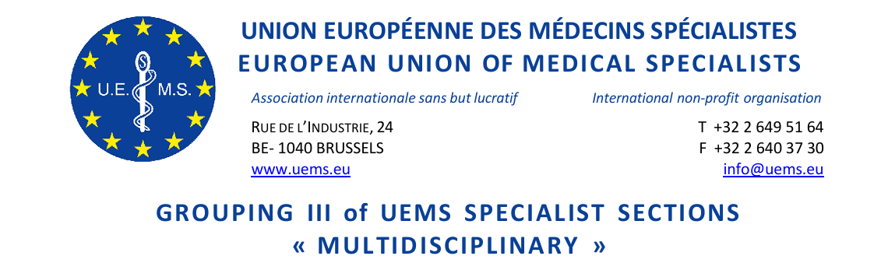

GROUPING III MEETING of UEMS SPECIALIST SECTIONS & EUROPEAN BOARDS
Friday, 17 October 2025
Sheraton Grand Tbilisi Metechi Palace 20 Telavi Street,
Tbilisi 0103 Georgia
13:30-15:00
Room USHBA

DRAFT AGENDA

- Roll call of Sections (+for registered Sections)
Anaesthesiology
Child & Adolescent Psychiatry & Psychotherapy
Clinical Neurophysiology
Dermatology and Venereology +
Emergency Medicine
Geriatrics+
Laboratory Medicine/ Medical Biopathology+
Medical Genetics +
Medical Microbiology
Neurology+
Nuclear Medicine+
Occupational Medicine
Pathology+
Pharmacology
Psychiatry+
Public Health Medicine+
Radiation Oncology and Radiotherapy
Radiology+

- Approval of the Agenda
- Approval of the minutes of last Meeting (25 April 2025, Brussels)(document attached)
- Specialist issues - European Training Requirements*

  - Professional Development Module PDM for the Competence in Obstetric Anaesthesiology
  - European Training Requirements for the Specialty of Geriatric Medicine
  - European Training Requirements for the Competence in Reproductive Medicine
  - European Training Requirements for the Competence in Transitional Care of Adolescents and Young Adults
  - European Training Requirements for the Specialty of Pathology
- Constitutional Matters*

  - Winding up the UEMS Section of Cardiothoracic Surgery
  - Winding up the UEMS Thematic Federation for Vertigo
  - Proposal to establish a new UEMS Section for Cardiac Surgery
  - Proposal for the establishment of a new UEMS MJC, for Disaster Medicine
- Miscellaneous/AOB
Experience with NMAs failing to contribute fee to Sections – Patrick Twomeny, Section for Laboratory Medicine / Medical Biopathology
- Report of Grouping III

* Decision required
**Supporting documents available at UEMS Autumn Council Meeting: 17-18 October, 2025 Tbilisi, Georgia | uems.eu

