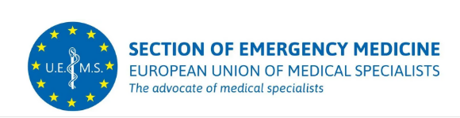

Lugano, 14 July 2025

**Proposal for the Establishment of a Multidisciplinary Joint Committee in Disaster Medicine**

I am writing to propose the formation of a Multidisciplinary Joint Committee (MJC) focused on Disaster Medicine.

Over the past decade, European healthcare systems and medical professionals have encountered challenges that extend well beyond conventional specialized medical practice. The recent COVID-19 pandemic clearly exemplified a crisis that tested the capabilities of emergency physicians, intensivists, infectious disease specialists, public health experts, and many other specialists.

Given the ongoing impact of climate change, we are witnessing an increase in patients requiring medical assistance, the emergence of new infectious diseases and potential pandemics, as well as a rise in the frequency and severity of natural disasters, all of which threaten our healthcare environments.

Additionally, the war in Ukraine has brought conflict into Europe, posing unprecedented challenges to the continent since World War II. This situation demands specific expertise.

Disaster medicine is inherently complex, and although it represent a necessary part of the curriculum of emergency medicine, it demands seamless cooperation across multiple disciplines involved in the process of preparedness, response and mitigation of disasters.

The establishment of a Multidisciplinary Joint Committee in Disaster Medicine aims to unite diverse specialties to ensure comprehensive training and effective responses to the growing need for expertise. This committee will also facilitate collaboration with the EU and European scientific societies to ultimately harmonize Disaster Medicine training across Europe.

Thank you for considering this proposal. I look forward to discussing it further and working together on this crucial initiative.

Sincerely,

Dr. Roberta Petrino HonFESEM, FEBEM  
President UEMS Section & Board of Emergency Medicine