Friday 17th October – social activity for accompanying persons
Tour Price for 15-20 pax is 420 Euro – 21 Euro per person
Tour price for 30-40 pax is 600 Euro - 15 Euro per person
OPTIONAL:
Wine degustation 10 Euro per person
Museum: 3 Euro per person
Lunch is optional (which we decide on the way), 25 euros per person, including Wine

Day tour to the Wine region of Kakheti
The tour starts at 10 am by bus we drive for two and a half hours we drive to the Bodbe convent, where we visit a 4th-century church, which is the grave of St. Nino, a lady who brought Christianity to Georgia, and a newly built church with a view to Alazani velley and Caucasian mountain chain, later we visit Signagi the love town - The city’s name, meaning shelter, was initially chosen by King Erekle II for strategic purposes, you can still see remnants of this today with the remaining medieval architecture like an 18th-century fortress, known for the 4km-long city walls, which are an impressive sight today let alone encountering them as an invading army a couple of hundred years ago.


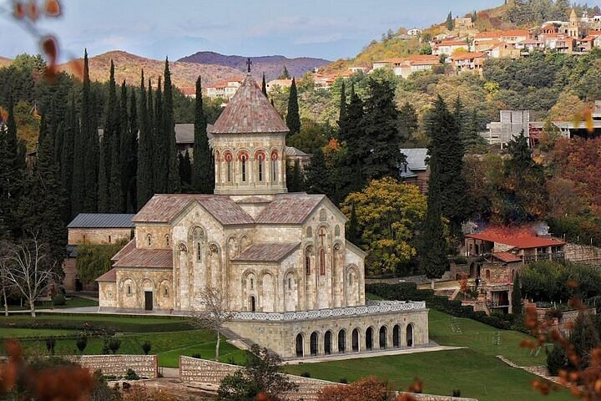
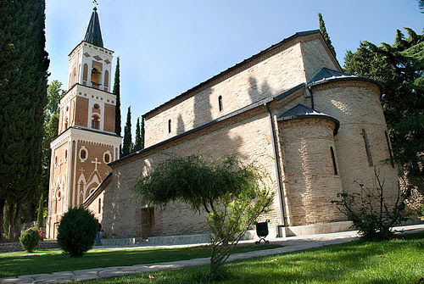

As Georgia is the motherland of wine, after all, we drive to Tsinandali - Shumi Winery, where we get closer to wine-making tradition and history, the oldest artefacts of wine-making date by the 6th millennium BC. We visit the wine cellar and the museum, have a degustation, and relax in the beautiful yard.
In the evening, back to Tbilisi


