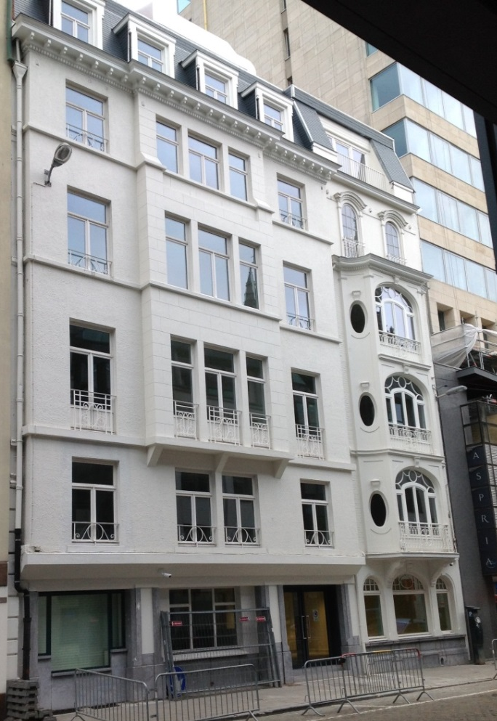

LOCATION

The UEMS House - Domus Medica Europaea

Rue de l’Industrie 24, 1040 Brussels

Secretariat : +32 (2) 486 06 40
Office : +32 (2) 649 51 64

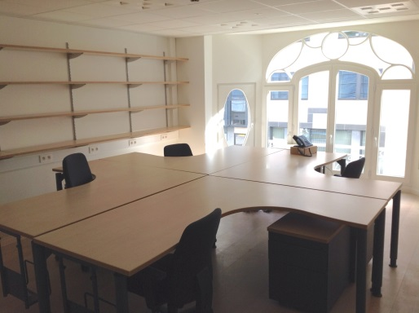
info@uems.eu
secretariat@uems.eu

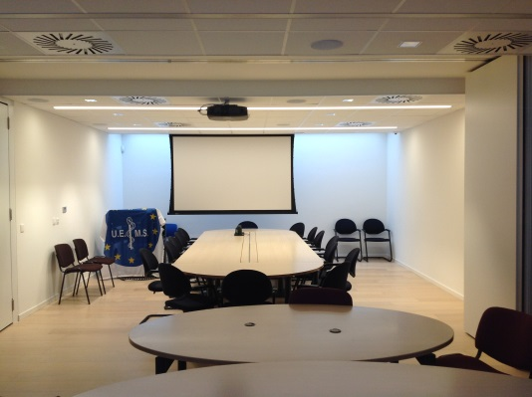

http://www.uems.eu/news-and-events/news/news-more/opening-uems-house-domus-medica-europaea
- From Central station: Metro lines ① or ⑤ stop at Arts-Loi Station
- From Gare du Midi: Metro lines ② or ⑥ stop at Trône Station

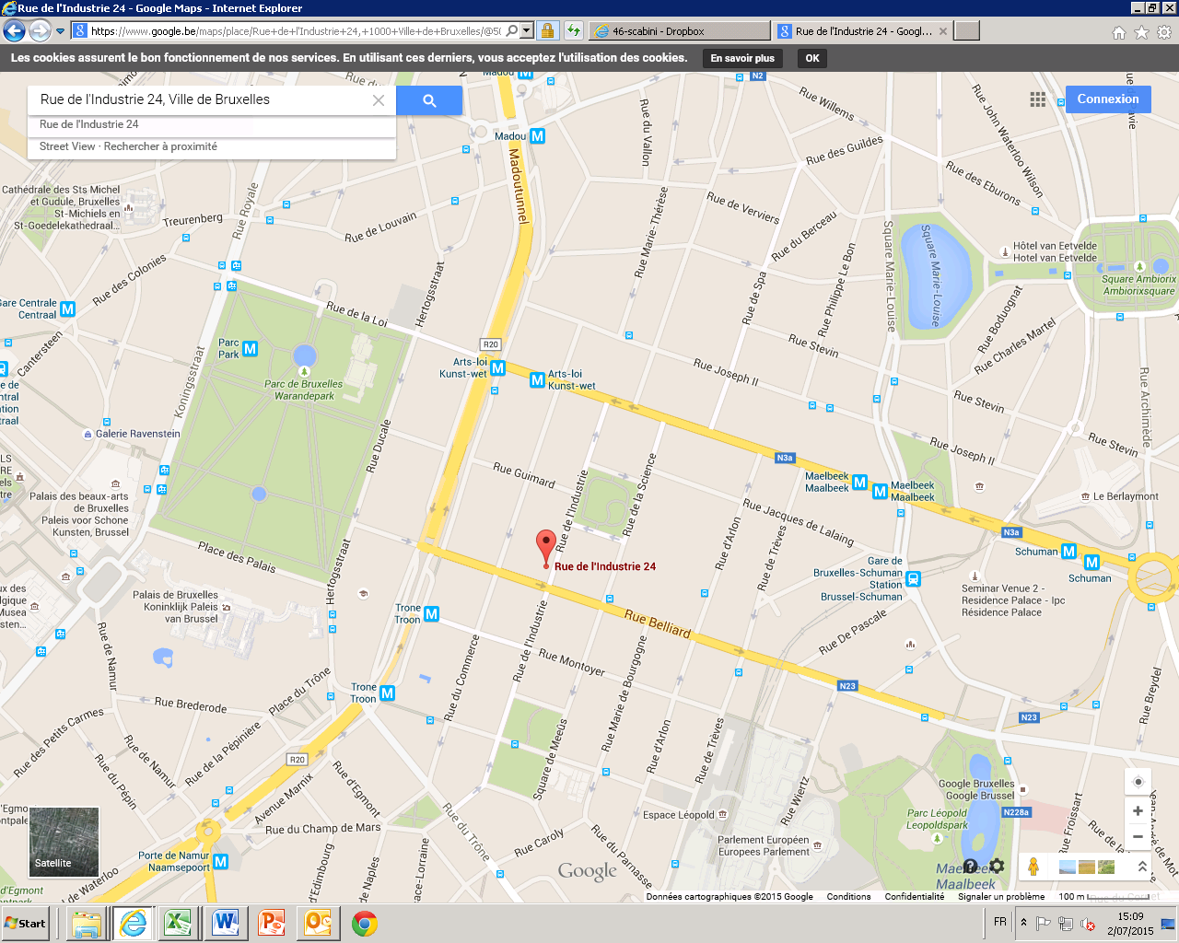
Arts- Loi Station
EU Commission
Thon Hotel
DOMUS
Central Station
Trône Station

List of hotels nearby the UEMS House - Domus Medica Europaea

Thon Hotel EU ****

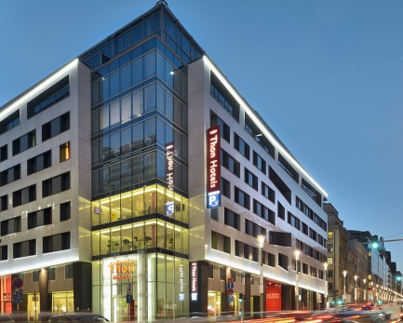
Rue de La Loi 75, 1040 Brussels, Belgium

Phone : +32 2 700 78 78

Fax : +32 2 205 15 25

Website : www.thonhotels.com/eu

UEMS Rate 2016

Double room for single use:

Best Available Rate – 15%

Breakfast buffet included/excluded

Excluding city tax (€7,58 per room per night)

Book you preferred rate:

Directly on our website: By email: reservations@thonhotels.be

http://www.thonhotels.com/log-in/ Please mention your customer number: TH8204

Login using the following

Customer number: TH8204 By phone: +32 2 700 78 78

Company name: UEMS Please mention your customer number: TH8204

Extra advantages:

- Cancellation policy: free of charge until 4 pm day of arrival ( please cancel by email)

- Free High Speed WIFI

- 10% discount in our other Thon Hotel properties in Brussels

- Arrival on Friday and Saturday only € 90,00 ( this rate will also apply during low seasons)

Fair periods:

In the following busy periods your preferred rates will not be available. But the Best Available Rate will be offered to you.

Intensive Care: From the 14th March to the 17th March

Cancellation policy: Until 7 days prior to arrival free of charge

Sea Food: From the 25th April to the 28nd April

Cancellation policy: Until 21 days prior to arrival free of charge

European Open days: From the 10th October to the 13th October

Cancellation policy: Until 7 days prior to arrival free of charge

Others :

Stanhope Hotel ***** Rue du Commerce 9, 1000 Brussels, Belgium

Leopold Hotel EU **** Luxemburgstraat 35, 1050 Brussels, Belgium

Radisson BLU EU **** Rue d'Idalie 35, 1050 Brussels, Belgium

Renaissance Hotel **** Rue Parnasse 19, 1050 Brussels, Belgium

Hotel Chambord *** Rue de Namur 82, 1000 Brussels, Belgium

