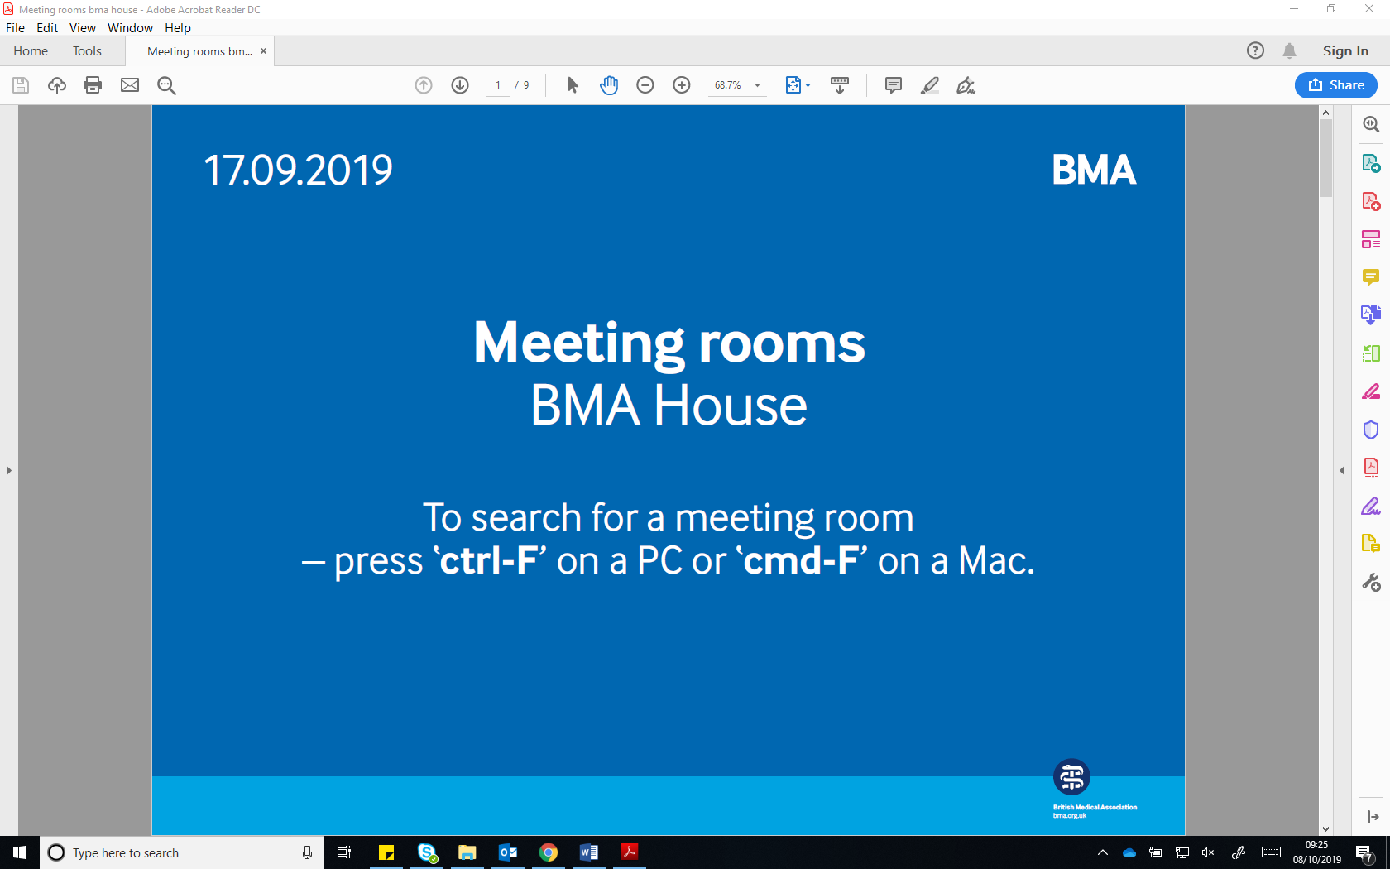
UEMS Meeting
Thursday 17 – Saturday 19 October

Meeting room locations

Thursday 17 October
8.30am – 6pm | UEMS Secretariat Office:  Carter Room, First Floor
10.30am – 5pm | UEMS EEC Meeting:  Murrell Barnes Suite, Ground Floor

Friday 18 October
8.30am – 6pm | UEMS Secretariat Office:  Carter Room, First Floor
9 – 11am | UEMS Board Meeting:  Council Chamber, First Floor
11am - 12pm | Working Groups:
Postgraduate Training:
Bevan Suite, Third Floor
Quality in patient care and specialist practice in current health systems:
Harvey Room, Third Floor
CME-CPD:
Courtyard Suite, Ground Floor
E-Health:
Jenner Room, Third Floor
Friday 18 October continued
12 – 1pm | Lunch:  The Lutyens Suite, Ground Floor
1 – 2pm | Meetings of the Three Groupings of UEMS Specialist Sections and European Boards
Grouping I:
Harvey Room, Third Floor
Grouping II:
Courtyard Suite, Ground Floor
Grouping III:
Bevan Suite, Third Floor
2 – 5pm | UEMS Advisory Board:  Great Hall, First Floor
Saturday 19 October
8.30am – 6pm | UEMS Secretariat Office:  Carter Room, First Floor
9am – 5pm | UEMS Council Meeting:  Great Hall, First Floor
1 – 2pm | Lunch:  The Lutyens Suite, Ground Floor

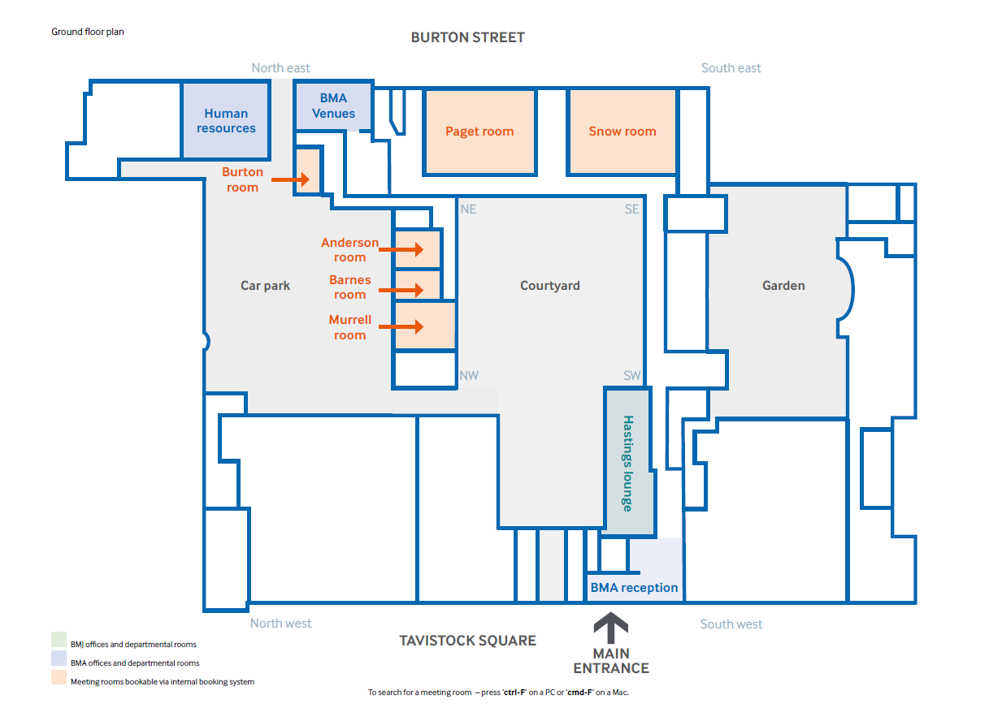
Lunch
Ground floor plan
UEMS EEC Meeting

- CME-CPD Working Group
- Grouping II

Courtyard Suite
Lutyens Suite
Murrell Barnes Suite
Registration
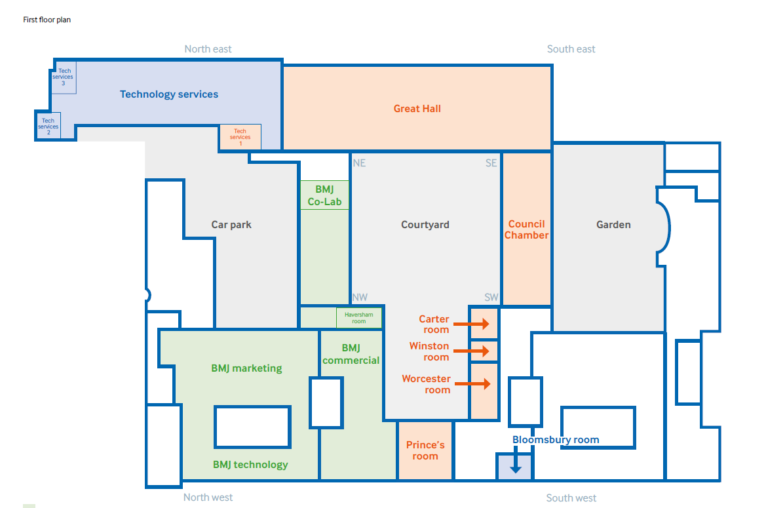
First floor plan
UEMS Board Meeting
- UEMS Advisory Board
- UEMS Council Meeting
UEMS Secretariat Office
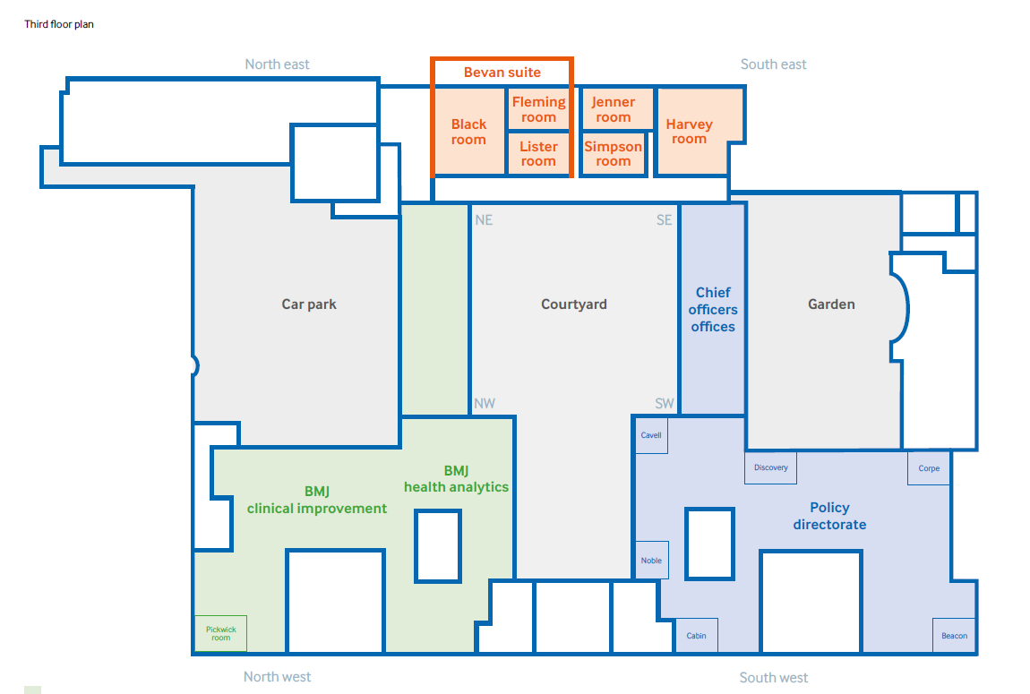
- Quality in patient care and specialist practice in current health systems Working Group
- Grouping I

Third floor plan
E-Health Working Group

- Postgraduate Training Working Group
- Grouping III

