Emergency Department
St Mary’s hospital
Praed Street
London
W2 1NY

Professor Papalois
President UEMS
24 Rue de l'Industrie
1040 Brussels
Belgium

March 10th 2021

Dear Professor Papalois

I am writing on behalf of the UEMS Section and Board for Emergency Medicine to invite the UEMS Council consideration of our request for a change of name. Thank you for the opportunity to discuss this at the forthcoming Council. In advance I would like to provide the background for our request.

The UEMS Section and Board for Emergency Medicine is seeking to request a change in the generic title of Accident and Emergency in European Legislation. This nomenclature was utilised originally for a specialty that was still developing.

However, the specialty, now named Emergency Medicine, has reached maturity and is fully established throughout the world including USA, Australasia and the Far East as well as most of Europe. Emergency Medicine is internationally recognised as the specialty for doctors working in emergency care.

At the heart of this request is Article 47 of the European Treaty between member states, which lays down that directives should be issues for the mutual recognition of diplomas, certificates and other evidence of formal qualification.

The European directive DIRECTIVE 2005/36/EC recognises the primary medical qualification and specialty recognition that allows in principle for practise in Europe without additional restrictions. This also allows for Member states to make any person pursuing a profession subject to specific requirements due to the application of professional rules justified by the general public interest. The Directive currently lists the specialty of emergency medicine as “accident and emergency medicine” and it is this change we are seeking to allow harmony across Europe and internationally.
There are 19 of the EU states (including the United Kingdom) who regulate the profession and so have it as a recognised medical specialty – and the majority call it emergency medicine.

Change can be made to the directive by a number of professional associations who can submit common platforms representative at national and European level. A common platform is a set of criteria which make it possible to compensate for the widest range of substantial differences which have been identified between the training requirements in at least two thirds of the Member States including all the Member States which regulate that profession.

The common platform is the name which we request to change to Emergency Medicine. To support this request we would emphasise that:
- The UEMS has itself has recognised our title as Emergency Medicine and has previously agreed to our title being the Section and Board for Emergency Medicine
- The Section and Board has submitted and gained approval for a European Training Requirement for Emergency Medicine
- We have established a European Board Examination in Emergency Medicine for specialists at the end of training
- Our diplomas certified by UEMS, are awarded in Emergency Medicine

We accept that the practice of Emergency Medicine varies throughout Europe and that training programmes where they exist, are not all 5 years. However we strongly feel that by uniting our colleagues under the term “emergency medicine” and therefore joining the international specialty, we will support the development of appropriate programmes and healthcare systems throughout Europe.

We are therefore asking formally for your support in this request. There is no associated impact on other specialties or request to change the work of emergency departments or trained emergency medicine specialists, but it will align European countries with the correct nomenclature.

We look forward to discussing this at the Council in April 2021.

Yours sincerely

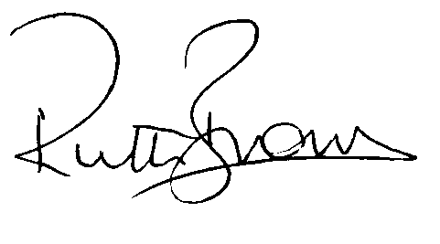

Ruth Brown
President of the UEMS Section and Board for Emergency Medicine

