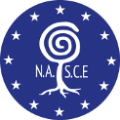
NASCE 2015 Scientific Meeting
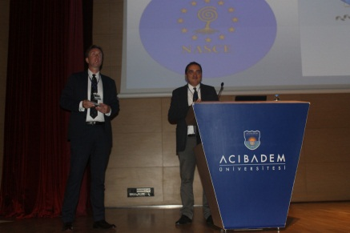
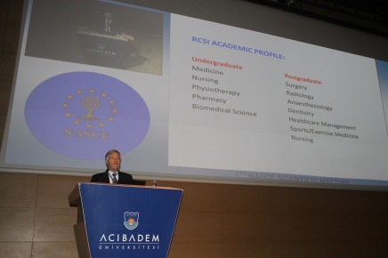
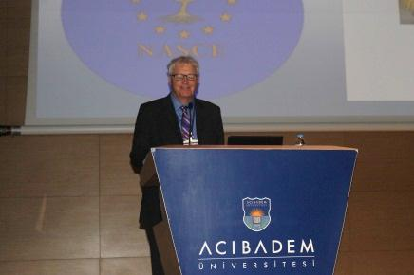
On September 14th and 15th 2015 the first NASCE Scientific Meeting was held at our center called as Acibadem University-CASE (Center of Advanced Simulation and Education in Istanbul. More than 60 participants joined the conference and accreditation certificates were handed over to the representatives of six European Centre’s, which were officially accredited by NASCE in 2015. The program started with an opening speech of NASCE Chairman Prof. Anders Bergenfelz and then continued with a keynote lecture held by the Chairman of ARB Prof. Oscar Traynor with the topic ‘ The Pathway to Competence in Operative Surgery ‘. Afterwards the representatives from each accredited centre made short presentations about their centres. Prof. Traynor continued with handing over the “NASCE Accreditation Certificates “ to the representatives of the centres. Ass. Prof. Emin Aksoy made
his speech on ‘ Designing A Medical Simulation Center for Interdisciplinary Trainings ‘ and Dr. Martina Vitz held her presentation about ‘Proficiency-based Training for Surgical Trainees: Importance of an Efficient and Competent Coaching of the Instructor’. The first day of the conference continued with oral Abstract presentations .
The social and networking program consisted of a Bosporus Cruise and a dinner given during the cruise.
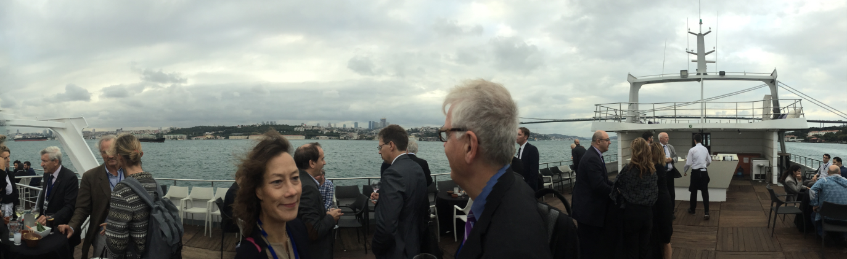
On the second day of the conference Prof. Pramod Luthra held a keynote lecture on ‘Training Trainers in Delivering Simulation Based Training and Education ‘. This was followed by a panel with the topic ‘What is Expecting Us in the Future?’ and oral poster presentations. Besides these, an interactive round table discussion about the accreditation criteria of NASCE was moderated by Assoc.Prof. Paul Ridgway with the presence of the NASCE Executive Committee.
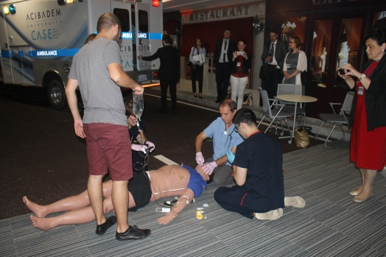
A simulation workshop named as ‘Interdisciplinary Approach to Multitrauma Patients‘ was performed with the volunteers among the participants of the meeting. Facility tours were organized in order to give the participants the opportunity to take a closer look into the facilities of our simulation center.

