X

X

X

X

Xx

*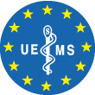*

*Warm season’s greetings*

Please support our Ukrainian colleagues by forwarding this

e-card and at the same time making a donation for them,

each time you send it with the mention

“WMA, CPME and EFMA Ukrainian Help Fund”

BICode GEBABEBB BE93 2100 6727 1067

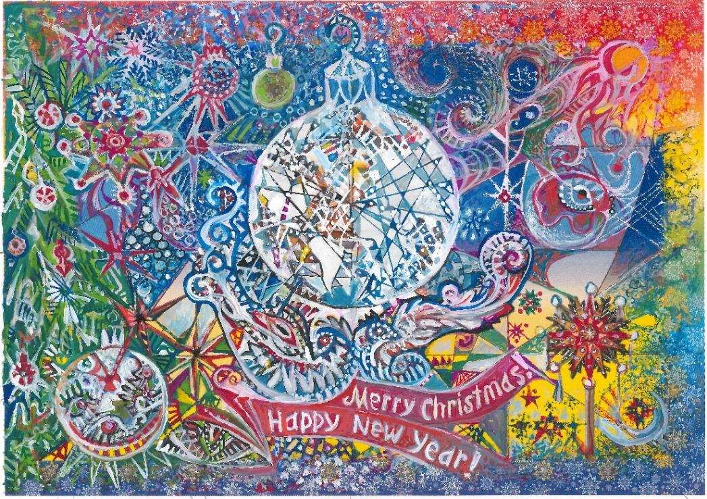

Painting by the Ukrainian artist Maria Ralko © UEMS aisbl